Math 100: DISCUSSION QUESTIONS, 28 Aug 2018

Riddles [some chosen from: Raymond Smullyan, What is the Name of this Book?, Dover (1978)]

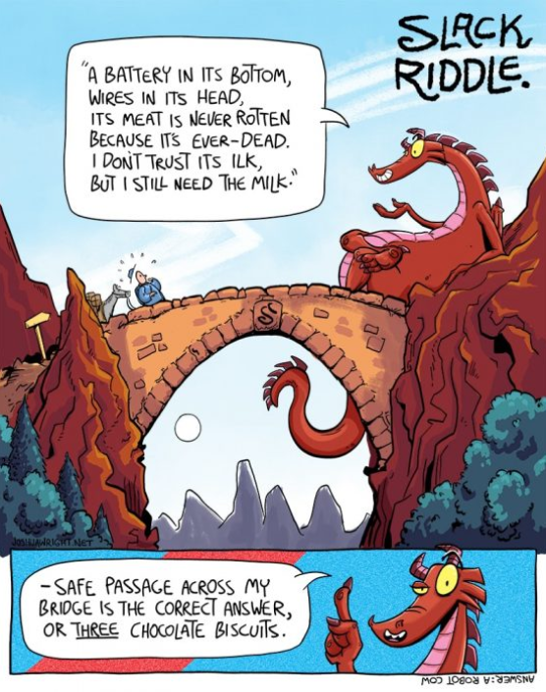

- What goes up when the rain comes down?
- Name the next letter in this sequence: J F M A M J J A S O N ?
- Can you name three consecutive days without using the words "Wednesday," "Friday," or "Sunday"?
- How can you give someone $83 using exactly 7 bills, without using any one-dollar bills?
- Who is in the portrait?
- Boris was looking at a portrait. Someone asked him, "Whose picture are you looking at?" He replied: "Brothers and sisters have I none, but this man's father is my father's son."
At whose picture was Boris looking?
- What if the statement had been: "Brothers and sisters have I none, but this man's son is my father's son."

A question of international law. If a plane crashes right on the border of the United States and Canada, in which country would you bury the survivors?

I have five and take away two, yet I am left with four. How is this possible? (Hint: think roman numerals)

There are two fathers and two sons. They walk into a candy store, and each buys a candy bar for 50 cents. The total for all of the candy bars was $1.50. How is that possible?

I gurgle but never speak, run but never walk, have a bed but never sleep. What am I?

What English word sounds the same even after you take away four of its five letters?

Albertine is sitting in her hotel room when there is a knock at the door. She opens the door to find a man whom she has never seen before. The man said, “Oh, I’m sorry, I thought this was my room.” He then went down the hallway and took the elevator. Albertine went back into her room and phoned security. Why?
- The Lion and the Unicorn. When Albertine entered the Forest of Forgetfulness, she did not forget everything; only certain things. She often forgot her name, and the one thing she was most likely to forget was the day of the week. Now, the Lion and the Unicorn were frequent visitors to the forest. These two are strange creatures. The Lion lies on Mondays, Tuesdays, and Wednesdays, and tells the truth on the other days of the week. The Unicorn, on the other hand, lies on Thursdays, Fridays, and Saturdays, but tells the truth on the other days of the week.
One day Albertine met the Lion and the Unicorn resting under a tree. They made the following statements:
- Lion: Yesterday was one of my lying days.
- Unicorn: Yesterday was one of my lying days too.
From these two statements, Albertine (who is a bright Loyola first-year student) was able to deduce the day of the week. What day was it?




