Class Discussion: Nov 1st
Systems of linear equations: 2 unknowns
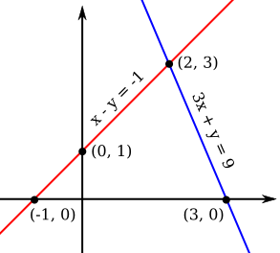
(A) Solve each of the following pairs of linear equations using the method of substitution. Check your answers. Sketch the lines.
1. y = 3x – 5
y = -4x + 9
2. 2x + y = 11
x + 3y = 18
3. 3x – y = 10
5x – 9x = -20

(B) * Solve each of the following systems of linear equations by Gaussian elimination. Determine which are inconsistent and which are dependent.
Check your answers if time permits.
- 7x + 2y = 47
5x – 4y = 1
- 2x – 5y = 1
7x + 3y = 24
- 5x – 10y = 3
x – 2y = 8
- 3x + 4y = 10
4x + y = 9
- x + 2y = 13
3x + 4y = 14
- 4x + 7y = 29
x + 3y = 11
- 15x + 77y = 92
55x – 33y = 22
- 3x = 7y
12y = 5x – 1
- x – y = 5
x/4 – y/5 = 2
- 5(x + 2y) – (3x + 11y) = 14
7x – 9y – 3(x – 4y) = 38
- x/2 – y/5 = 4
x/7 – y/15 = 3
- 3x – y = 8
33x – 11y = 88
* Problems from Hall & Knight, Elementary Algebra (1896)

What is straight? A line can be straight, or a street, but the human heart, oh, no, it's curved like a road through mountains.
- Tennessee Williams
