**Class discussion: 8 November 2018**

**Rational & negative exponents**

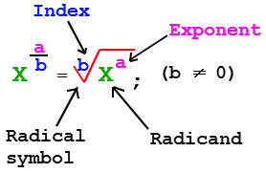

1. Find the value of each of the following:
2. 163/4 (b) 4-5/2  (c) 1252/3  (d) 8-2/3  (e) 36-3/2
3. (g) 2432/5  (h) ${\left(\frac{8}{27}\right)}^{-\frac{1}{3}}$ (i) ${\left(\frac{81}{16}\right)}^{\frac{3}{4}}$ (j) ${\left(\frac{32}{243}\right)}^{-\frac{7}{5}}$
4. Express with *positive indices:*
5. 2x -1/4 (b) 3a-2/3  (c) 4x-2a3 (d)  (e) 1/(4a-2)

(f) 1/(5x-1/2) (g) 3a-3x2/(5y2c-4) (h) (2x1/2)(3x-1) (i)

**powers of 10**

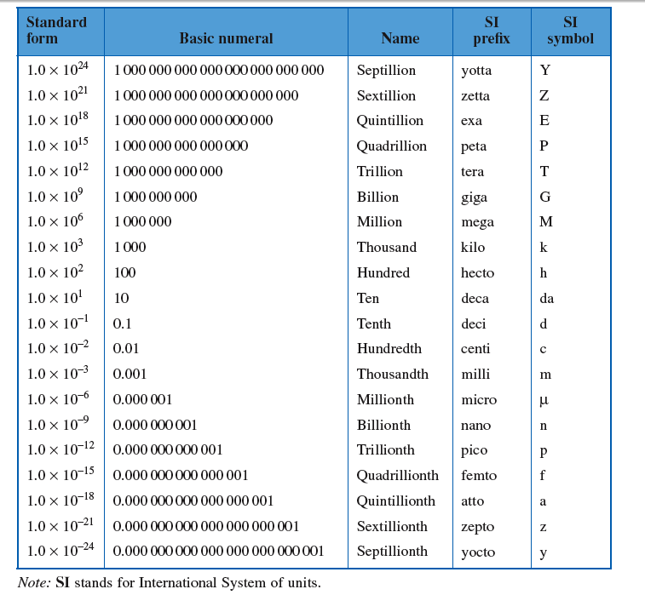

1. Watch the YouTube video on [powers of 10](http://www.youtube.com/watch?v=0fKBhvDjuy0) (vintage 1977).
2. Write each of the following in scientific notation:
3. 789,123
4. 0.478
5. 1,234,567
6. 0.00101
7. 0.000000093
8. 51,777,111
9. The speed of light is 299,792,458 meters/sec. Express this in scientific notation.
10. Express each in decimal form:
11. 7.5 104  (b) 9.33 10-7 (c) 8.881 106
12. Express each of the following products or quotients in scientific notation:
13. (5,100,000,000) (7,300,000)
14. (0.0003) (0.00009)
15. (1,200,000,000) (41,000,000)
16. (3.3 10-18) (2 1023)
17. (7.1 1041) (9.33 1055)
18. 
19. 
20. 
21. Roughly, how many seconds are in one century? How many minutes? (Try not to use a calculator.)
22. Roughly, how long is a micro-century (i.e., one-millionth of a century)?
23. The distance between the sun and Earth is about 93 million miles. Express this in scientific notation.
24. The predicted Gross National Product (GDP) for [2018 is 20.014 trillion dollars](https://www.whitehouse.gov/sites/whitehouse.gov/files/omb/budget/fy2018/budget.pdf). Express this in scientific notation.
25. The [current population of the world](http://www.worldometers.info/world-population/) is estimated to be **7,632,819,325**. Express this in scientific notation.
26. The current population of the United States is estimated to be **326,766,748** and that of Iceland **337,780**. Using scientific notation, compute the *ratio* of the population of the U.S. to that of Iceland. How many orders of magnitude greater is the population of the U.S.?
27. Assume that the original height of the [Incredible Shrinking Man](http://en.wikipedia.org/wiki/The_Shrinking_Man) was 6 feet. If his height is diminished [](https://www.youtube.com/watch?v=3gJJ74S9o0c)

"If nature existed on endless levels, so also might intelligence."

- [The Incredible Shrinking Man](http://en.wikipedia.org/wiki/The_Shrinking_Man)

[trailer](https://www.youtube.com/watch?v=VnDfrveCADo)

by 50% every month, approximately how long will it take for him to be 0.001 inches high? What would your answer be if his height were reduced by only 10% each month?

1. 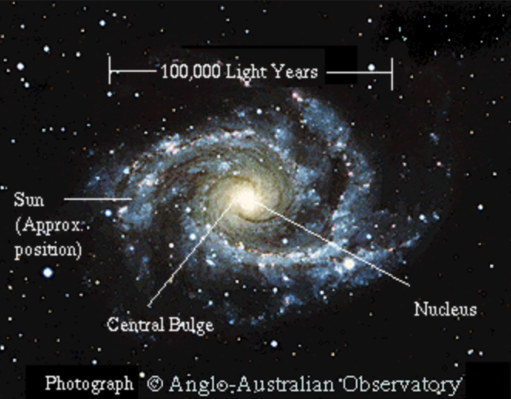The diameter of the Milky Way Galaxy is believed to be about 1,000,000,000,000,000,000,000 meters. By contrast, the diameter of the nucleus of a Carbon atom is only approximately 0.000 000 000 000 01 meters. Express each number in scientific notation. How many orders of magnitude larger is the size of the Milky Way than that of the Carbon atom?
2. Imagine that there is a rope around the equator of the earth. Add a 20-meter segment of rope to it. The new rope is held in a circular shape centered about the earth. Then the following can walk beneath the rope without touching it: (a) an amoeba (b) an ant (c) I (the student) (d) all of the above.