Math 100: Class discussion
11 October 2018

Linear functions, continued
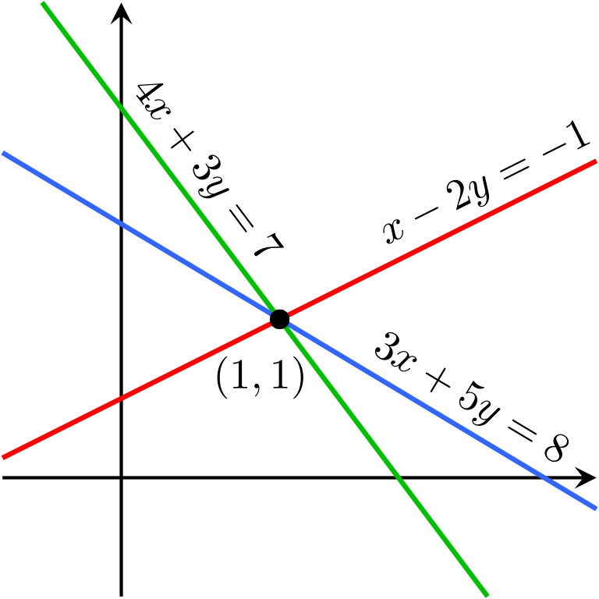
- Identify the quadrant in which each of the following points lie:
(a) (7, -11), (b) (-9, -9), (c) (8, 3), (d) (-13, 5), (e) (π − 1, π – 4)
- Find the equation of a line passing through the two points P = (1, 3) and Q = (9, 2). What is its slope? (a) Write this equation in slope intercept form. (b) Write this equation in point-slope form. (c) Write this equation in standard form.
- Consider the line y = 2x + 3. For each of the following points, determine if it lies on the line, above the line or below the line: (a) (3, 9), (b) (5, 4), (c) (-3, 0), (d) (7, 17), (-4, -9)
- Let y = 6x + 5. Find the slope and the y-intercept.
- The town of Alphaville has a population of 20,000 people. It grows by 3,000 people each year. Since the population, P, is growing at a constant rate of 3,000 people per year, P is a linear function of time, t, in years.
- What is the rate of change of P over every time interval?
- Create a table that gives the town’s population every five years over a 25-year period. Graph the population.
- Find a formula for P as a function of time, t.
- Albertine’s new start-up company spends $40,000 on computer equipment and, for tax purposes, chooses to depreciate it to $0 at a constant rate over a five-year period.
- Create a table and a graph showing the value of the equipment over the five-year period.
- Find a formula for the value, V, of the equipment as a function of time, t.
- The following table gives values of two functions, p and q. Could either of these functions be linear? Explain.
x | 50 | 55 | 60 | 65 | 70
p(x) | 0.10 | 0.11 | 0.12 | 0.13 | 0.14
q(x) | 0.01 | 0.03 | 0.06 | 0.14 | 0.15

- Which of the following functions might be linear? Explain.

t | 1 | 2 | 3 | 4 | 5
G(t) | 5 | 4 | 5 | 4 | 5

x | 0 | 5 | 10 | 15
F(x) | 10 | 20 | 30 | 40
(c)
x | 0 | 100 | 300 | 600
g(x) | 50 | 100 | 150 | 200
(d)
x | 0 | 10 | 20 | 30
h(x) | 20 | 40 | 50 | 55
(e)
x | -3 | -1 | 0 | 3
j(x) | 5 | 1 | -1 | -7
(f)
x | 9 | 8 | 7 | 6 | 5
p(x) | 42 | 52 | 62 | 72 | 82

- In 2010, the population of Betaville was 17,089 and growing by 71 people each year. Find a formula, P, for the town’s population, in terms of t, the number of years since 2010.
- In 2018, the year of the zombie apocalypse, the town of Woodbury, Georgia, had 173 residents. Each year after 2018, the population fell by 13 people. Find a formula for the population of Woodbury t years after 2018.
- Odette, a woodworker, sells rocking horses. Her start-up costs, including tools, plans, and advertising, total $5,000. Labor and materials for each horse cost $350.
- Calculate Odette’s total cost, C, to make 1, 2, 5, 10, and 20 rocking horses. Graph C against n, the number of rocking horses that she carves.
- Find a formula for C as a function of n.
- What is the rate of change of the function C? Interpret the meaning of this.
- For each of the following linear functions, rewrite the equation in standard form and in y-intercept form.
- y + 3x – 3 = 0
- y + 2(x – 1) = 4 – 11
- 3x + 6 = y
- 1 – (x – y) = 4 + 3(1 – (x – 5))
- Find the x and y intercepts of each of the following straight lines:
- x + 5y = 19
- y – x = 8
- y = 7x + 9
- y = 3(x – 1) + 7
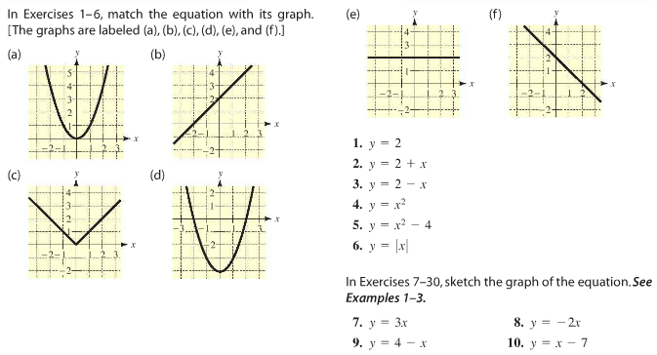
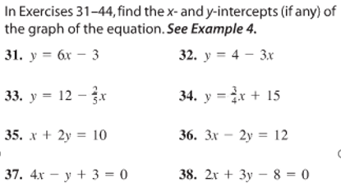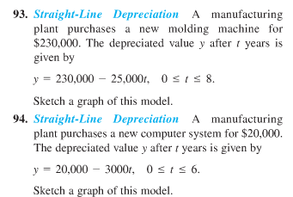

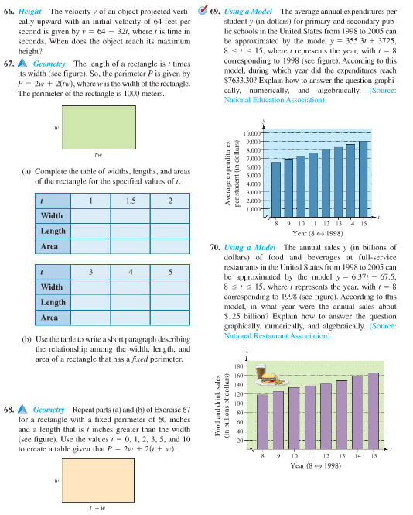
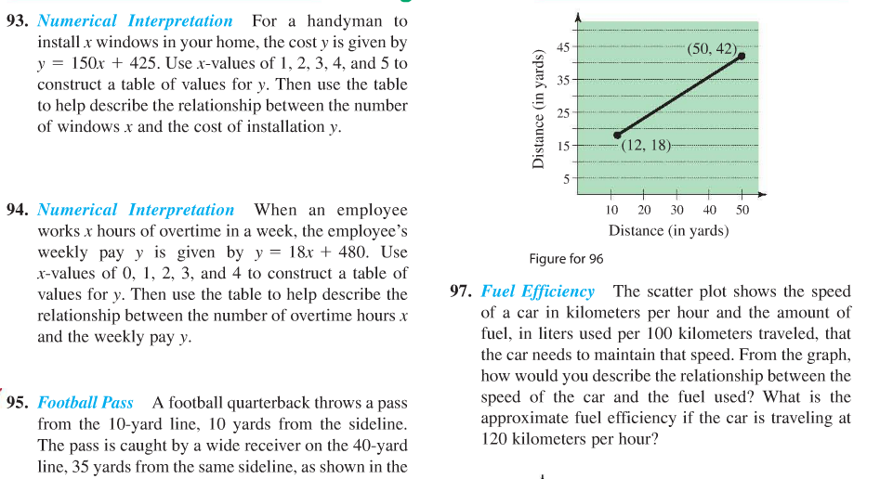
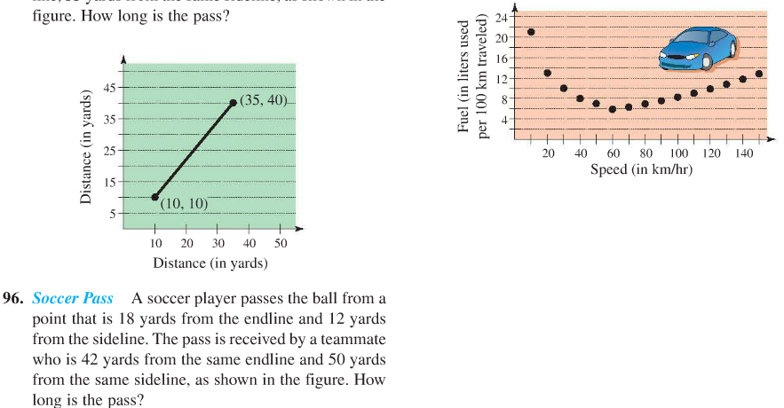

Everything you've learned in school as 'obvious' becomes less and less obvious as you begin to study the universe. For example, there are no solids in the universe. There's not even a suggestion of a solid. There are no absolute continuums. There are no surfaces. There are no straight lines.
- Buckminster Fuller (1895-1983)

