MATH 100: class discussion 16 October
Parallel, perpendicular lines
Graphing inequalities
Relations vs functions
Domain & range
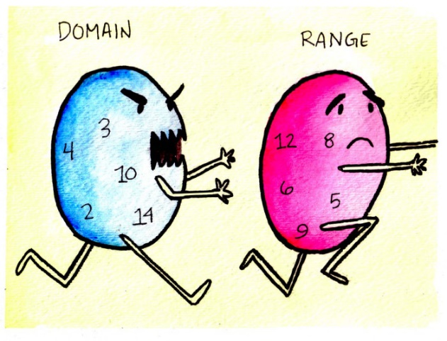
- What is meant by point-slope form of a straight line? What is meant by slope-intercept form of a straight line?

- Find an equation of a line that is parallel to 2x + 4y = 1 and passes through
(-3, -5).
- Are the following lines perpendicular? Why?
3x – 5y = 1 and 10x + 6y = 7
- Find an equation of a line that passes through (1, ½) and is perpendicular to the line y – 3x = 4.
- Write the following in slope-intercept form:
2y + x = -(4 – y – x) + 9(x – 3y)
- Which of the following lines (if any) are parallel?
- y = 5x – 3
- y – x = 3(x – y) + 1
- 3 = 2y – (x + y)
- 1 – 5(x – 1) +7(x + 5) = 8 + 2(y + x) – y + x
- For each problem in question (5), find the x and y-intercepts of the line.
- Write the equation of a line that has x-intercept of 7 and y-intercept of -9.
- Graph each of the following linear inequalities:
- y > x
- y < x – 4
- y ≥ 2x + 5
- x + y < 7
- 2x + y ≥ -1

- Find t such that the point P = (t, 5) lies on the line of slope m = -3 that passes through the point (7, 11).
- Find the midpoint of the line segment joining P = (1, 4) and Q = (-3, -9).
- If the bat population of BetaVille is currently 2300 and declining by 73 bats each year, when will the bats become extinct?

- Find the distance between the following pairs of points. Also plot the points.
- P = (2017, 77), Q = (2017, 97)
- P = (5, 44), Q = (9, 44)
- P = (1, 1), Q = (4, 5)
- P = (- 3, 4), Q = (4, 5)
- P = (99, -104), Q = (100, -101)
- P = (3, 5), Q = (3, 5)

- Which of the following triples of points are collinear? Plot each triple.
- P = (2, 6), Q = (5, 2), R = (8, -2)
- P = (2, 3), Q = (2, 6), R = (6, 3)
- P = (8, 3), Q = (5, 2), R = (2, 1)
- P = (2, 4), Q = (1, 1), R = (0, -2)
- Find the perimeter of the triangle with vértices
A = (-1, -1), B = (0, 5), C = (4, 4).
- Using a table, graph each of the following:
- y = |x|
- y = |x – 1|
- y = |x| + 1
- y = |2x – 1|
- Find the domain of each of the following functions:
- y = 7x + 19
- $y=1+\frac{1}{x}$
- $y=12{(x+3)}^{5}$
- $y=\frac{x}{x-3}$
- y = 5|2x – 1|
- $y=\sqrt{1-4x}$
- $y=\sqrt[3]{1-4x}$
- $y=\frac{(x+1)(x+2)}{(x+3)(x+4)(x+5)}$
- $y=\sqrt{x^{2}+1}$
- Find the range of the functions (a), (c), and (i) above

Additional exercises from text:
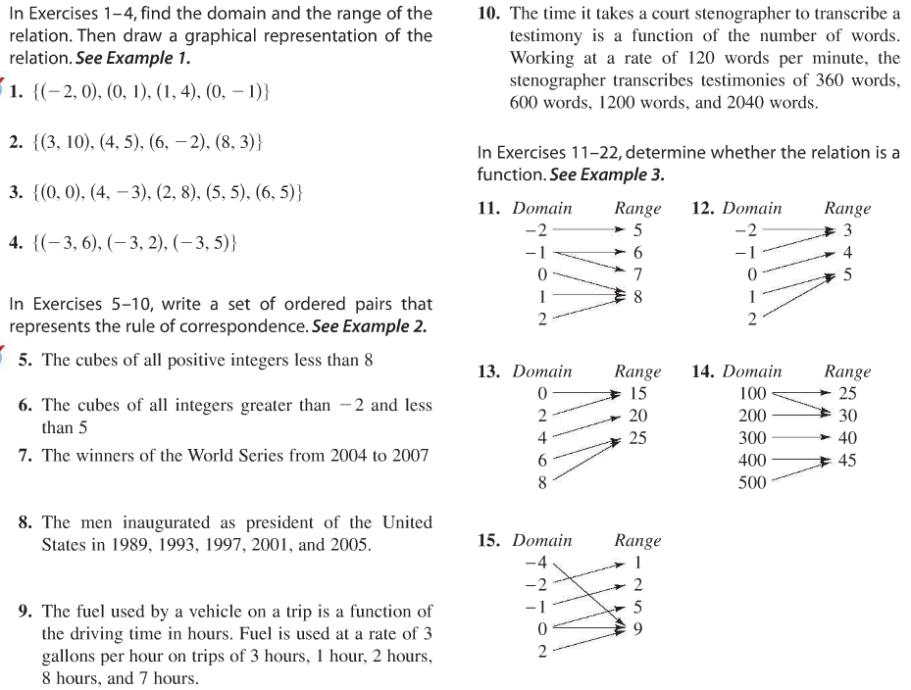
- For each of the following, determine if the relation is a function:
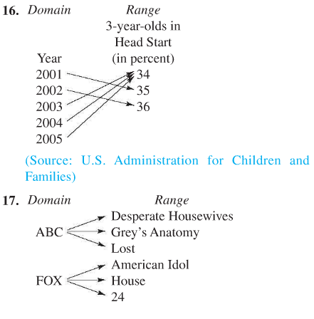

Life and death are one thread, the same line viewed from different sides.
- Lao Tzu

