Math 100: Class discussion
18 October 2018

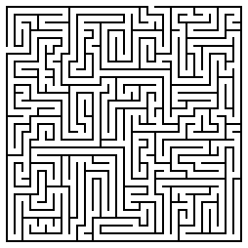
REVIEW
- What is meant by “slope of a straight line”?
- Find the slope of a line that passes through the points (1, -4) and (8, -3). Plot.
- Sketch the graph of a linear function that
- passes through the points (4, 0) and (0, 8). (What is the slope of this line?)
- passes through the points (1, 1) and (-3, -4) . (What is the slope of this line?)
- passes through the point (1, 2) and has slope 3
- passes through the point (0, 3) and has slope -4.
- passes through the point (1, 2) and has slope 7/2.
- Find the x and y intercepts of the line 3x + 8y = 3.
- Find the x and y intercepts of the line y = 4x – 13
- Which of the following triples of points are collinear? Plot each triple.
- P = (2, 6), Q = (5, 2), R = (8, -2)
- P = (2, 3), Q = (2, 6), R = (6, 3)
- P = (8, 3), Q = (5, 2), R = (2, 1)
- P = (2, 4), Q = (1, 1), R = (0, -2)
- Find an equation of a line that is parallel to 2x + 4y = 1 and passes through (-3, -5).
- Are the following lines perpendicular? Why?
3x – 5y = 1 and 10x + 6y = 7
- Find an equation of a line that passes through (1, ½) and is perpendicular to the line y – 3x = 4.
- Write each of the following in slope-intercept form:
- 1 – x – 5y = 8
- 3(2 – y) = 1 + 4(x – 2)
- 2(1 – 3(1 – x – y)) = x + y
- 2y + x = -(4 – y – x) + 9
- Use the point-slope form to find an equation of a line with the given properties:
- slope = 7, through P = (3, 1)
- slope = -4/5, through Q = (-1, -2)
- through P = (1, 3) and Q = (5, 9)
- Find t such that the point P = (t, 5) lies on the line of slope m = -3 that passes through the point (7, 11).
- For each of the following linear functions, rewrite the equation in standard form and in y-intercept form.
- y + 3x – 3 = 0
- y + 2(x – 1) = 4 – 11
- 3x + 6 = y
- 1 – (x – y) = 4 + 3(1 – (x – 5))
- Find the x and y intercepts of each of the following straight lines:
- x + 5y = 19
- y – x = 8
- y = 7x + 9
- y = 3(x – 1) + 7
- The town of Alphaville has a population of 20,000 people. It grows by 3,000 people each year. Since the population, P, is growing at a constant rate of 3,000 people per year, P is a linear function of time, t, in years.
- What is the rate of change of P over every time interval?
- Create a table that gives the town’s population every five years over a 25-year period. Graph the population.
- Find a formula for P as a function of time, t.
- Albertine’s new start-up company spends $40,000 on computer equipment and, for tax purposes, chooses to depreciate it to $0 at a constant rate over a five-year period.
- Create a table and a graph showing the value of the equipment over the five-year period.
- Find a formula for the value, V, of the equipment as a function of time, t.
- Find the distance between the following pairs of points. Also plot the points.
- P = (2018, 77), Q = (2018, 97)
- P = (5, 44), Q = (9, 44)
- P = (1, 1), Q = (4, 5)
- P = (- 3, 4), Q = (4, 5)
- P = (99, -104), Q = (100, -101)
- Find the perimeter of the triangle with vértices
A = (-1, -1), B = (0, 5), C = (4, 4).
- Odette, a woodworker, sells rocking horses. Her start-up costs, including tools, plans, and advertising, total $5,000. Labor and materials for each horse cost $350.
- Calculate Odette’s total cost, C, to make 1, 2, 5, 10, and 20 rocking horses. Graph C against n, the number of rocking horses that she carves.
- Find a formula for C as a function of n.
- What is the rate of change of the function C? Interpret the meaning of this.

Introduction to Functions
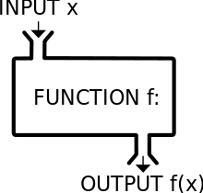
1. Write each of the following relationships using function notation:
(a) Weight, w, is a function of caloric intake, c.
(b) The number of molecules, m, in a gas, is a function of the volume of the gas, v.
(c) The final exam grade, G, of a student is a function of the number of hours, t, of sleep s/he has the night before the final.
2. Let f(t) be the number of people in the U.S., in millions, who own cell phones t years after 1990. Explain the meaning of each of the following statements:
(a) f(9) = 100.3; (b) f(a) = 20; (c) f(25) = b; (d) n = f(t)
3. Suppose that you ride on a Ferris wheel beginning at time zero, and remain on the wheel for three complete revolutions before exiting. Draw a graph of your height above the ground as a function of time. Be certain to label the axes, and to define the units.

4. Sketch a curve of the height of a person from time of birth until time of death. What is the independent variable? the dependent variable?

5. The population, P, of the land of Oz in millions, is a function of t, the number of years since 1980; so P = f(t). Explain the meaning of the statement f(45) = 12

6. Let g(x) = 3x + 5 be a function. Compute and simplify each of the following:
(a) g(3)
(b) g(-9)
(c) g(3x)
(d) g(x³)
(e) g(5 + z)
(f) {g(x + h) – g(x)} / h

7. Let f (x) = x² – 4x + 5 be a function.
(a) Find f (-1), f (0), f (3), and f (0.1).
(b) Find f(2b)
(c) Find f(c – 1)
(d) Find f(x²)
(e) Find f(1+h) – f(1)
(f) Simplify {f(1 + h) – f(1 – h)}/h
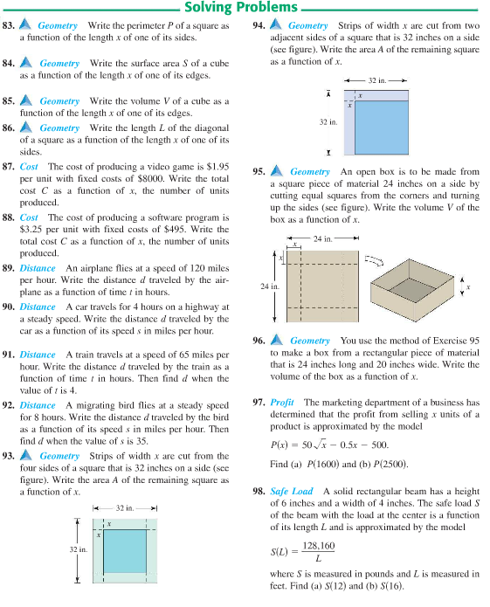
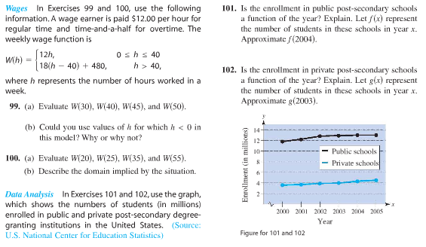

Vocabulary: function, independent variable, dependent variable, domain, range, vertical line test

Life and death are one thread, the same line viewed from different sides.
- Lao Tzu

