Math 100: Class discussion
13 September 2018
Story problems: an introduction
[several chosen from Hall & Knight, Elementary Algebra]
- Determine the perimeter of the following figure. Assume that the units are meters.
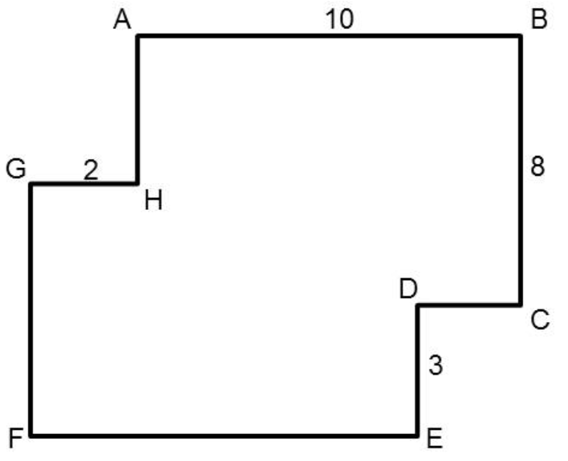
- One number exceeds another by 5, and their sum is 29; find them.

- Albertine walks 10 miles, then travels a certain distance by train, and then twice as far by coach. If the whole journey is 70 miles, how far does she travel by train?

- Twenty-three times a certain number is as much above 14 as 16 is above seven times the number: find it.

- Divide $47 among A, B, C, so that A may have $10 more than B, and B $8 more than C.

- The difference between the squares of two consecutive numbers is 121; find the numbers.

- A sum of $7 is made up of 46 coins which are either quarters or dimes: how many are there of each?

- A father is four times as old as his son; in 24 years he will only be twice as old. Find their ages.

- A’s age is six times B’s, and fifteen years hence A will be three times as old as B: find their ages.

- The length of a room exceeds its width by 3 feet; if the length had been increased by 3 feet, and the width diminished by 2 feet, the area would not have been altered: find the dimensions.

- Recall that the sum of the angles of a triangle is 180°. Find the three angles of a triangle if one angle is 20° greater than the smallest angle and the third angle is twice the smallest angle.

- Swann is shopping for a new suit. He finds that the sale price of a suit that was reduced by 35% is $244.87. Find the original price of the suit.

- The cost of renting a U-Haul is $40 a day plus 21 cents per mile. How far can Max drive in one day if he has only $100?

- After Madame Verdurin is seated in a restaurant, she realizes that she has only $85. If she must pay 7.5% sales tax and leave an 18% tip (on the total bill), what is the maximum price of the lunch that she can order?

- If Jack can mow an acre of lawn in 5 hours and Jill can do the same work in 4 hours, how long will it take them to mow the lawn if they decide to work together?

- Ivan’s grades on five biology tests were 71, 89, 95, 65, and 75. If the final exam counts three times as much as each test, what grade must Ivan earn on the final exam to achieve an 82 average?

- The perimeter of a triangular garden is 82 feet. Find the length of the three sides if one side is 7 feet greater than twice the length of the smallest side, and the third side is 3 feet less than three times the length of the smallest side.

- Odette owns a nut shop. She sells almonds for $8 per pound and walnuts for $11 per pound. She receives a request from a favorite customer who wants to purchase 40 pounds of a mixture of almonds and walnuts for $360. How many pounds of almonds and walnuts should be mixed?

