Math 100: Class discussion
25 September 2018
Story problems: a continuation
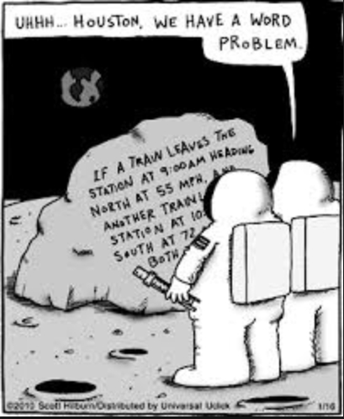

- Charlotte, a young chemist, has two acid solutions; one has 20% acid and the other 75% acid. Find, to the nearest integer, the number of cubic centimeters of each solution she must use in order to produce 200 cubic centimeters of a solution that is 60% acid.

- Odette owns a nut shop. She sells almonds for $8 per pound and walnuts for $11 per pound. She receives a request from a favorite customer who wants to purchase 40 pounds of a mixture of almonds and walnuts for $360. How many pounds of almonds and walnuts should be mixed?

- Two acid solutions are available to Walter White. One is a 33% sulfuric acid solution, but the label that indicates the strength of the other sulfuric acid solution is missing. Three hundred milliliters of the 33% acid solution and 100 milliliters of the solution with the unknown strength are mixed together. Upon analysis, the mixture was found to have a 27% sulfuric acid concentration. Find the strength of the solution with the missing label.

- A coffee merchant wishes to blend coffee worth $4.50 per pound with coffee worth $8.30 per pound. Her goal is to obtain a mixture of 50 pounds of coffee valued at $6.90 per pound. How many pounds of each type should she use?

- A sum of $7 is made up of 46 coins that are either quarters or dimes: how many are there of each?

- Recall that the sum of the angles of a triangle is 180°. Find the three angles of a triangle if one angle is 20° greater than the smallest angle and the third angle is twice the smallest angle.

- Swann is shopping for a new suit. He finds that the sale price of a suit that was reduced by 35% is $244.87. Find the original price of the suit.

- The cost of renting a U-Haul is $40 a day plus 21 cents per mile. How far can Max drive in one day if he has only $100?

- After Albertine is seated in a restaurant, she realizes that she has only $85. If she must pay 7.5% sales tax and leave an 18% tip (on the total bill), what is the maximum price of the lunch that she can order?

- If Jack can mow an acre of lawn in 5 hours and Jill can do the same work in 4 hours, how long will it take them to mow the lawn if they decide to work together?

- The perimeter of a triangular garden is 82 feet. Find the length of the three sides if one side is 7 feet greater than twice the length of the smallest side, and the third side is 3 feet less than three times the length of the smallest side.

- A sum of $16 was paid in dollars, half-dollars, and dimes. The number of half-dollars used was four times the number of dollars and twice the number of dimes. How many were there of each?

- A Halloween store located in Hell, Michigan, is selling two types of candy: chocolate mini-bats and caramel mini-witches. If the mini-bats sell for $13 per pound and the mini-witches sell for $9.99 per pound, how many pounds of each should be mixed together to obtain an 8-pound mixture that sells for $12.15 per pound?

- Pozzo has 85 coins of which some are nickels and the rest quarters. If the total value of his coins is $14.65 , how many coins of each type are there?

- Jean-Pierre drives a Renault. In the city, the car averages 21 miles per gallon. On the highway, the car averages 32 miles per gallon. In driving 300 miles, he uses 10.85 gallons of gasoline. How many miles were driven in the city and how many on the highway?

