**MATH 100:  class discussion**

**6 September 2018**

* **Algebra exercises from Hall & Knight I** (continued from last class)

1. If a = 7, b = 2, c = 0, x = 5, y = 3, find the value of: (A) ab3, (B) a4by, (C) a5c5yx, (D) 1x+3y, (E) abcxy, (F) 2a + 5b + 9c, (G) 3x2 + 1, (H) , (I) 

2. If a = 2, b = 3, c = 1, p = 0, q = 4, r = 6, find the value of: (A) , (B) 3a2bc, (C) , (D) ,

(E) 

3. If a = 2, b = 3, c = 1, d = 0, find the numerical value of: (A) 3bcd + 5cda – 7dab + abc,

(B) 2a2 + 3b3 – 4c4, (C) a2 + b2 + c2 + d2, (D) a4 + b4 – c4

4. If a = 2, b = 1, c = 3, x = 4, y = 6, z = 0, find the value of:

(A) c2(y – x) – b2(c – a) , (B) (2a – c)(x + 2y – z), (C) ,

(D) , (E) 

5. When *x* has the values 0, 3, 6, 8, 10, find the values of x2 – 9x + 20.

6. Show that, if a = 10 and b = 7, then the following two expressions are equal:

4(a – b) + 3(a + b), 5(a + b) + 2(a – 3b)

Are these expressions equal *for all values of a and b?*

7. When x = 5, show that 4x2 + 4x – 3 is equal to 9(x + 8).

8. Show that 6x3 – 11x2 + 3x is equal to 0 when x = 1/3, and when x = 3/2. Find its value in the form of a decimal when x = 1/10.

*Oral exercises (from Hall & Knight):*

1. The quantity *c* is to be multiplied by the quantity *x*. How is this expressed?

Give the product if c = 7 and x = 3.

1. If *x* *factors*, each equal to *c*, are to be multiplied together, express this algebraically.

What is the value if x = 2 and the factor c = 7?

1. The quantities *a, b, c* are to be added together. Express this algebraically.

What is the answer if a = 5, b = 7, c = 11?

1. The quantity *r* is to be taken from the quantity *s*. Give the algebraic expression that denotes this.

What is the answer if r = 27 and s = 41?

1. Albertine starts playing with x marbles and wins y. Express the number she then has.

If x = 25 and y = 9, what number has she?

1. Albertine plays with her increased number and loses *z*. Express the number she then has.

If z = 17, how many has she left?

1. A farmer takes *f* sheep to market and sells *g* of them. How many has she left?

What is the *remainder* if f = 64 and g = 48?

1. Another farmer takes *k* sheep to market and returns with *l* of them. How many has she sold?

If *k* = 75 and *l* = 32, what is the number she has sold?

1. Give the sum and product of the three quantities *a, b, c.*

If a = 5, b = 7, c = 6, give the arithmetical value of each.

1. If I walk *y* miles per hour for *y* hours, what is the algebraic expression for the length of my walk? If y = 4, what is the answer?

Terminology

1. Additive inverse
2. Multiplicative inverse
3. Additive identity
4. Multiplicative identity

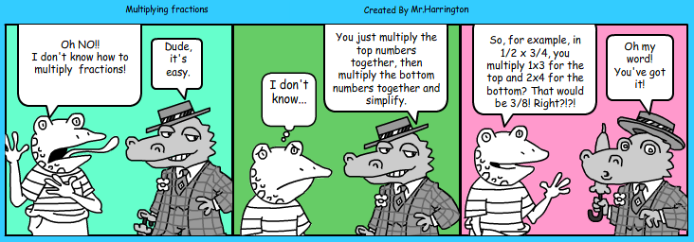

Complex Fractions

Simplify each of the following:

$7-\frac{3}{7}$

$\frac{2}{5}-\frac{1}{10}$

$\frac{5}{12}-\frac{1}{6}+\frac{3}{4}$

$\frac{3/4}{ 5 }$

$\frac{\frac{3}{4}+\frac{1}{8}}{ 5 }$

$\frac{7}{\frac{2}{5}+\frac{3}{10}}$

$\frac{3+\frac{3}{4}}{6}$

$\frac{ 3+\frac{3}{4} }{\frac{1}{2}-\frac{1}{9}}$

$\frac{2+\frac{4}{5}}{2+\frac{3}{5}}$

Geometric problems

1. Find the área and the perimeter of the following figure.

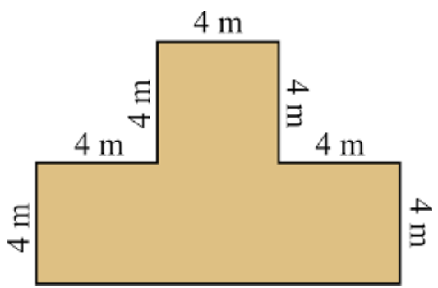

2. Find the área and the perimeter of the following figure.

