Survival Sheet: Math 100

Intermediate Algebra

Fall 2018

Required Text: Ron Larson, Intermediate Algebra (5th ed.), Cengage (2009); packaged with WebAssign or WebAssign stand-alone

Calculator: Only a basic non-graphing calculator is appropriate for this class. Indeed, many quizzes and tests may be “calculator free.”
Instructor: A. Saleski, 612 BVM Hall (contiguous with IES) building # 37 on map (6349 N. Kenmore Ave., Chicago, IL 60660)
e-mail: asalesk@luc.edu OR alan.saleski@gmail.com
office phone: (773) 508-3577
Course URL:
http://www.math.luc.edu/~ajs/courses/100fall2018/index.pdf
WebAssign: https://www.webassign.net/luc/login.html
Office Hours: MWF noon – 1:00 pm; 4:00 – 4:45 pm;
TTh 11:30 am – 1:00 pm
or by appointment.
Ground Rules: The final grade is computed according to the following recipe:
quizzes | 11 %
tests | 38 %
homework (WebAssign) | 7 %
groupwork | 4%
essay | 4 %
Piazza | 3 %
final exam | 33 %
extra credit | At most 3 %
Grading standards
Supplemental Instruction (SI), led by Ayisha Mag Adeniran, aadeniran@luc.edu, is an excellent resource! Discussion hours and locations will be soon be announced by Ayisha. Check Piazza!

Tutoring Services:
The Tutoring Center offers FREE tutoring services to all LUC students!

Important Dates:
Quizzes: (each on a Thursday)
September 6, 13, 20; October 4, 11, 18; November 1, 8, 15
• Tests: (each on a Thursday)
September 27; October 25; November 29
- Holidays:
- Labor Day: Monday, September 3rd

- mid-semester break: Monday & Tuesday, October 8th – 9th
- Thanksgiving break: Wednesday – Sunday, November 21st – November 24th

- Last day to withdraw without a grade of WF: midnight, Friday, November 2nd
• Last day of Class: Thursday, December 6th
• Final Exam, Saturday, December 15th (4:15 – 6:15 pm)
• Loyola Calendar (Fall 2018)

Remarks:

- Quizzes will be based upon recent class discussion. Each quiz will last about 10 minutes. The lowest two of the nine quiz grades will be dropped. There will be no make-up quizzes unless the circumstances are extraordinary.

- Each test will require the full class period. Make-up tests will be given only for non-frivolous reasons. In such cases, the student should make prior arrangements with the instructor, if at all possible.

- The final exam is cumulative.

- The minimum penalty for cheating is failure in the course. A student who improperly aids another with a homework assignment, a test, a quiz, or the final exam, is considered to be equally culpable. Smart-phones, fitbits, headphones, etc., are not permitted during quizzes/tests/final. It is required by the University that incidents of academic dishonesty be reported to the appropriate Dean.

- Extra credit may be earned in many ways, including finding errors or dead links on webpages, critiquing appropriate films or outside lectures, and reviewing appropriate articles or books.

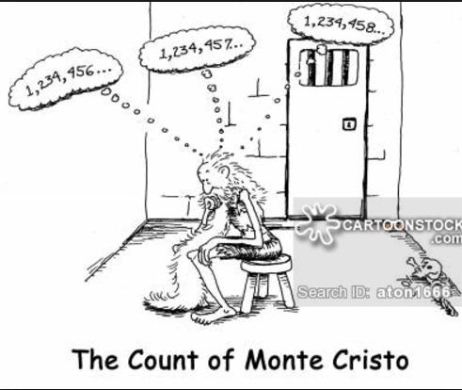

The institutionalized values school instills are quantified ones. School initiates young people into a world where everything can be measured, including their imaginations, and, indeed, man himself. But personal growth is not a measurable entity. It is growth in disciplined dissidence, which cannot be measured against any rod, or any curriculum, not compared to someone else's achievement. In such learning, one can emulate others only in imaginative endeavor, and follow in their footsteps rather than mimic their gait. The learning I prize is immeasurable re-creation.
- Ivan Illich, Deschooling Society

Course Home Page Department Home Page Loyola Home Page

