Math 100 – Intermediate Algebra

Rambler Success

Fall 2018
Section 012: Tues/Thurs 2:30 – 3:45 pm
117 Dumbach Hall
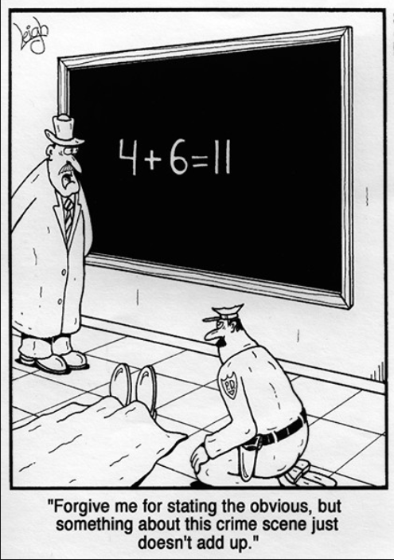

- Ground Rules
- Syllabus
- Piazza
- Homework & Reading Assignments
- WebAssign
- Discussion Questions
- Tutoring Services and Schedule
- Advice from Hall & Knight
- Essay Topics
- Practice Tests (T1, T2, T3)
- Practice Final
- Quiz Solutions (Qz 1, Qz 2, Qz 3, Qz 4, Qz 5, Qz 6, Qz 7, Qz 8, Qz 9)
- Test Solutions (T 1, T2)
- Useful References (Greek alphabet; relevant websites & texts)
- History of Algebra (I, II, III)

“Every minute dies a man. Every minute one is born.” I need hardly point out to you that this calculation would tend to keep the sum total of the world’s population in a state of perpetual equipoise, whereas it is a well-known fact that the said sum total is constantly on the increase. I would, therefore, take the liberty of suggesting that in the next edition of your excellent poem the erroneous calculation to which I refer should be corrected as follows: “Every moment dies a man, And one and a sixteenth is born.” I may add that the exact figures are 1.067, but something must, of course, be conceded to the laws of meter.

- Charles Babbage, letter to Alfred Lord Tennyson, about a couplet in his “The Vision of Sin.”

Department Home Page Loyola Home Page

