MATH 100 Solutions: Old TEST I
September 2017
Instructions: Choose any 15 of the following 18 problems. You may answer more than 15 to earn extra credit! For each problem, be certain to show your work! You may use your calculator, but you still must show your reasoning! Be sure to place a box around your answer.

- Compute the value of
a¹⁷⁸⁹ + (3b + 99a + 2017)⁰ + (a + 2b)² – (b – 2a)⁹⁹ when b = 2 and a = 1.
Simplify your answer fully.
Solution: Since r⁰ = 1 for any non-zero number r and 1^{s} = 1 for all s:
1¹⁷⁸⁹ + (2 + 99(1) + 2016)⁰ + (1 + 2(2)) ² – (2 – 2(1))⁹⁹ =
1 + 1 + 5² – 0⁹⁹ =
2 + 25 – 0 = 27
2. Compute the value of 7(2 + x – x²)³ when x = -3. Simplify your answer fully.
Solution: 7(2 + x – x²)³ = 7{2 + (-3) – (-3)²}³ = 7( 2 – 3 – 9)³ = 7(-10)³ = -7000

3. An eagle is 4 times as old as a falcon. Three years ago, the eagle was 7 times as old as the falcon. Find the present age of each bird now. (Guessing will result in little or no credit.)
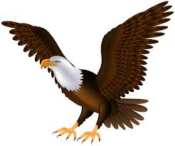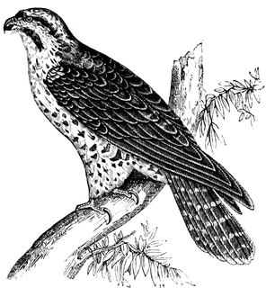
Solution: Let x = current age (in years) of the falcon.
Consequently, 4x = current age (in years) of the eagle.
Creating an appropriate table:

 | Current age | Past age (3 years ago)
Falcon | x | x – 3
Eagle | 4x | 4x – 3

Given the fact that 3 years ago the eagle was 7 times as old as the falcon, yields:
4x – 3 = 7(x – 3)
Solving for x, first distribute the 7:
4x – 3 = 7x – 21
Subtracting 7x from both sides; -3x – 3 = -21
Adding 3 to both sides: -3x = -18
Dividing both sides by – 3: x = 6
Since x = 6, 4x = 24.
Hence the current age of the falcon is 6 years and the current age of the eagle is 24 years.

4. The time required to go by train between AlphaVille and BetaVille is three hours less than the time required to go by Greyhound bus. The average rate of the bus is 25 miles an hour less than the average rate of the train. Assume that the two cities are 300 miles apart. If r denotes the rate of the train, write an equation that can be used to solve for r. (Do not solve.)
Solution: Let r be the rate of the train in mph. Then the train requires 300/r hours to complete its journey of 300 miles. The rate of the bus is r +25 mph. So the time rewuired by the bus to make the journey is 300/(r + 25). Since we are told that the time required by the bus is 3 hours more than the time required by the train, we obtain the equation: 300/(r + 25) = 3 + 300/r

5. If p snow plows clear 9 streets in 36 days, how many days does it take for one snow plow to clear one street? Explain your reasoning.
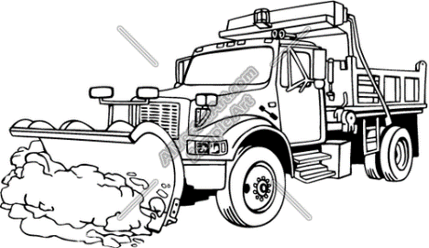
Solution: Since p snow plows can clear 9 streets in 36 days, p snow plows can clear one street in 36/9 = 4 days. Thus one snow plow can clear one street in 4p days.

6. If pumpkins sell at 5 for $18 dollars and Halloween candy sells at 17 bags for $11, how much will it cost to buy x pumpkins and y bags of candy?
Solution:
First note that one pumpkin costs $18/5 and one bag of candy sells for $ 10/11.
Thus x pumpkins will cost $ (18/5)x and y bags of candy will cost $ (10/11)y.
So the total cost is 18x/5 + 10y/11 dollars.

7. Subtract x⁴ – 8x³ + 2x² – 3x + 1 from x⁴ + 11x³ – x² + 4x – 4 and simplify your result.

Solution: (x⁴ + 11x³ – x² + 4x – 4) – (x⁴ – 8x³ + 2x² – 3x +1) =
x⁴ + 11x³ – x² + 4x – 4 – x⁴ + 8x³ – 2x² + 3x – 1 =
19x³ – 3x² + 7x – 5
Equivalently, using a table, subtracting the second row from the first row yields:
x⁴ | + 11x³ | – x² | + 4x | – 4
x⁴ | – 8x³ | + 2x² | – 3x | + 1
 | 19 x³ | – 3x² | + 7x | – 5

8. Albertine purchases a used car from the AtYourOwnRisk Enterprise for $4,800.00. The car’s price had been reduced by 35 %. What was the original price of the car? (Disregard tax.) Give your answer to the nearest penny.
Solution: Let p be the original (non-sale) price (in dollars) of the bike. Albertine has paid 65% of the original price. Hence
Then $4,800.00 = 0.65 p and thus p = $4,800.00/0.65 = $ 7384.62

9. The perimeter of a triangular garden is 82 feet. Find the length of each of the three sides if one side is 7 feet greater than twice the length of the smallest side, and the third side is 3 feet less than three times the length of the smallest side.
Solution: Let L = the length of the smaller side (in feet)
Then the other two sides are given by: 7+2L and 3L–3.
Now L + (7 + 2L) + (3L – 3) = 82
So 6L + 4 = 82
6L = 78
L = 13
Thus the lengths of the three sides are: 13 feet, 30 feet, and 33 feet.

10. Currently 12,345 wombats live in Alphaville. Suppose that the population of Alphaville increases by 175 wombats each year. Currently 20,000 wombats live in Betaville. Suppose that the population of Betaville diminishes by 80 wombats each year. In how many years from now will Alphaville and Betaville have the same wombat population? Round your answer to the nearest year.
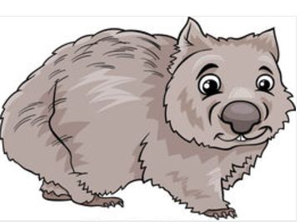 Solution: At time t = 0, Alphaville has 12,345 inhabitants and BetaVille has 20,000.
Let A(t) = wombat population of AlphaVille at time t (years).
Let B(t) = wombat population of BetaVille at time t (years).
We are given that A(t) = 12,345 + 175t and B(t) = 20,000 – 80t.
If we want the populations fo the two towns to be equal, we set
A(t) = B(t). So 12,345 + 175t = 20,000 – 80t
Solving for t: 255 t = 7655. Hence t = 30 years.
11. Walking at a constant rate, Odette can walk 13 miles in 3 hours. Albertine can walk twice as fast as Odette. How long does it take for Albertine to walk z miles? Show your work!
Solution: Odette’s rate = (change in distance)/(change in time) = 13/3 mph.
Hence Albertine’s rate = 26/3 mph.
The time it takes Albertine to walk z miles is then (change in distance)/(change in time) = z/(26/3) = 3z /26 hours.

12. The length of a room exceeds its breadth by 8 feet; if the length had been increased by 2 feet, and the breadth had been increased by 2 feet, the area would have been increased by 60 square feet: find the original dimensions of the room. Write an equation in one variable that can be used to solve this problem. Do not solve.
Solution: Let W = original length of the room (in feet).
Then the original length of the room is W + 8.
So the initial area is W(W + 8)
Now, we are told that, (W +2)(W + 10) = W(w + 8) + 60.

13. Find two numbers which differ by 4, and such that one-half of the greater exceeds one-sixth of the lesser by 8. Solve explicitly for the two numbers.

Solution: Let x be the smaller of the two numbers. Then the larger of the two is x + 4.
We are told that: ½ (x + 4) = (1/6) x + 8. Multiplying both sides by 6:\
3(x + 4) = x + 48.
So 3x + 12 = x + 48
2x = 36
x = 18
Thus the two numbers are 18 and 22.

14. Compute the value of 7(1 + x²)³ when x = -3. Simplify your answer fully.
Solution: 7 {1 + (-3)²}³ = 7(10³) = 7000

15. Solve for x: x(x – 2) – x(2x + 1) = 5 – x² + 3(x – 4)
Solution: Working step by step,
x(x – 2) – x(2x + 1) = 5 – x² + 3(x – 4)
x² – 2x – x(2x + 1) = 5 – x² + 3(x – 4)
x² – 2x –2x² – x = 5 – x² + 3(x – 4)
x² – 2x –2x² – x = 5 – x² + 3x – 12
–x² – 3x = 5 – x² + 3x – 12
–x² – 3x = –x² + 3x – 7
–3x = 3x – 7
0 = 6x – 7
6x = 7
x = 7/ 6
16. Simplify fully the expression:
–2{– [– (x – y) ]} + {–2[– (x – y)]}
Solution: Working step by step,
–2{– [– (x – y)]} + {–2[– (x – y)]}
–2{– [– x + y]} + {–2[– x + y)]}
-2(x – y) – 2(-x + y)
-2x + 2y +2x – 2y
0

17. Solve 7x – 5[x – {7 – 6(x – 3)}] = 3x + 1
Solution:
7x – 5[x – {7 – 6(x – 3)}] = 3x + 1
7x – 5[x – {7 – 6x + 18}] = 3x + 1
7x – 5[x – {25 – 6x}] = 3x + 1
7x – 5[x – 25 + 6x] = 3x + 1
7x – 5[7x – 25] = 3x + 1
7x – 35x + 125 = 3x + 1
125 – 28x = 3x + 1
124 = 31x
x = 124/31 = 4

18. The sum of four consecutive odd integers is 8072. Find the smallest number.
Solution: Let n = smallest of the four integers. Then the others are n + 2, n + 4, and n + 6.
Thus n + (n + 2) + (n + 4) + (n + 6) = 8072
So 4n + 12 = 8072
4n = 8060
n = 2015
Hence the smallest of the four integers is 2015.
