Math 100 Practice Problems for Test iI (revised)
PART I
- Solve each of the following inequalities.

(a) |x – 3| < 5
(b) (6x – 1)(x + 2) > (3x + 4)(2x + 5)
(c) 1 – 2(1 – 3(x – 4)) ≥ 9x + 4
(d) |3x + 4| > 1
(e) x⁴ + x² + 1 < 0
(f) 2x + 5 ≤ 4x – 7
(g) |3x – 17| < 0
(h) |3x – 4| < 5|
(i) |4x + 13| < -1789
(j)

2. Graph each of the following linear inequalities:
- y > 2x
- y ≤ 3x – 4
- y ≥ x + 5
- x + y < 7
- 2x + y ≥ 0

3. Find the domain of each of the following functions:
(c) Hint: Can x⁴ + 99 be equal to 0?
4. Let f(x) = 2x² – 3x. Find and simplify:
(a) f(-1)
(b) f(a – b)
(c) f(x + h)
(d) f(x – 2h)
(e) f(a + b + c)
5. Albertine, a woodworker, sells unusual wooden pumpkins. Her start-up costs, including tools, plans, and advertising, total $5000. Labor and materials for each pumpkin costs $350.
(a) Calculate Albertine’s total cost, C, to make 1, 2, 5, 10, and 20 wooden pumpkins.
(b) Graph C as a function of n, the number of wooden pumpkins that she carves.
(c) Find a formula for C in terms of n

6. Walter White needs to rent a fast car; he compares the charges of three different companies. Company A charges 20 cents per mile plus $20 per day. Company B charges 10 cents per mile plus $35 per day. Company C charges $70 per day with no mileage charge.
(a) Find formulas for the cost of driving cars rented from companies A, B, and C, in terms of x, the distance driven in miles in one day.
(b) Graph the costs for each company for 0 ≤ x ≤ 500. Place all three graphs on the same set of axes.
(c) Use the graph from part (b) to find under what circumstances Company A is the cheapest. What about Company B? Company C? Explain.

7. Odette has $24 to spend on Coke and chips for a party. A six-pack of Coke costs $3 and a bag of chips costs $2. The number of six-packs she can afford, y, is a function of the number of bags of chips we decide to buy, x.
(a) Find an equation relating x and y.
(b) Graph the equation. Interpret the x and y intercepts and the slope in the context of the party.

8. (a) If y = f(x) is a linear function and if f(-2) = 7 and f(3) = -3, find a formula for f.
(b) Find the midpoint of the points P = (-8, -9) and Q = (-19, -1).

9. The cost of an Alpha refrigerator is $950, and it depreciates $50 each year. The cost of a Beta refrigerator is $1200, and it depreciates $100 per year.
(a) If an Alpha and a Beta refrigerator are purchased at the same time, when do the two refrigerators have equal value?
(b) If both refrigerators continue to depreciate at the same rates, what happened to the values of the refrigerators in 20 years time? What does this mean?
10. Line L is given by y = 3 – 2x/3. Point P = (6, 5).
(a) Find an equation of the line containing P and parallel to L.
(b) Find an equation of the line containing P and perpendicular to L.
(c) Graph the two lines obtained in (a) and (b).

11. Find an equation of a line that
(a) passes through the points (-1, 5) and (2, -1).
(b) has slope -4 and x-intercept 7
(c) has x-intercept 3 and y-intercept -5
(d) slope 2/3 and passes through the point (5, 7).
Next, express each line above in slope-intercept form.

12. (a) The points (1, -2), (t, 2), and (5, 6) lie on a straight line. Find the value of t.
(b) Two linear functions are given by the equations y = 2x + 3 and y = 7 – 9x.
Find their point of intersection.

13. Let f(x) = 3x – 7. Compute and simplify:
- f(2)
- f(f(1))
- f(4x)
- f(x³)
- f(2x + 11) – f(x)
- {f(x + h) – f(x)}/ h for h 0.

14. Let g(x) = x² – x + 2.
(a) Find g(-1), g(0), g(3), and g(0.1).
(b) Find g(2b)
(c) Find g(c – 1)
(d) Find g(x³)
(e) Find g(1 + h) – g(1)
(f) Simplify {g(1 + h) – g(1 – h)}/h
15. Find the domain and range of each of the following functions:
(a) f(x) = |x + 1|
- g(x) = 2 + |x|
- h(x) = -x²
- F(x) = 11
- G(x) = x³

16. Determine which of the following points lie on the graph of the equation
x + 3y = 6
(a) (3, 1), (b) (7, 11), (c) (0, 0), (d) (3, -4), (e) (-9, 5)
Of those not on the line, which lie above and which lie below?
17. Does the following function appear to be linear? Justify your answer!
t | -3 | 4 | 5 | 7 | 9
G(t) | -8 | 13 | 16 | 22 | 28
18. In 2018, the year of the zombie apocalypse, the town of Woodbury, Georgia, had 189 residents. Each year after 2018, the population fell by 13 people.
Find a formula for the population of Woodbury t years after 2018. this rate, when will Woodbury cease to exist as a town?

19. Violette, a biologist, measures the amount of contaminant in a lake 2 hours after a chemical spill and finds that there are 72 cubic tons of contaminant in the lake. When she takes a measurement 14 hours after the spill, she finds the amount of contaminant to be 24 cubic tons. She sets up a linear model to determine the amount of the chemical that would remain in the lake t hours after the spill. The model assumes the contaminant is leaving the lake at a constant rate. Find a function that gives the amount of contaminant in the lake t hours after the spill.

20. Does the following function appear to be linear? Justify your answer!
t | -3 | 4 | 5 | 7 | 9
G(t) | -8 | 13 | 16 | 22 | 28
21. Solve each of the following equations:
(a) |x – 4| = |3 – 7x|
(b) |5x + 9| = 0
(c) |17x – 11| = 9
(d) |7 – 99x| = -1
22. Are the following three points collinear? P = (6, 8), Q = (9, 14), R = (15, 26)
Justify your answer. (A graph does not suffice.)
23. Find the midpoint of the line segment AB, where A = (-2, -3), B = (-5, -7).
24. Find the perimeter of the triangle with vértices X = (0, 2), Y = (-3, -2), Z = (5, 12)
25. Let f(t) be the number of people in the U.S., in millions, who own cell phones t years after 1990. Explain the meaning of each of the following statements:
(a) f(9) = 100.3; (b) f(a) = 20; (c) f(25) = b; (d) n = f(t)
26. Find the equation of a straight line that has x-intercept = - 13 and y-intercept = 5.

PART II: relations & functions
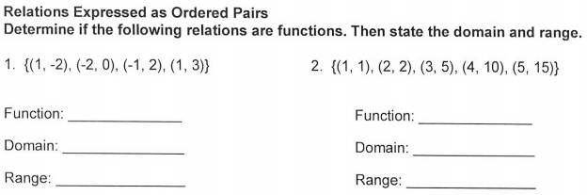

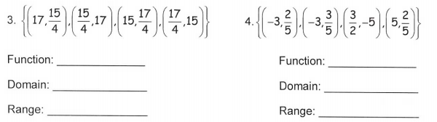

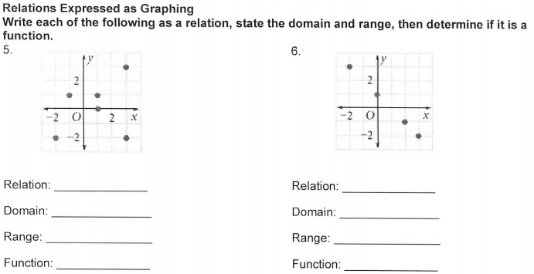
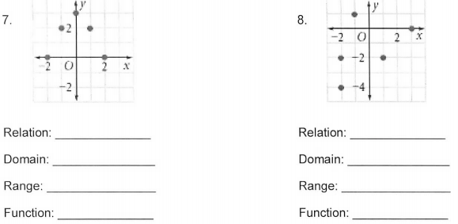
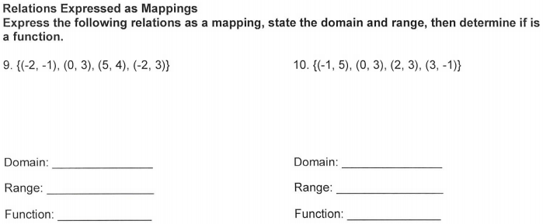
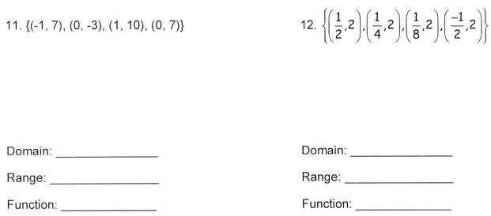
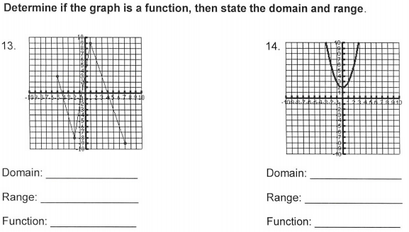
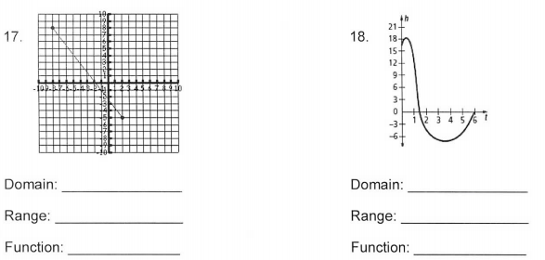
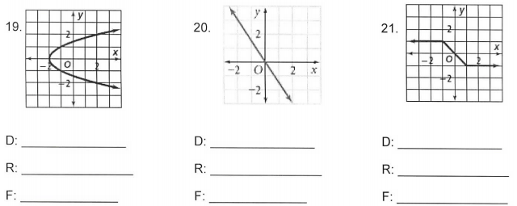
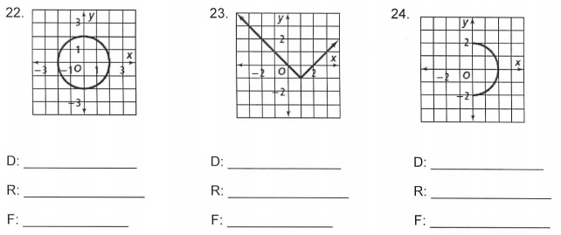
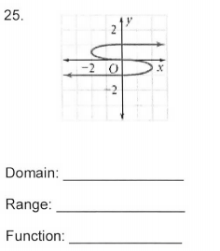

We live in a moment of history where change is so speeded up that we begin to see the present only when it is already disappearing.

- R. D. Laing

