Math 100 Practice Problems for Test III



1. Find the domain of each of the following functions:





2 . Express in scientific notation: 

3. Let f(x) = 2x2 – 3x. Find and simplify:

(a) f(-1)

(b) f(a – b)

(c) f(x + h)

(d) f(x – 2h)

(e) f(a + b + c)

4. Find the ***domain*** of each of the following functions:

1. y = 7x + 19


5. y = 5|2x – 1|

5. Use 2 unknowns: The sum of the ages of Pozzo and Vladimir is 61 years. Twenty years from now (provided they survive) Vladimir will be 26 years less than twice Pozzo’s age. Find their current ages.

6. Solve each of the following:

(a) |3x – 4| = |5 – x|

(b) |4x + 13| = -1789

7. Express each of the following sums or differences in scientific notation.

### (a) 4.9 × 102 + 7.9 × 103

(b) 4.9 × 10-6 – 7.9 × 10-5

8. Factor fully: (a) x8 – 1 (b) 4(x – y)2 – (x – y) (c) 500x2y – 20y3

(d) 3x2 – 5x – 2 (e) 4x2 + 12x + 9 (f) 9x2 – 49

(g) a3 – ax (h) (i) 5a2bx3 – 15abx2 – 20b3x2

(j) 500x2y – 20y3

9. Factor: (a) 6x2 – 11x – 10, (b) 3x2 – 17x2 – 28 , (c) 4x2 + 47x + 33

(d) x2 – 11x + 30 (e) x2 – x – 240 (f) x2 – x – 240

(g) x2 – 5xy – 24y2 (h) x2 – 20xy – 96y2

10. Express each product or quotient in scientific notation.

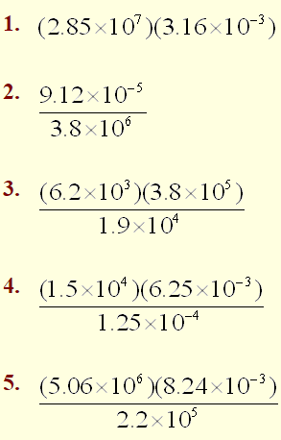

11. Which of the following numbers are divisible by 3? (a) 33333 (b) 123450 (c) 718191001

12. Factor and simplify: (A) (3a + 1)2 – (2a – 1)2 (B) (a + b)4 – 1

(C) 1 – (x – y)2

13. Solve using scientific notation.

(a) Light travels art approximately 3.0 x 108 m/sec. How far does light travel in one week?

(b) Assume that there are 20,000 runners in the New York City Marathon. Each runner runs a distance of 26 miles. If you add together the total number of miles for all runners, how many times around the globe would the maratón runners have gone? Hint: Assume that the circumference of the earth is 2.5 × 104 miles.

(c) Mercury’s average distance from the sun is 57,910,000 km. The Earth is approximately 93,000,000 miles from the sun. What would be the distance of a trip from Mercury to Earth via the Sun? (Note: 1 km = 0.62 miles)

14. Find the gcd and lcm of: (a) 77 and 33 (b) 880, 50, 320]

15. Find gcd and lcm of: (a) x(x+1), x(x+2)3, 4x2(x+2)2

(b) 5(x+7)(x+9), (x+9)(x+10), 4(x+7)(x+9)33

16. Let p(x) = 3x3 – 3x + 1 and let q(x) = x2 – x – 1.

1. Compute q – 2p and express it as a polynomial in standard form (that is, decreasing exponents).
2. Compute pq and express it as a polynomial in standard form (that is, decreasing exponents).

17. Without using your calculator, compute 800012 – 799992 *showing all of your steps*.

1. Find all the roots of the polynomial

f(x) = (x2 + 1) (x2 – 4) (x2 + 9)(x2 – 16)(4x2 – 16x + 15)

1. Find the *domain* of the function 
2. Perform the indicated operations of multiplication or division.
3. 
4. 
5. 
6. 
7. 
8. 
9. 
10. 
11. 
12. 
13. 
14. 
15. 
16. 
17. 
18. Evaluate each of the following.
19. 645/3
20. (625/121)-1/2
21. (25/16)-3/2
22. Express with *positive* indices.
23. c-1 b-9/4 c5/6
24. a-5 b-9/c-3
25. 4x-3y5 / (24a7y-8)
26. Solve for *x*:



1. Let p(x) = 5x4 + x2 + x + 3 and let q(x) = x4 – 2x3 – x2 – 5. Compute pq and express it as a polynomial in standard form (that is, decreasing exponents).
2. Solve for *x*:



1. Solve for *x*: 
2. Use two unknowns: Gilberte bought 135 pieces of candy to give away on Halloween. She bought two kinds of Candy, paying 18 cents each for Tootsie Rolls and 24 cents a piece for chocolate skeletons. If she spent $26.70 for the Candy, how many pieces of each kind did she buy? *(Need not solve.)*
3. Use two unknowns: Albertine earns twice as much per hour for tutoring math as she does working at Starbuck’s. If her average wage is $11.25 per hour, how much does she earn per hour at each job? *(Need not solve.)*
4. Use two unknowns: Last year, Madame Vedurin invested 50,000 euros. She invested part of her money in a real estate venture in Bretagne that paid 7.5% for the year and the rest in a café venture that returned 12% for the year. The combined income from the two investments for the year totaled 5190 euros. How much did she invest at each rate? *(Need not solve.)*
5. Let p(x) = x2 – x + 2 and q(x) = x3 + x2 + x + 1. Compute and simplify:

(a) 3p (b) q – 4p (c) p2 (d) pq

(e) q2 (f) p(x + 1) – p(x)

1. Use two unknowns: Swann, a fruit dealer, paid a total of $67 for strawberries and peaches. He sold the strawberries at a profit of 20% on the cost and the peaches at a loss of 2% on the cost. If his total profit was $8.56, how much did he pay for each kind of fruit?
2. Find the roots of the polynomials:

(a) y = x3 (x – 2)5 (x + 7)5(x2 + 1), (b) y = (x2 – 14x – 15)4, (c) y = x8 – 4x6,

(d) y = (x – 9)(x – 5) – (x – 9)(2x – 8)

1. Use two unknowns: The length of a room exceeds its width by 7 feet; if each dimension had been increased by 1 foot, the area would have been increased by 51 square feet; find the original dimensions of the room.
2. Use two unknowns: Sir Charles exercises every day. He walks at 3 miles per hour and then jogs at 5 miles per hour. If it takes him 0.9 hours to travel a total of 3.5 miles, how long does he jog?
3. Using Gaussian elimination solve the system:

9x – 7y = 4

6x + 3y = 1



$Simplify each of the following:$

$\left(a\right) \frac{6/5}{9/25}$ (b) $\frac{\frac{ab}{cd}}{\frac{a+b}{cd}}$ (c) $\frac{\frac{abc}{bc^{2}d}}{\frac{ab(c+d)}{bc}}$

1. Using Gaussian elimination solve:

9x – 7y = 4

6x + 3y = 1



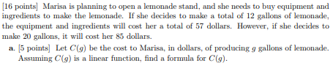



 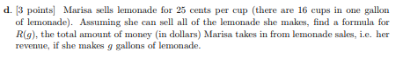



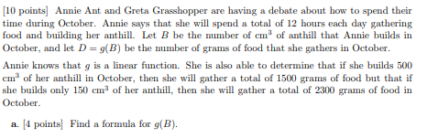



*We live in a moment of history where change is so speeded up that we begin to see the present only when it is already disappearing.*

- R. D. Laing 