MATH 100 Solutions: QUIZ I 6 sept 2018
(calculator free)
To obtain credit, you must show your work for each problem! Place a box around each answer.
- [4 pts] Simplify fully: 4(1 – 3(x – 11)) – 12(4 – x)

Solution: Do not skip steps!

4(1 – 3(x – 11)) – 12(4 – x) =
4(1 – 3x + 33) – 12(4 – x) =
4(34 – 3x) – 12(4 – x) =
136 – 12x – 12(4 – x) =
136 – 12x – 38 + 12x =
88
Quick check: Let x = 0. Then 4(1 – 3(x – 11)) – 12(4 – x) = 4(1 – 3(– 11)) – 12(4) = 4(1 + 33) – 48 = 4(34) – 48 = 136 – 48 = 88.

- [4 pts] Simplify fully: $\left({(3+4)}^{2}+4\right)-7+ 4^{2}$

Solution: Do not skip steps!
$\left({\left(3+4\right)}^{2}+4\right)-7+ 4^{2}=$
$\left({\left(7\right)}^{2}+4\right)-7+ 4^{2}=$
$\left(49+4\right)-7+ 4^{2}=$
$\left(53\right)-7+ 4^{2}=$
$53-7+ 16=$
$53-7+ 16=$
$69-7=$
$$62$$

- [4 pts] Let a = 3, b = 1, c = 0, d = 4. Evaluate
$$\frac{a+2b+3c+4d}{3+19abcd}$$
Solution: Using the fact that any multiple of 0 is 0:
$$\frac{a+2b+3c+4d}{3+19abcd}=$$
$$\frac{3+2(1)+3(0)+4(4)}{3+19(3)(1)(0)(4)}=$$
$$\frac{3+2(1)+4(4)}{3}=$$
$$\frac{3+2+16}{3}=$$
$$\frac{21}{3}=$$
$$7$$
- [4 pts] Solve |x – 4| = 5.
Solution: Either x – 4 = 5 or x – 4 = -5.
If x – 4 = 5, then x = 9. If x – 4 = -5, then x = -1.
We should check each solution to be certain it satisfies the given equation:
If x = 9, then |x – 4| = |9 – 4| = |5| = 5. So this checks.
If x = -1, then |x – 4| = |-1 – 4| = |-5| = 5. So this checks as well.
Hence the solutions to the given equation are x = 9, x = -1.

- [4 pts] If artichokes sell at 5 for 4 dollars how much will it cost (in dollars) to buy x artichokes?
Solution: One artichoke will cost 4/5 dollars. Thus the price of x artichokes is
$$\frac{4}{5} x dollars$$
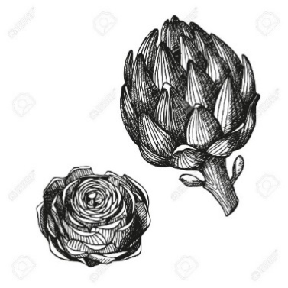
Extra Credit [4 pts] Simplify fully: 8x – {16y – [3x – (12y – x) – 8y] + x}

Solution: Do not skip steps!
Beginning from the innermost pair of parentheses:
8x – {16y – [3x – (12y – x) – 8y] + x} =
8x – {16y – [3x – 12y + x – 8y] + x} =
8x – {16y – [3x – 12y + x – 8y] + x} =
8x – {16y – [4x – 20y] + x} =
8x – {16y – [4x – 20y] + x} =

8x – {16y – 4x + 20y + x} =
8x – {– 3x + 36y} =
8x + 3x – 36y =
11x – 36y

