MATH 100 Solutions: QUIZ II 13 sept 2018
(calculator free)
To obtain any credit, you must show your work for each problem! Place a box around each answer.
- [3 pts] Solve for t: 2{3 + 4(5 – 6t)} = -170 (Express the answer as a fraction --- not as a decimal.)
Solution:
2{3 + 20 – 24t} = - 170 (Distributing the 4 on left-hand side.)
2(23 – 24 t) = -170 (Collecting like terms on left-hand side.)
23 – 24t = -85 (Dividing both sides by 2.)
-24t = -85 – 23 = -108 (Subtracting 23 from both sides.)
Hence t = 108/24 = 9/2

- [3 pts] Add together the three expressions 3y² – 15y + 7, 2y³ – 5y – 5, and 4y³ + 9y – 3. Simplify your answer!
Solution:
 | 3y² | –15y | 7
2y³ |  | -5y | – 5
4y³ |  | 9y | – 3
6y³ | 3y² | -11y | – 1

Thus we obtain for the sum: 6y³ + 3y² – 11y – 1.

- [2 pts] If Albertine spends 6 hours bicycling at the rate of 12 miles/hour, what distance will she cover? (Use appropriate units.)
Solution:
For constant speed, distance is the product of speed and time. Hence Albertine will travel 6(12) = 72 hours.

- [3 pts] Each week a horse consumes a bushels of corn and a donkey b bushels of corn. How many bushels will they together consume in 5 weeks? Your answer will include the letters a and b.
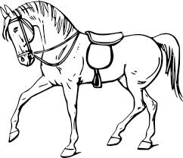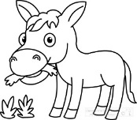

Solution: In one week, a horse and donkey together consume a+b bushels of corn. In 5 weeks they will consume
5(a + b) bushels.

- [3 pts] Simplify fully: $\frac{7}{\frac{2}{5}+\frac{3}{10}}$
Solution:$\frac{7}{\frac{2}{5}+\frac{3}{10}} = \frac{7}{\frac{2}{5}\left(\frac{2}{2}\right)+\frac{3}{10}}=\frac{7}{\frac{4}{10}+\frac{3}{10}}=\frac{ 7 }{\frac{7}{10}}=7 \frac{10}{7}=10$

- Consider the following geometric figure.
- [2 pts] Find the perimeter (use appropriate units).
Solution: perimeter = 4 + 7 + 6 + 2 + 10 + 9 = 38 cm

- [2 pts] Find the area (use appropriate units).
Solution: area = sum of the area of A and the area of B = 4(7) + 10(2) = 48 cm²
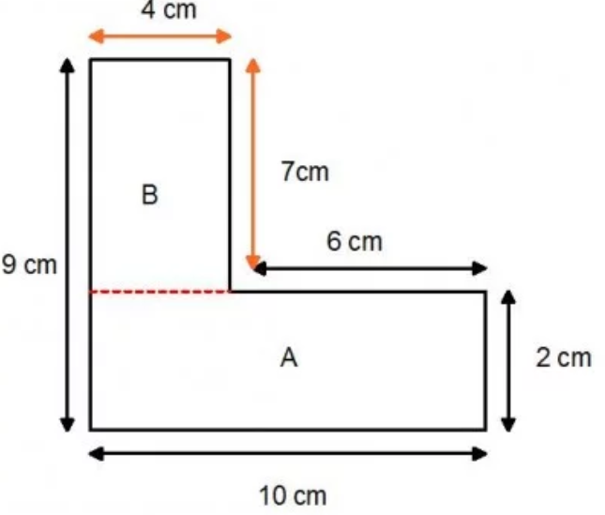
Extra Credit:
- [1 pt] Albertine's mum has four children. The first child is called April. The second May.The third June.
What is the name of the fourth child?

Solution: Since Albertine’s mum has four children, her fourth child must be Albertine.

- [2 pts] A logician with some time to kill in a small town, Ontonagon, Michigan, decided to get a haircut. The town has only two barbers, each with his own shop. The logician glanced into one shop and saw that it was extremely untidy. The barber needed a shave, his clothes were unkempt, and his hair was badly cut. The other shop was extremely neat.
The barber was freshly shaved and spotlessly dressed, his hair neatly trimmed. Why did the logician return to the first shop for his haircut? Explain!

Solution: Each barber must have cut the other's hair. The logician picked the barber who had given his rival the better haircut. This would be the first barber.

Mathematics is the language in which the laws of the universe are encoded, and without it, we would have no idea of where we are or how we got here.
- Tim Radford, British-New Zealand journalist, and science writer

