MATH 100 Solutions: QUIZ VI 18 October 2018

- [4 pts] Consider the line L given by the equation y = −3 + 0.2x
Find the slope and both intercepts of L.

Solution: If we write the line in the form y = mx + b, we find that m, the slope, is 0.2 and the y-intercept is -3. To find the x-intercept, set y = 0 in the equation y = -3 + 0.2x. So 0 = -3 + 0.2 x, from which it follows that x = 15.

Answers: Slope = 0.2
x-intercept = 15
y-intercept = -3

- [4 pts] Find an equation for the line that is perpendicular to the line y = −13 + $\frac{1}{3}$ x and passes through the point C = (4, −2).

Solution: Since the slope of the given line is 1/3, the slope of a perpendicular curve is -3.
Thus, using point slope form, y – (-2) = -3(x – 4), or equivalently: y + 2 = - 3(x – 4)

- [4 pts] Write an equation of the line that has x-intercept equal to 5 and y-intercept equal to -7.
Solution: Basically we are given that P = (5, 0) and Q = (0, -7) are points on the line.
Thus $m=\frac{∆y}{∆x}=\frac{-7-0}{0-5}=\frac{7}{5}$
Using point-slope form:
$$y=\frac{7}{5}x-7$$

- [4 pts] Write an equation of the line that is parallel to 4x – 3y = 1789 and passes through the point P = (3, 4).

Solution: Writing the given line in slope-intercept form:
$$y=\frac{4}{3}x-\frac{1789}{3}$$
So we see that the slope of the given line is m= $\frac{4}{3}$.
Writing the parallel line in point-slope form: $y-4=\frac{4}{3}(x-3)$ or, equivalently, $y=\frac{4}{3}x$

- [1 pt] Which (if any) of the following relations are actually functions? List all of those relations given below that are actually functions. (Note: there may be none, exactly one, or more than one.)
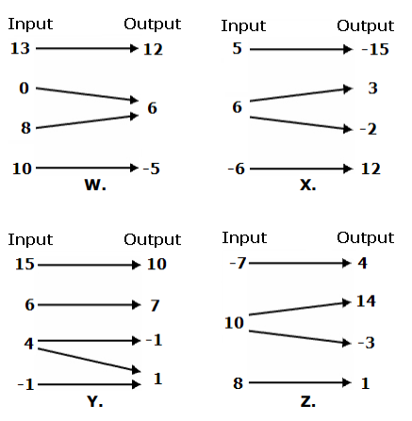

ANSWER: Only W is a function

- [1 pt] Which (if any) of the following relations are actually functions? List all of those relations given below that are actually functions. (Note: possibly none, possibly only 1, possibly 2, …)

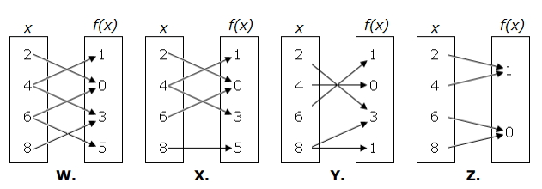

ANSWER: Only Z is a function

- [1 pt] Which (if any) of the following relations are actually functions? List all of those relations given below that are actually functions. (Note: possibly none, possibly only 1, possibly 2, …)

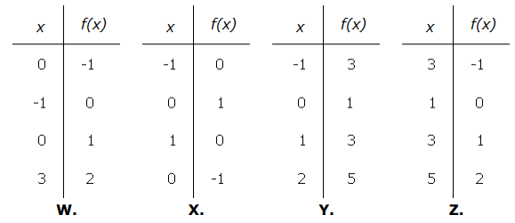

ANSWER: Only Y is a function

- [1 pt] Which (if any) of the following graphs represent functions? List all of the graph given below that are actually functions. (Note: possibly none, possibly only 1, possibly 2, …)
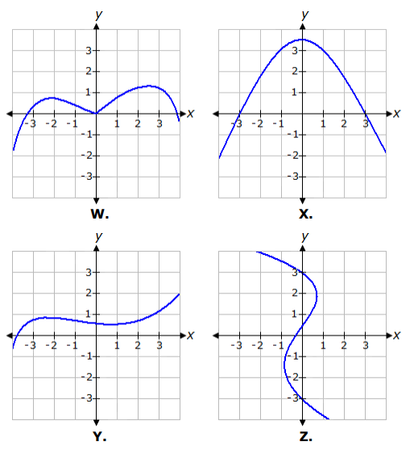

ANSWERS: W, X, and Y are functions

Extra Credit [4 pts]

The following curve is actually a straight line “in disguise.” Find its slope.
2(1– x) + 3(x + 5(x – 2)) = (x + 1)² – (x + x²) + 1 + y

Solution:
Simplifying the left-hand side:
2(1– x) + 3(x + 5x – 10) = (x + 1)² – (x + x²) + 1 + y
2(1– x) + 3(6x – 10) = (x + 1)² – (x + x²) + 1 + y
2 – 2x + 18x – 30 = (x + 1)² – (x + x²) + 1 + y
2 – 2x + 18x – 30 = (x + 1)² – (x + x²) + 1 + y
16 x – 28 = (x + 1)² – (x + x²) + 1 + y

Expanding (x + 1)² :
16 x – 28 = x² + 2x + 1 – (x + x²) + 1 + y

Simplifying the right-hand side:
16 x – 28 = x² + 2x + 1 – x – x² + 1 + y
16 x – 28 = x + 2 + y
Solving for y:
15 x – 30 = y
y = 15x – 30
Since the equation is now in slope-intercept form, we see that its slope is 15.

The supreme accomplishment is to blur the line between work and play.
- Arnold J. Toynbee

