MATH 100 solutions: QUIZ VII 1st November 2018

- [4 pts] The temperature at the base of a mountain in the land of Oz is $90° F$ and decreasing by $5° F$ for every thousand-foot increase in elevation
- Find a function, T(h), which expresses the temperature in degrees Fahrenheit at an elevation of h thousand-feet.
Answer: T(h) = 90 – 5h

- What does T(4) = 55 mean?
Answer: T(4) = 55 means that when your elevation is 4 thousand feet above the base of the mountain, the temperature is $55° F.$

- [4 pts] Let f(x) = x² + 3
- Find f(-2).
Solution: f(-2) = (-2)² + 3 = 7
- Find $\frac{f\left(1\right)+1}{f\left(2\right)-1}$
Solution: $\frac{f\left(1\right)+1}{f\left(2\right)-1}=\frac{4+1}{7-1}=\frac{5}{6}$

- Find f (1 + f(2))
Solution: $f\left(1+f(2)\right)=f\left(1+7\right)=f\left(8\right)=67$

- Find f (1 + f(1) + f(2))
Solution: $f\left(1+f\left(1\right)+f(2)\right)=f\left(1+4+7\right)=f\left(12\right)=147$

- [2 pts] At the University of Oz, at the end of the semester, students’ math grades are listed in a table that gives each student’s ID number in the left column and the student's grade in the right column. Let N represent the ID number and G represent the grade. Which quantity, N or G, must necessarily be a function of the other?

Solution: G is a function of N, namely G = f(N).
Each ID number determines a student that then determines the grade.
On the other hand, knowing the grade does not determine who the student is.

- [6 pts] Match each story about a bike ride to one of the graphs
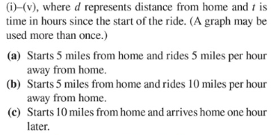
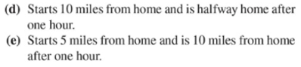
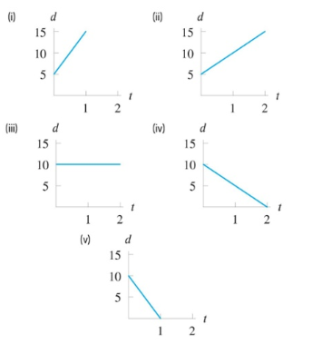
Answers:
Story (a): (ii)
Story (b): (i)
Story (c): (v)
Story (d): (iv)
Story (e): (ii)

- [6 pts] Ten inches of snow is equivalent to about one inch of rain.
- Write an equation for the amount of precipitation, measured in inches of rain, r = f(s), as a function of the number of inches of snow, s.
Answer: $r=f\left(s\right)=\frac{1}{10} s$

- Find and interpret f (5).
Solution:
$$f\left(5\right)=\left(\frac{1}{10}\right)\left(5\right)=\frac{1}{2}$$
This means that 5 inches of snow is the equivalent of ½ inch of rain.

- Find s such that f(s) = 5 and interpret your result.

Solution: If s = 50 then f(50) = 5. This means that 50 inches of snow is the equivalent of 5 inches of rain.

