Math 117 – Precalculus I

Spring 2018
Section 010: TTh 1:00 – 2:15 pm (6 Dumbach Hall)

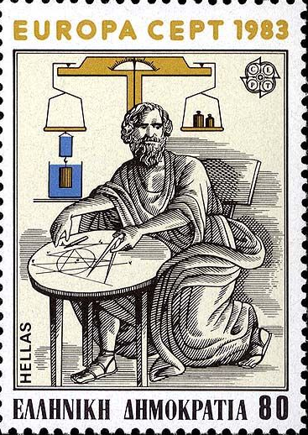

- Ground Rules
- Syllabus
- Homework & Reading Assignments
- Piazza
- Worksheets
- Tutoring Services and Schedule
- Advice from Hall & Knight
- Practice Tests
- Test Solutions
- Useful References (Greek alphabet; related websites and articles)
- History of Algebra (I, II, III)

“Every minute dies a man. Every minute one is born.” I need hardly point out to you that this calculation would tend to keep the sum total of the world’s population in a state of perpetual equipoise, whereas it is a well-known fact that the said sum total is constantly on the increase. I would therefore take the liberty of suggesting that in the next edition of your excellent poem the erroneous calculation to which I refer should be corrected as follows: “Every moment dies a man, And one and a sixteenth is born.” I may add that the exact figures are 1.067, but something must, of course, be conceded to the laws of meter.
– Charles Babbage, letter to Alfred Lord Tennyson, about a couplet in his “The Vision of Sin”

Department Home Page Loyola Home Page

