MATH 117 Practice problems for Final
26 April 26 2018

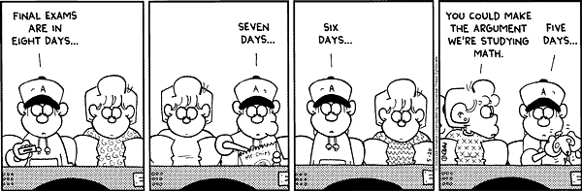

- Let f(x) = 3x² + x + 4, and let g(x) = 4x – 3.
  - Calculate f(2x) – 3g(x²). Simplify your answer.
  - Calculate $\frac{g\left(x+h\right)-g(x)}{h}$ . Simplify your answer as much as possible h
  - Calculate $\frac{f\left(x+h\right)-f(x-h)}{2h}$. Simplify your answer as much as possible.
  - Compute $g∘f$(x).
  - Compute $f∘g$(x).
  - Compute $g∘g$(x).

- Find an equation of a straight line that has x-intercept 11 and is perpendicular to the line that passes through the points P = (5, 4) and Q = (7, -1).

- Factor fully each of the following:
    - 16x⁴ – 1
    - 2x⁵ – x⁴ – 15x³
    - x² – 16y²
    - x³ + x² – 7x +2 given that x = 2 is a root
    - x⁴ + 6x³ – 68x² – 150x – 77 given that x = -1 is a root of multiplicity 2
    - x³ – 8 (given that x = 2 is a root)

- Simplify by removing brackets:
a – 2b – [4a – 6b – {3a – c + (5a – 2b – (3a – c + 2b) )}]

- Solve for x in each equation below:

    - 84 + (x + 4)(x – 3)(x + 5) = (x + 1)(x + 2) (x + 3)

    - 3(x – 1)² – 3(x² – 1) = x – 15

- Find the domain of each of the following functions:
- y = 4x³ + x² + 7x – 11
- $y=\sqrt{2x+4} - \sqrt[3]{3-x }$
- $y=\frac{x(x-1)(x-3)}{(x-4)(x+9)}$
- Using th e method of completing the square, determine the maximum or minimum value achieved by each of the following:
    - f(x) = 7 + 4x + 2x²
    - g(x) = – 4x² + x + 1
    - h(x) = x² 0 – 0 – 3x + 5

- Solve the following equation for x:
(2x – 1)(3x + 5) + 7x + 5 = (6x + 5)(x – 3) – 10(x + 4)

- In the year 2018, Alphaville had 4011 inhabitants and Betaville had only 1880. The population of Alphaville is declining by 79 persons each year. The population of Betaville is growing by 333 persons every year. When will the population sizes of Alphaville and Betaville coincide? (Express your answer to the nearest year.)

- Perform long division; identify the quotient polynomial and the remainder polynomial:
$$\frac{x^{6}-x^{5}+4x-4}{x^{2}+2x-1}$$
- Find an equation of the inverse of the function: $$y= \frac{3x-5}{1-2x}$$
- Sketch each of the following rational functions. Include zeros, singularities, sign analysis, and limiting behavior.
- $y=-{(x-2)}^{2}(x-3)({x-8)}^{4}$

- $y=\frac{x{\left(x+2\right)}^{2}(2x-4)}{{(x-5)}^{5}}$

- $y=\frac{x}{{\left(x-1\right)}^{2}(x+3)(x+4)}$

- True or False? (You need not provide an explanation.)
- (a + b + c)² = a² + b² + c² for all real numbers a, b and c.
- $\sqrt{a+b} = \sqrt{a}+\sqrt{b}$ for all non-negative a and b
- $\sqrt{0}=0$
- $\sqrt{\frac{a}{b}}$ = $\frac{\sqrt{a}}{\sqrt{b}}$ for all positive b and all non-negative a.
- The ratio of the circumference of a circle to its diameter is π.
- If the radius of a circle is halved, then its circumference is halved.
- If the radius of a circle is tripled, then its area is tripled.
- (-55)⁰ = 1
- (81/10000)^{3/2} =729/1000000
- 0⁰ = 1
- (a) Find the distance between the points A = (7, 11) and B = (17, -13). (Simplify your answer.)
(b) Find the midpoint of the line segment joining points A and B.
- (a) Write an equation of the circle with center C = (1, -2) and radius of 5.
(b) Consider the line 3y = 4x – 10. Does this line intersect the circle? If so, find the points of intersection.
- Suppose that a rope is just long enough to cover the equator of the Earth. About how much longer would the rope need to be so that it could be suspended 3 feet above the entire equator.
- Consider the circle having equation x² – 6x + y² + 10y = 4. Find the:
  - center
  - radius
  - circumference
- Find the largest value of the expression 1 – 4x – 2x² . (Hint: Complete the square.)
- Find all values of x satisfying the equation:
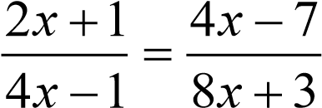
- Suppose that the domain of a function y = f(x) is the interval [0, 7] and that the range of f is [-2, 4]. Define a new function, h, as follows: h(x) = 13 + 5f(3x – 9)
(a) Determine the domain of the function h.
(b) Determine the range of the function h.
- Let f(x) = x³ + x + 1. Find the value of $\frac{f\left(x+3\right)-f(x)}{3}$ and simplify as much as possible.

- Let F(x) be a function with domain [-6, 2] and range [-4, 4]. The graph of F is displayed below:
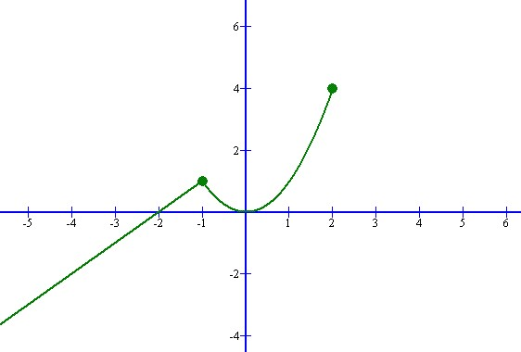
Sketch the graph of each of the following:
  - F(2x)
  - F(x+3)
  - F(x – 2)
  - 3F(-x)
  - F(x/3)
  - 4 – 2F(x)
  - 2 + 2F(x/2)
- Simplify fully the following expression: $\frac{x+1}{x-3}-\frac{x^{2}+2}{x^{2}-9}$ (Hint: Find common denominator.)
- Let $f\left(x\right)=1+\frac{1}{x^{3}}$
      - Evaluate f ⁻¹(2).
      - Evaluate (f(2))⁻¹.
      - Evaluate f(2⁻¹).
- Let $H\left(x\right)=\sqrt[5]{2018+x^{2}}$ . Find functions, F and G, each simpler than H, such that $H\left(x\right)=F∘G\left(x\right).$

- Let f(x) = 2x – b and g(x) = 3x + 5. Find b for which $f∘g\left(x\right)=g∘f(x)$.

- Using the method of Gaussian elimination (no matrices, please), solve each of the following systems of linear equations.(Give exact answers … not decimals.)

$$\left(a\right)$$
3x – 4y = 5
5x – 8y = 7

$\left(b\right)$
$$11x-4y=1$$
$$5x-11y=3$$

- Suppose that the graph of f is a parabola with vertex at (1, 2). Let g(x) = 4x + 5. Find the vertex of the parabola $y=g∘f(x)$.
- Find all the roots of the polynomial p(x) = x³ – 2x² – 23x + 24 ?
Hint: x = 1 is a root of this polynomial.
- For which value(s) of the constant b will the following equation have only one root? 3x² + bx + 1 = 0
- Consider the graph of the polynomial y = f(x) = –x²(x – 2)⁴(x – 3)⁵(x – 5)(x² + x + 1)
(a) The domain of f is:
    - The zeroes of the polynomial are:
    - What happens to y as x → ∞ ?
    - What happens to y as x → -∞ ?

- Suppose that f is an odd function and that $f\left(x\right)=\frac{x}{1+2x^{2}}$ when x ≥ 0. What is the value of f(-2) ?
- Find the center of the circle: x² – 18x + y² + 40y = 1
- Find the vertex of the parabola y = 4x² + x + 2.
- Find the largest value of f(x) = 5 – (3x⁴ + 1)²⁰¹⁸ .
- Find the domain of the function $$f\left(x\right)=\sqrt{x-5}+\sqrt{14-2x} +x^{4}+2018$$
- Which of the following functions, if any, is one-to-one? (Identify any and all that are one-to-one.) You need not give reasons for your answers.
  - y = (x – 1) (x – 3)
  - y = x⁸ + x² + 5
  - y = 5 + 4x^{1/5}
- How many (real) roots?
- y = (x – 2)³(x + 4)⁸(x² + x + 1)
- $y=4x^{2}-144x+9$
- $y={\left(x^{2}-3x+4\right)}^{3}$
- $y=6x^{2}-4x+5$
- Using the quadratic formula, solve each of the following:

- $y=4x^{2}-x-1$
- $y=3-9x^{2}+5x$

- Factor and simplify each of the following. (Caution: Do not multiply out!)
  - (a + 2b)² – 16x²
  - (2x + a – 3)² – (3 – 2x)²
- (a) Without actually dividing, explain why x + 3 is a factor of x³ + 6x² + 11x + 6
(b) Explain why x – 1 is a factor of 32x⁷⁴ – 33x³³ + 1 .
- Find the quotient when x³ – 4x² + 5x + 6 is divided by x – 2.
- Solve each of the following equations and inequalities:
- |x – 1| = |3x – 1|
- |2x + 3| < 8
- |7 – 3x| ≥ 9
- |4x + 7| < -1
- Assume that the domain of the function g is [1, 5] and that its range is [-2, 7].
Let F(x) = 7 + 4g(2x – 1).
    - What is the domain of F ?
    - What is the range of F ?

- Multiply the two polynomials and express in standard form:
$$\left(x^{3}-2x^{2}+x-3\right)\left({2x}^{3}-x^{2}+3x+2\right)$$
- Albertine and Swann have 4 children: Alana, Brentley, Clarissa, and Donovan. Let A(t), B(t), C(t), and D(t) denote the height, in inches, of Alana, Brentley, Clarissa, and Donovan, respectively, at time t, measured in years since January 1, 1990. Alana was born on January 1, 1990.
- Alana and Brentley are twins (i.e. they were born at the same time), but Brentley is shorter. He is always 5% shorter than Alana. Write a formula for B(t) in terms of A(t).
- Clarissa was born exactly 4 years after Alana. Clarissa is always the same height as Alana was when she was the same age. Write a formula for C(t) in terms of A(t).
- Donovan was born exactly 6 years after Brentley. However, Donovan has a larger build, and is always 4 inches taller than Brentley was at the same age. Below, you are given a portion of the graph of y = B(t). The coordinates of four points on the graph are labeled. Using this information, sketch as much as possible of the graph of y = D(t) on the same axes. Label four points on your graph.

