Math 117 Practice Problems for Test I

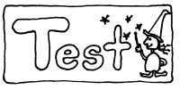

Part I (5 min max)

1. Use **WolframAlpha**: Consider the graph of the function y = x5- 4x2 + x + 1.0

Express each of your answers to the nearest hundredth.

1. Find any local minima, giving both x and y values.
2. Find any local maxima, giving both x and y values.
3. Is there a global max? If so, where?
4. Is there a global min? If so, where?
5. Find the roots of the function.

Part II

ONLY AN INEXPENSIVE NON-GRAPHING CALCULATOR IS PERMITTED!

1. Consider the three vertices of a triangle A=(-3, 2), B = (-6, 4), C = (1, 8).
2. Find the midpoint of the side of the triangle AB.
3. Find the distance from A to B.
4. Of the three sides, AB, BC, and CA, is there a pair that are perpendicular? Explain.
5. Let f(x) = 3x2 + x + 4 and let g(x) = 4x – 3.

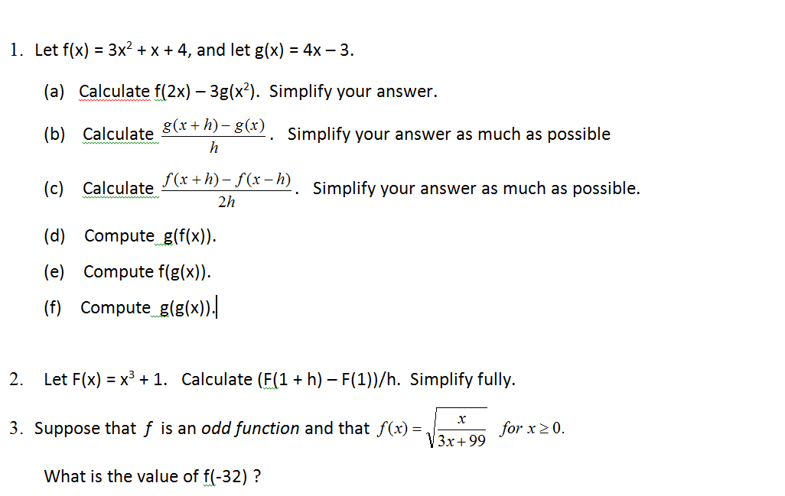



1. What is the value of f(-32)?
2. Same question as (a) but now suppose *f* is an even function.

4. Expand and simplify fully:

(a + b) ( a – c) – (a – b) (a + c) + (a + c) (b – c)

5. Solve for x:

3(1 – 2(1 – 4x)) = 10x – (3 – 5x) + 45

6. Simplify by removing brackets:

a – 2b – [4a – 6b – {3a – c + (5a – 2b – (3a – c + 2b))}]

7.    Solve the following equation for *x*:

(2x – 1)(3x + 5) + 7x + 5 = (6x + 5)(x – 3) – 10(x + 4)

8. *True* or *False?* (You need not provide an explanation.)

1. *(a + b + c)2 = a2 + b2 + c2* for all real numbers *a, b* and *c.*

*________*

1. * ________*
2. * _______*
3. * ________*
4. (12345 + 54321)0 = 1 __________
5. 00 = 1 __________
6. **
7. (-1)123 + (-1)2018 = 0

9. Find all values of *x* satisfying the equation:



1. Find the *largest value* of f(x) = 5 – (3x4 + 1)2018

11. Factor fully each of the following:

1. 3x2 + 5x – 6
2. 4x4 + 4x3 + x2

(c) 6x2 – 19x – 42

(d) 10x2 + 23xy – 5y2

(e) x2 – 16y2  
(f) (a – 2b + 3c)2 – (a + 4b – 7 d)2 Hint: This too is a difference of two squares!

(h) 20x2 + 3x – 9

12. Simplify fully the following expression:



13. The quantity, *Q* mg, of nicotine in the body *t* minutes after a cigarette is smoked is given by *Q = g(t).* Using a *complete sentence*, interpret the statement g(20) = 0.36 *without using any mathematical terminology.*

14. Consider the following piecewise defined function:



Find the value of each of the following: G(1), G(2), G(-1), G(-3)

15. Determine which, if any, of the following equations represents y as a function of x?

1. y = x3(1 + 2x)99
2. x + 2y = 1789
4. x2 + y2 = 1
5. y = |x + 19|
6. y2 = x2

16. Let g(x) = 3(x2 + 1)(x – 4). Compute (without simplifying)

(a) g(0)

(b) g(2x)

(c) g( x + 4)

(d) g(x – 1)

(e) g(2/x)

17. Simplify fully:



18. Explain why the height *h* of the demon, Pinhead, is a function of its age N in years. Given that a Pinhead is 2 feet tall at the time of its creation, experiences growth spurts at ages 3, 23 and 160, and lives to be about 250 years old with a maximum height of 9 feet, sketch a rough graph of the height function.

19. Find the *domain* of each of the following functions:

(a)

(b)

(c)

20. Consider the function f(x) = x2 – 3x + 4. Compute the “Newtonian difference quotient” of f, *viz.*

$$\frac{f\left(x+h\right)-f(x)}{h}$$

Simplify fully.

21. Given a function y = f(x) with domain [1, 5], find the domain of each of the following transformations of f:

(a) g(x) = f(x/9)

(b) h(x) = f(3x – 4) + 99

(c) L(x) = f(-x)

(d) M(x) = 4 f(1 – 2x) + 1

22. Find the *domain* of each of the following functions:

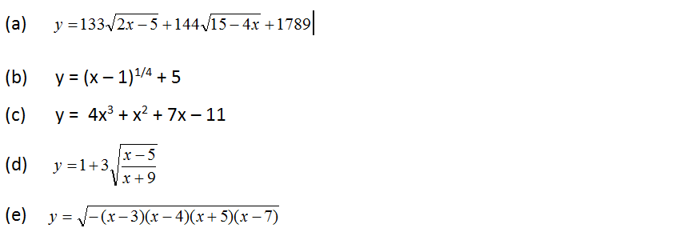

23. The population of AlphaVille can be modeled by the function $P\left(t\right)=\frac{420 t}{t+12}$, where t = 0 represents the year 1903. What is a reasonable domain of P? What range “makes sense” for this function? What does P(0) represent? What does P(50) represent? What about P(100)? What do you think will happen to the town of AlphaVille in the distant future?

24. Which, if any, of the following relations is a function? Explain!

(a) {(1, 0),(2, 1),(4, 2),(8, 3),(16, 4),(32, 5), . . .}

(b) {. . . ,(−3, 9),(−2, 4),(−1, 1),(0, 0),(1, 1),(2, 4),(3, 9), . . .}

(c) {(1, 2), (3, 3), (4, 2), (19, 3}

(d) {(x, y}, x2 + y2 = 4}

25. Given a graph of y = f(x), identify local extrema, global extrema, regions of increase, regions of decrease.

26. Matching functions and graphs.

27. For each function below, determine if the function is even, odd, or neither.

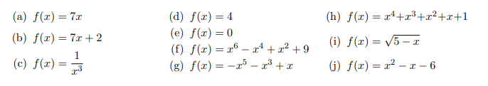

28. Find the x and y-intercepts of each of the following functions:

(a) ) f(x) = $f\left(x\right)=2\sqrt{x+4}-2$

(b) g(x) = (x – 1)(x – 2)2(x – 3)3

29. The complete graph of y = f(x) is given below. Use it to graph the following functions.

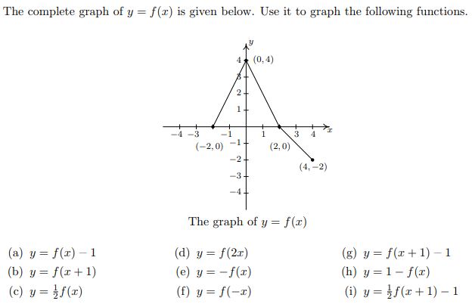

30. Suppose that *f* and *g* are functions completely defined by the rules below.

|  |  |  |  |  |  |  |  |  |  |  |  |  |  |  |  |  |  |  |  |  |  |  |  |  |  |  |  |  |  |  |  |
| --- | --- | --- | --- | --- | --- | --- | --- | --- | --- | --- | --- | --- | --- | --- | --- | --- | --- | --- | --- | --- | --- | --- | --- | --- | --- | --- | --- | --- | --- | --- | --- |
| |  |  | | --- | --- | | **x** | ***f*(x)** | | 0 | 17 | | 3 | 5 | | 4 | 7 | | 7 | 4 | | 11 | 7 | | 13 | 4 | | |  |  | | --- | --- | | **x** | ***g*(x)** | | 0 | 19 | | 2 | 11 | | 4 | 10 | | 7 | 13 | | 10 | 9 | | 14 | 0 | | 19 | 33 | |

(a) Find (f+g)(4)

(b) Find (3f – g)(0)

(c) Find (fg) (4)

1. Find $\frac{f}{g} (7)$
2. Find f(g(7))

31. You are given the graph of y = f(x). Match equations of transformations of f with given graphs.

32. Which of the following functions, if any, is *one-to-one*? (That is, which satisfy the “horizontal line test”?) You need not give reasons for your answers.

1. y = (x – 1) (x – 3)
2. y = x8 + x2 + 5
3. y = (x + 1)2
4. y = (x + 3)3 + 1
5. y = 5 + 4x1/5

*I must study politics and war that my sons may have liberty to study mathematics and philosophy. My sons ought to study mathematics and philosophy, geography, natural history, naval architecture, navigation, commerce and agriculture in order to give their children a right to study painting, poetry, music, architecture, statuary, tapestry, and porcelain.*

### - Letter from John Adams to Abigail Adams, May 12, 1780

