Math 117 Practice Problems for Test II
Revised (3/6/2018)
1. Find two numbers, t, such that the points A = (3, 5), B = (t + 1, 2t), and
C = (2, t) are collinear (that is, the three points lie on the same straight line).
2. Using the method of Gaussian elimination, solve each of the following pair of linear equations for the point of intersection (or explain why there is no point of intersection).
(a) 2x + 5y = 7
3x – 10y = 1

(b) 5x + 9y = -11
6x – 5y = 1

(c) 12x – 2y = 1
18x – 3y = 4
(d) 5x – 8y = 2
3x + 5y = 4

3. Consider the following piecewise defined function:
Find the value of each of the following: G(1), G(2), G(-1), G(-3)

- Find the slope of each of the following lines, or explain why the slope does not exist.
- 3x – 4y = 12
- 3y + 4x = 7 – 3x
- 2(x – 1) + 5(y – 2) = 13
- ax + b(y – 1) = c
- x = 3
- y = 99
- There were 238 million bushes of wheat grown in Michigan in 1990 and the wheat
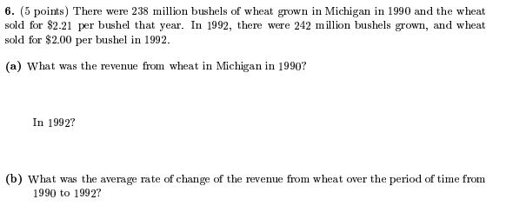
- Given that 8 degrees Alpha corresponds to 12 degrees Beta and that 20 degrees Alpha corresponds to 60 degrees Beta, find a linear relation between Alpha degrees and Beta degrees. Express Alpha as a function of Bets. What is the average rate of change of Alpha degrees with respect to Beta degrees?

- In GammaVille, the cost of gasoline has risen dramatically in the last six months.
At the beginning of September, the cost was 21 gammas per liter, but at the beginning of March, the cost was 38 gammas per liter.

- Suppose that the cost of gasoline, C, measured in gammas per liter is a linear function of time, t. Find a formula for the cost of gasoline as a function of time t, in months, since the beginning of September.
- Suppose further that you drive 200 km per month and that your car averages 27 km per liter. Use your formula from part (a) to calculate the price of gasoline at the beginning of July. Assuming that the cost stays the same throughout the month of October, calculate your gas cost for the month of October.

- Find the equation of a straight line that passes through the points P = (7, 18) and Q = (-4, -3).

- (a) Find the equation of a straight line that has slope 5 and x-intercept 14.
(b) Find the equation of a straight line that is parallel to the line x – 5y = 131 and has y-intercept equal to 9.
(c) Find the equation of a straight line that has x intercept of 5 and y-intercept of 9.

- A function f(x) has the following graph:
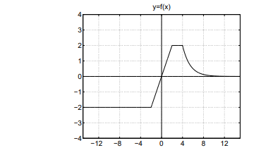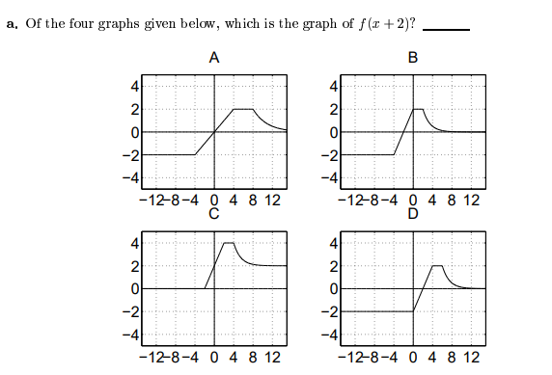
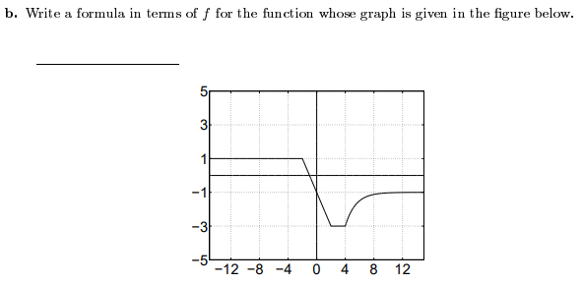
- (a) Find the midpoint of the line segment joining P = (0, 4) and Q = (8, 19).

(b) Find the equation of a line that is perpendicular to the line x – 8y = 123 and passes through the point R = (14, 11).

- Find the equation of a straight line whose slope is 3 and whose y-intercept is the same as that of the line whose equation is y = 4x – 5.

- Find the equation of a straight line that is parallel to the line x – 5y = 131 and has y-intercept equal to 9.

- Find the midpoint of the line segment joining P = (0, 4) and Q = (8, 19).

- Find the point of intersection of the lines y = 3x – 2 and y = 7x + 3.

- Find numbers x and y such that (-2, 8) is the midpoint of the line segment connecting (5, 3) and (x, y).

- If y = g(x) has domain [0, 1] and range of [2, 3], find the domain and range of y = 1 +3g(4x – 5) ?

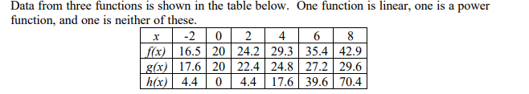
Determine which set of data is linear. Then find a corresponding formula.

14. Let y = F(x) be a function with domain [-6, 2] and range [-4, 4]. The graph of F is displayed below.
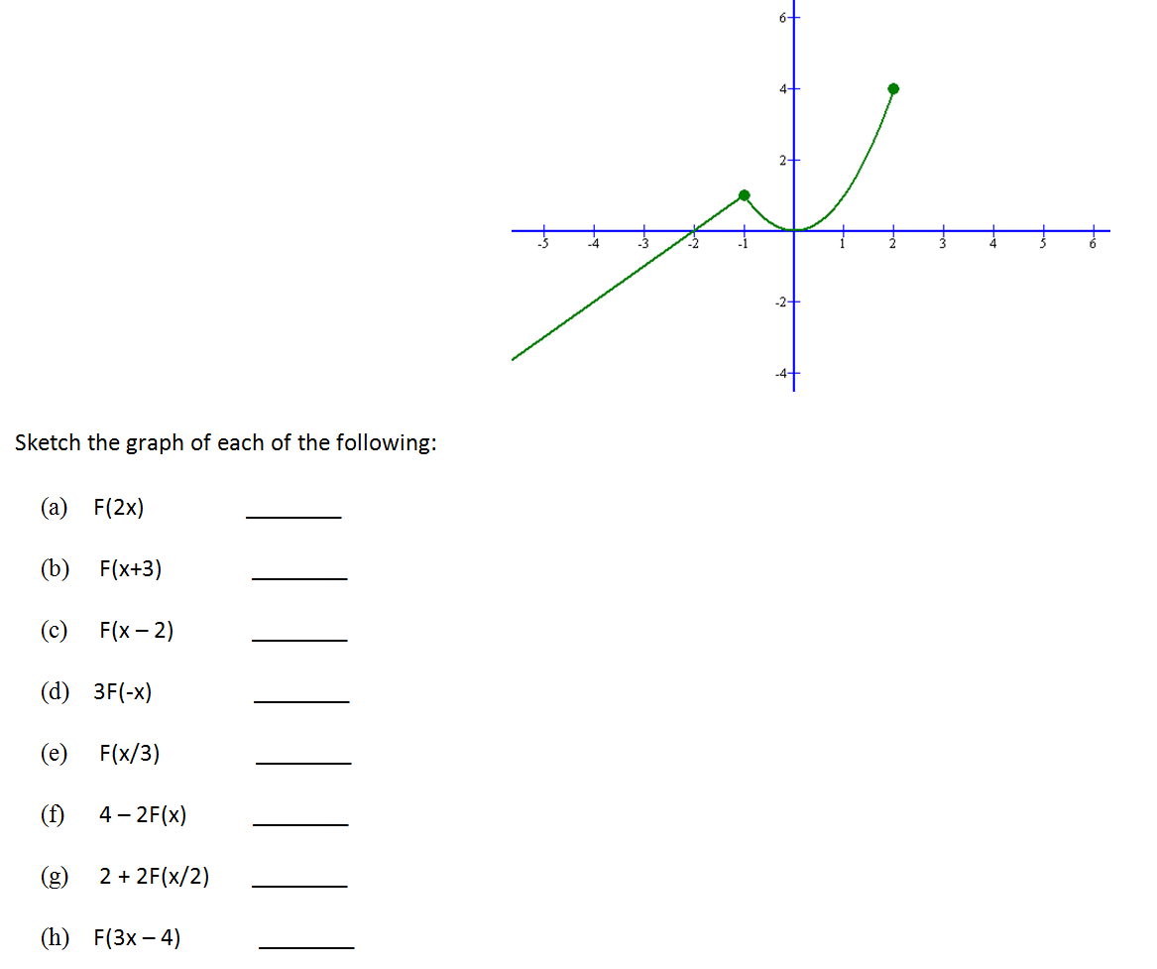
- (Note: The question below may not have unique answer.)

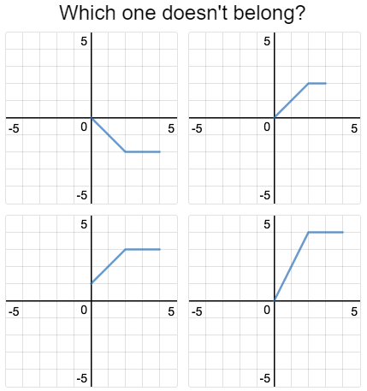
16. Let y = f(x) = x². Explain what happens to the graph of f if we perform the following transformations. Sketch the graphs of the transformed functions.
- y = 3f(x) – 1
- y = 8 – 2f(x)
- y = f(x – 5)
- y = 3f(x – 1) + 4
- y = -2f(5x)
- y = 4f(x/2) – 8
- y = f(2x – 4)
Has the domain or range changed for any of the above? Explain!

17.
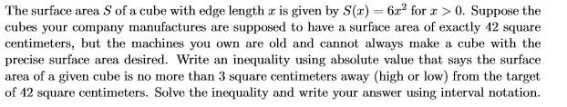
18.

19. Solve each of the following equalities:
(a) |3x – 1| = 6
(b) 4 – |5x + 3| = 7
(c) 3 - |x+5| = 1
(d) |x – 2| + 1 = x

20. Solve each of the following inequalities:
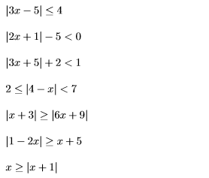
21. In the following, compute the average rate of change of the given function over the interval [x, x+h]. Here we assume that [x, x+h] is in the domain of the function.

(a) f(x) = x³
(b) f(x) = 1/x
(c) f(x) = (x + 4)/(x – 5)
(d) f(x) = 4x² + 3x – 13
(e) f(x) = 1/x.

22. For each of the following assume that y = f(x) is the graph written in an unbroken curve. Express each transformations (dashed line), as an appropriate function of f.

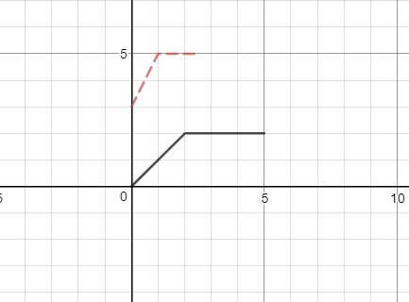 | 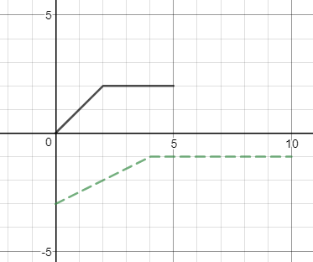

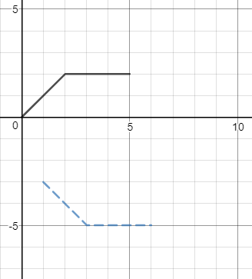 | 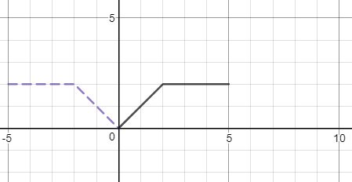

23. If y = f(x) has domain [-1, 1] and range of [2, 3], find the domain and range of y = 1 +3 f(4x – 5).
24.
25. Complete the square of each of the following quadratics to express the quadratic function in standard form, viz. y = a(x – h)² + k. Also, find the vertex, the axis of symmetry, and any x- or y-intercepts.
(a) y = x² – 6x + 1
(b) y = x² – 8x + 13
(c) y = x² + 9x + 1
(d) y = 2x² – 8x + 13
(e) y = 6 – x – x²

26. Using the quadratic formula, solve for the roots of each of the following:
(a) y = x² – 4x + 1
(b) y = 2x² – 5x + 1
(c) y = 4x + 1 – 3x²
(d) y = 1 – x – x²
27. Without solving, determine the number of roots that each quadratic has:
- y = x² – x + 1
- y = x² – x – 1
- y = x² – 18x + 81
- y = 5x – 4 – x²

28. We need to enclose a field with a fence. We have 500 feet of fencing material and a building is on one side of the field so won’t need any fencing. Determine the dimensions of the field that will enclose the largest area.

29. Find the largest rectangular area one can enclose with 14 inches of string?
30. Graph (a) y = |x² – 5|
(b) y = 3(x – 4)² + 3
31. Solve each of the following inequalities:
(a) |x – 3| < 3
(b) |x – 5| > 7
(c) |1 – 5x| < 3
(d) |x – 5| < 0
(e) |3x + 4| ≤ 1
(f) |x² – 3| < 4
(g) x² + 4 ≤ 4x

32. The temperature T, in degrees Fahrenheit, t hours after 6 AM is given by:
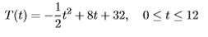
What is the warmest temperature of the day? When does this happen?

33. Suppose C(x) = x² − 10x + 27 represents the costs, in hundreds of euros, to produce x thousand pens. How many pens should be produced to minimize the cost? What is this minimum cost?

34. Albertine wishes to plant a vegetable garden along one side of her house. In her garage, she found 32 linear feet of fencing. Since one side of the garden will border the house, Albertine does not need fencing along that side. What are the dimensions of the garden that will maximize the area of the garden? What is the maximum area of the garden?

35. What is the largest rectangular area one can enclose with 14 inches of string?

36. The height of an object dropped from the roof of an eight-story building is modeled by
Here, h is the height of the object oﬀ the ground, in feet, t seconds after the object is dropped. How long will it take until the object hits the ground?

37. The height h in feet of a model rocket above the ground t seconds after lift-oﬀ is given by
When does the rocket reach its maximum height above the ground? What is its maximum height?

38. Gilberte’s friend Swann participates in the annual Games of Oz. In one event, the hammer throw, the height h in feet of the hammer above the ground t seconds after Jason lets it go is modeled by
What is the hammer’s maximum height? What is the hammer’s total time in the air? Round your answers to two decimal places.

Wolfram Alpha problems:

- Determine the point(s) on $y=x^{2}+1$ that are closest to (0, 2).

- You have 900 feet of fencing to enclose a rectangular garden. One side of the enclpsure is a river. What is the largest such gardern which can be enclosed with the fencing ang the river?
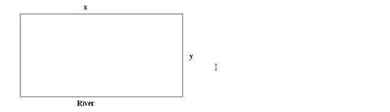
- Find two nonnegative numbers whose sum is 9 such that the product of one number and the square of the other number is a maximum.
- Build a rectangular pen with three parallel partitions using 500 feet of fencing. Which dimensions will maximize the total area of the pen?
- An open rectangular box with square base is to be made from 48 ft² of material. Which dimensions will result in a box with the largest possible volume?
The universe stands continually open to our gaze, but it cannot be understood unless one first learns to comprehend the language and interpret the characters in which it is written. It is written in the language of mathematics, and its characters are triangles, circles, and other geometric figures, without which it is humanly impossible to understand a single word of it; without these, one is wandering about in a dark labyrinth.

- Galileo Galilei

