# MATH 117 Practice TEST III 5 April 2018

*The limits of my language mean the limits of my world.*

- Ludwig Wittgenstein, **Tractatus Logico-Philosophicus**(1922)

1. Find the *domain* of the functions

(a) 

(b) f(x) =

2. Show that x = 1 is a root of the polynomial p(x) = x3 – 4x2 – 13x + 16.

Then find the quotient when p(x) is dividd by x – 1.

3. Consider the function g(x) = x4 – 7x2 – 6x. Circle the numbers below that are roots of g. (There may be several or perhaps none.) Show your work.

1. 0 (b) 1 (c) -1 (d) 2 (e) -2 (f) 3 (g) -3 (h) 7

4. Divide p(x) = x6 – 3x5 + 2x4 – x + 13 by x2 – x + 3.

*Quotient = ___________________________________________*

*Remainder = _________________________________________*

5. Let g(x) = 2x2 + x + 1. Find and *simplify* the expression



6*. [University of Michigan precalculus final exam]*  In this problem, the constants *a, b, c,* and *d* are all *positive and different from each other*. Consider the function:



(a) What is the y-intercept of *G*? If there is not a y-intercept, write *NONE*.

(b) Find all zeroes of *G*. If there are no zeroes, write *NONE*.

1. Give the equation(s) of all vertical asymptote(s) of *G*. If there are none, write *NONE*.

7. Find the *domain* of each of the following functions. *Explain!*

(a) 

(b) 

8. Let F(x) = 31 – $\frac{1}{x^{3}}$. Here is a plot of *F*.



1. What is the *domain* of F?
2. What are the vertical asymptote(s)?
3. Find any horizontal asymptote(s).
4. What is the *range* of F?

9. Suppose that 

(a) If f(x) = $1+\sqrt{x+9}$  
find a function *g* such that 

(b) If f(x) = $1+\sqrt{x}$  
 find a function *g* such that 

10. If g(x) =   
 find a function *f* such that 

1. . Suppose that 
2. If  find a function *g* such that 
3. If  find a function *g* such that 
4. If find a function f such that 
5. *How many real roots* does each of the following equations possess? (*Hint:* These questions require very little calculation.)
6. (x – 1) (x + 5) (x2 + 13)4 = 0
7. 5x2 – 4x + 1 = 0
8. x2 – 4x – 1 = 0
9. 3x2 – 4x + 8 = 0
10. (x4 + 2)(x + 1)(x2 – 9) = 0
11. Find functions *f* and *g*, each simpler than the given function *h*, such that 









17.   Factor fully each of the following:

(a) x3 + x2 – 7x + 2 given that x = 2 is a root

(b) x4 + 6x3 – 68x2 – 150x – 77 given that x = -1 is a root of multiplicity 2

(c) x3 – 8 given that x = 2 is a root

(d) x5 + 1 given that x = -1 is a root

18. Find an equation of a polynomial that has zeroes at x = 1, 4, 5 and has y-intercept of 11.

19. (a) Without actually dividing, explain why x + 3 is a factor of

x3 + 6x2 + 11x + 6

(b) Explain why x – 1 is a factor of 32x74 – 33x33 + 1

20. Multiply the following two polynomials:

p(x) = 3x3 – 4x2 + x +1

q(x) = x5 + x3 + 3x2 +1

21. Consider the polynomial

y = f(x) = –x2(x – 2)4(x – 3)5(x – 5)(x2 + x + 1)

1. The domain of *f* is:
2. The zeroes of the polynomial are:
3. What happens to y as x → ∞ ?
4. What happens to y as x → -∞ ?

22. Consider y = f(x), a rational function that has the graph below:

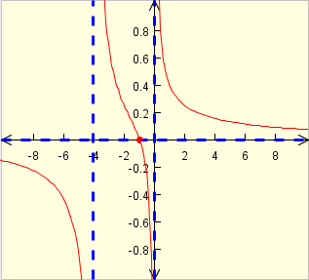

1. List the zeroes.
2. List the singularities.
3. List the horizontal asymptotes.
4. List the vertical asymptotes.

23. Perform polynomial division. What is the quotient? What is the remainder?





24. Find the quotient when x3 – 4x2 + 5x + 6 is *divided* by x – 2.

25. What are the roots of the polynomial p(x) = x3 – 2x2 – 23x + 24 ?

*Hint:* Since p(1) = 0, x = 1 is a root of this polynomial.

26. For which value(s) of *c* will the following polynomial be divisible by x – 3?

P(x) = 3x4 – cx2 + 3x – 72

27. Consider the following two rational functions:



Express each of the following as a rational function. Simplify.

1. r(x) + 3 s(x)
2. (s(x))2
3. (rs)(x)

28. Find a polynomial p(x) that has roots 1, 2, -3, -4 and satisfies the property that p(-1) = 5.

29. Explain the significance of the *discriminant of a quadratic expression*

Ax2 + Bx + C. Give examples of each of the three *types* of discriminants and their relationship to the corresponding graph of the parabola.

30. *How many real roots* does each of the following equations possess? (*Hint:* These questions require very little calculation.)

1. (x – 1) (x + 5) (x2 + 13)4 = 0
2. 5x2 – 4x + 1 = 0
3. x2 – 4x – 1 = 0
4. 3x2 – 4x + 8 = 0
5. (x4 + 2)(x + 1)(x2 – 9) = 0

31. Let p(x) = x2 + x – 2 and q(x) = x2 + 1. Compute and simplify each of the following:

1. 4p (x)
2. (p + q) (x)
3. (p – q) (x)
4. (3p + 5q) (x)
5. (pq) (x)
6. 
7. 
8. 
9. p(x + 1) – p(x)
10. If *p* and *q* are polynomials, in general, what can be said of deg(p + q), deg(p – q), deg(pq)
11. What is meant by the “dominant term” of a polynomial? What does this term tell us about the graph of the polynomial?
12. What is meant by “zero” of a polynomial?
13. Let p(x) = (x – 2)2(x2 + x + 1)3(x2 – 14x + 45)
14. What is the degree of *p*?
15. Find all the zeroes of *p*.
16. Graph each of the following polynomials. Focus primarily upon the qualitative behavior of the graph instead of plotting points.
17. F(x) = 2x + 5
18. y = x2 – 9
19. G(x) = 1 + x4
20. h(x) = (x + 1)3 + 2
21. q(x) = x2 (x – 1)2
22. F(x) = (x + 2)(x + 3)(x + 4)
23. Find the zeroes of the polynomial f(x) = x6 – 8x3 + 15. Hint: Let z = x3; then solve for z.
24. Find all zeroes of the polynomial g(x) = x8 – 1 Hint: Factor as difference of squares several times.
25. Find a number *b* such that 4 is a zero of the polynomial

p(x) = x3 – 2x2 + bx + 1.

1. Find a polynomial of third degree having roots (i.e., zeroes) of 1, 7, 11.
2. Let p(x) = x3 – 2x2 + x. For each given point, determine if it lies *on* the graph, *above* the graph, or *below* the graph of y = p(x).
3. (1, 1), (b) (2, 1), (c) (3, 12), (d) (-1, -5)
4. Which (if any) of the following polynomials have *x – 1* as a factor?
5. x9 – 1
6. x6 – x3 + 4x2 – 13x + 9
7. 2x13 – 4x + 3
8. x2014 – 5x + 4
9. For each of the following polynomials find at least one linear factor. *Hint:* Use the Factor Theorem.
10. x3 – 4x – 3
11. x4 – 9x + 2
12. x3 – 2x2 + 3x – 18
13. x5 + 32
14. x2018 – b2018
15. (a) For which value(s) of *c* will the following polynomial be divisible by *x – 2 ?*

p(x) = x3 – cx2 + 5x – 1

(b) For which value(s) of *c* will the following polynomial be divisible by x + 3?

p(x) = x3 + 5x2 – 2x + c

1. Using the factor theorem, factor fully: x3 – 1 and x3 + 1.

46. Long division practice.

(a) 

1. 
2. 
3. 
4. 
5. 

47. Find the *domain* of each of the rational functions in question 46.

48. What is meant by *singularity* of a rational function?

50. Let . What is the approximate value of *R*(1010)?

What about *R*(-1010)?

51.

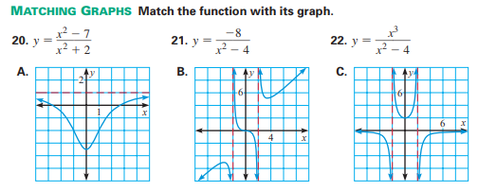

52. Match

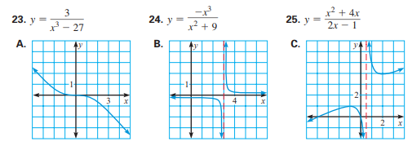

53. Match.

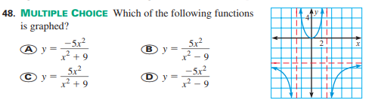

54. For each of the following functions, determine *domain, zeroes, singularities, limiting behavior* for large |x|, and perform a *sign analysis*. Sketch the curve indicating any and all horizontal and vertical asymptotes.

1. y = (x – 1) (x – 2) (x – 3)
2. y = (x – 1)2 (x – 2)3 (x – 3)
3. y = x4 (x + 5)2 (x – 3)4
4. 
5. 
6. 
7. 
8. 
9. 
10. 
11. 

55.

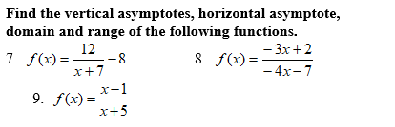

56.



57.



58. Match.

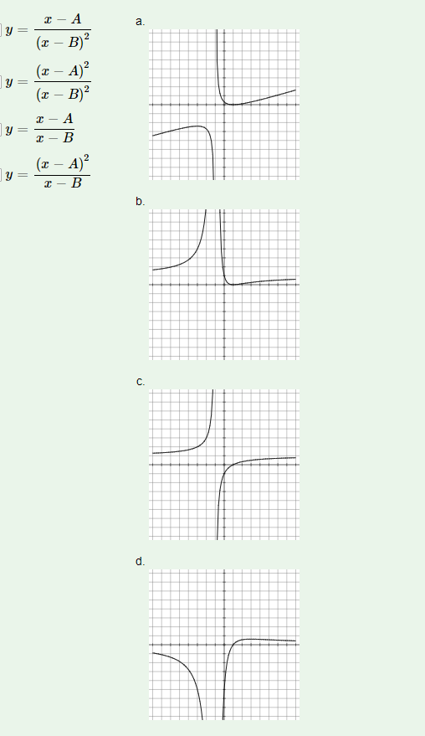

*You propound a complicated arithmetical problem: say cubing a number containing four digits. Give me a slate and half an hour’s time, and I can produce a wrong answer.*

* George Bernard Shaw