More practice problems: 1 June 2016

1. Link and Boots decided to have a race down a straight portion of Pauline Boulevard that is 1.1 kilometers long. Let L(t) and B(t) be Link’s and Boots’ respective distances from their starting point t seconds after the race began. A graph of L(t) and B(t) is shown below.
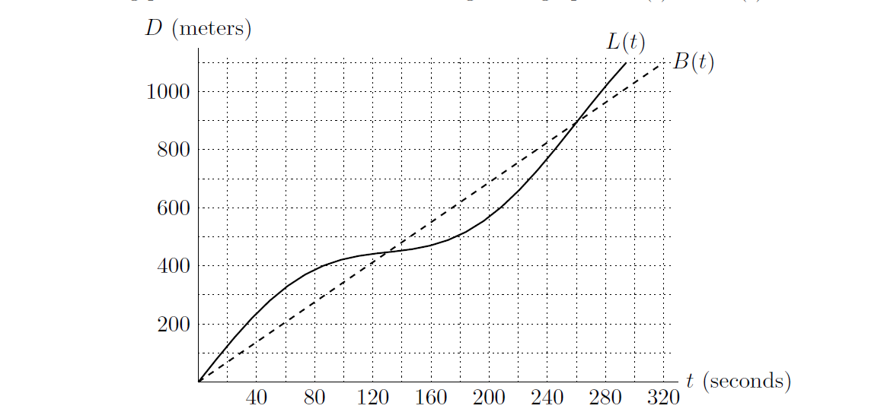
a. Who won the race?

b. Estimate the times at which Link and Boots were running at the same speed.

c. Estimate Link’s average velocity over the first 100 seconds of the race. Include
units.

d. Estimate Link’s instantaneous velocity 40 seconds after the race began. Include
units.
e. 160 seconds after the race began, is Link’s acceleration positive, negative, or
equal to zero?

2. In the land of Oz, the average property value P, in dollars per square foot, can be modeled as a function of the distance x, in miles, you are away from the city center. This relationship can be written P = g(x). Below is a table containing information about g(x). Usethe information in the table to answer the parts of this question.
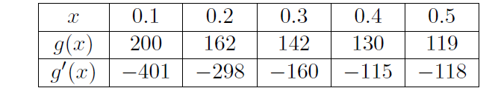

a. Estimate g′(0.15) using only values of g(x) from the table.

b. Estimate g′(0.45) using only values of g′(x) from the table.

d. Write a sentence expressing the meaning of

g′(0.3) = −160

which could be understood by someone who knows no calculus. The beginning of the sentence is given below.

If I am 0.3 miles from the center of the land of Oz looking at properties and I travel 0.05 miles toward the city center…..

