Math 161: Groupwork I

24th August 2015

(Problems selected from the University of Michigan precalculus final, Winter 2010.)

1. The population of a particular nest of bumblebees t minutes after observation begins





1. Suppose that  Find a formula for
2. Suppose *m* is a function with zeroes x = -2, x = 1, and x = 5 and horizontal



1. Find the zeroes of g.
2. Find the equation of a horizontal asymptote of g.
3. In this problem, the constants *a, b, c* and *d* are all positive and different from each



1. What is the y-intercept of *R*? If there is not a y-intercept, write NONE.
2. Find all zeroes of *R*. If there are no zeroes, write NONE.
3. Find the equation(s) of all vertical asymptote(s) of *R*. If there are none, write NONE.
4. Find the equation(s) of all horizontal asymptote(s) of *R*. If there are none, write NONE.
5. A company has 30 inch by 50 inch rectangular pieces of scrap sheet metal from

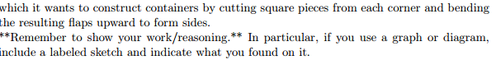

1. Find a formula for the volume *V = g(c)*, in cubic inches, of a container obtained by cutting the square pieces of side length *c* inches from each corner.
2. In the context of this problem, what is the domain of *g*? (Use interval notation.)