Groupwork III

1. Below is a table of values of an invertible function f(x) and the graph of a function g(x). Use these to answer the following questions.

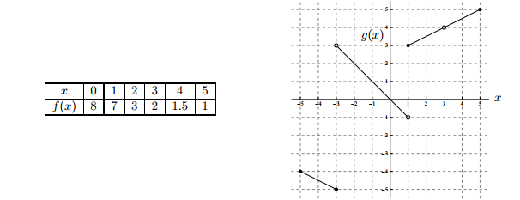

1. Give one number in the interval [-5, 5] that is not in the domain of g.
2. Give one number in the interval [-5, 5] that is not in the domain of g-1.
3. Evaluate f(f(5))
4. Evaluate g-1(f-1(1))









1. (a) Carefully state the Squeeze Theorem. (Include the case when x→∞.)





1. Using our result for compute 
2. Using an appropriate table (for example, letting x = 0.1, 0.01, 0.001, etc.) determine (to the nearest tenth) the behavior of the function  as x approaches 0. (*Show your work!*)

|  |  |
| --- | --- |
| ***x*** | ***f(x)*** |
| 1 |  |
| 0.1 |  |
| 0.01 |  |
| 0.001 |  |
| 0.0001 |  |
| 0.00001 |  |
| 0.000005 |  |

1. (b) Find 

(b) Find 

1. Suppose that  Find 