Group Work Assignments

GW I (20 January): calculus I problems from the University of Michigan
GW II (25 January): volume
GW III (27 January): practice quiz II

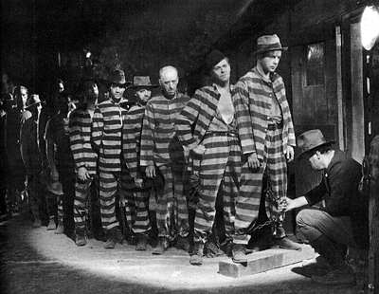
I Am A Fugitive from a Chain Gang (1932)

Course Home Page Department Home Page Loyola Home Page

