PHOMEWORK: MATH 161

Homework 0 Due: Tuesday, 25 August (midnight)
Briefly describe (in one or two paragraphs) information about yourself that will help me get to know you. If you wish, you may let the following questions serve as a guide: why are you taking Math 161? (for example: "major requirement", "just for fun because I love mathematics", "nothing else fits my schedule", "my parents forced me to take this course", "I am looking for an easy A to raise my gpa what is your major?, what is your career goal?, what has been the nature of your previous experience with math either in high school or in college (that is, have you enjoyed math in the past? Do you like to see applications more than theory, or do you prefer theory?), are you enrolled in other science or math courses this semester?, are you employed this semester? (Please eMail your response to me using as subject: 161 HW 0)
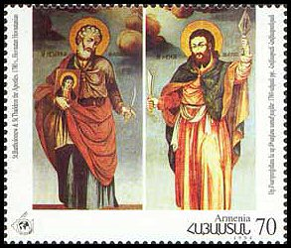
August 24: Feast of St. Bartholomew.
Bartholomew and Thaddeus are considered to be
the patron saints of Armenia. They were portrayed
in a series of commemorative stamps in 1995,
celebrating the 1700th anniversary of the arrival of
Christianity in Armenia.

Homework 1 Due: Wednesday, 2 September (midnight)
Review the material in Chapter 1 of Thomas, pp. 1 – 57. Also study the definitions and properties of hyperbolic functions given on pp. 439 – 440.
Solve: MyMathLab Homework 1 (Due: 11:59 pm on Wednesday)

Homework 2 Due: Wednesday, 9 September (midnight)
Read section 2.2 of Thomas. Solve: MyMathLab Homework 2 (Due: 11:59 pm on Wednesday)

Homework 3 Due: Wednesday, 16 September (midnight)
Read sections 2.4, 2.5 and 2.6 of Thomas. Solve: MyMathLab Homework 3 (Due: 11:59 pm on Wednesday)

International Day of Peace, September 21

Homework 4 Due: Wednesday, 23 September (midnight)
Read sections 3.1, 3.2 and 3.4 of Thomas. Solve: MyMathLab Homework 4 (Due: 11:59 pm on Wednesday)

Eid begins on Sept 23
Homework 5 Due: Tuesday, 29 September (midnight)
Review sections 3.2 and 3.4 of Thomas. Read section 3.3 Solve: MyMathLab Homework 5 (Due: 11:59 pm on Tuesday)
You are strongly advised to complete this assignment before Friday’s Test!
Recommended: Watch MIT 18.01 lecture 1 (rate of change), MIT 18.01 lecture 2 (limits), MIT 18.01 lecture 3 (derivatives: first 20 minutes only for now)
23 September 2015, 4:21 am | 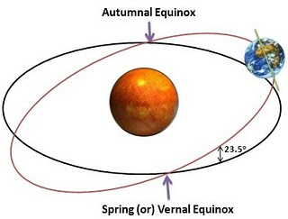

Homework 6 Due: Sunday, 11 October (midnight)
Due: Sunday, 11 October (midnight)
Review sections 3.5, 3.6 and 3.7 of Thomas. Solve: MyMathLab Homework 6 (Due: 11:59 pm on Sunday)

Recommended: Watch MIT 18.01 lecture 4 (chain rule) and MIT lecture 5 (implicit differentiation, inverses)
Homework 7 Due: Monday, 19th October (midnight)
Review sections 3.8, 3.9, 3.10, 11.1, and 11.2 of Thomas. Solve: MyMathLab Homework 7 (Due: 11:59 pm on Monday)

Recommended: Watch MIT 18.01 lecture 6 (exponential and logs, logarithmic differentiation, hyperbolic functions)
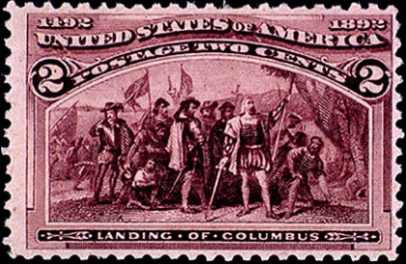
Recommended: Watch MIT 18.01 lecture 6 (exponential and logs, logarithmic differentiation, hyperbolic functions

Islamic New Year, Oct 14
Homework 8 Due: Monday, 2nd November (midnight)
Read sections 4.1 and 4.6. Begin reading section 4.8 of Thomas. Solve: MyMathLab Homework 8 (Due: 11:59 pm on Monday)
Prepare for Test II.

Recommended: Watch MIT 18.01 lecture 10 (curve sketching) and lecture 11 (max/min)
Homework 9 Due: Thursday, 5th November (midnight)
Read sections 4.3 and 4.4. Review section 4.8 of Thomas.
Solve: MyMathLab Homework 9 (Due: 11:59 pm on Thursday)
Recommended: Watch MIT 18.01 lecture 15 (anti-derivatives)
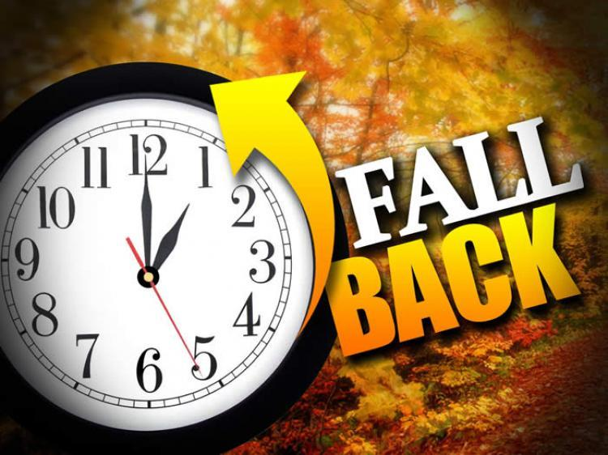

Homework 10 Due: Friday, 20th November (midnight)
Read sections 4.5, 4.6, 4.7, 4.8, 5.1, 5.2, 5.3 of Thomas.
Solve: MyMathLab Homework 10 (Due: 11:59 pm on Friday)
Recommended: Watch MIT 18.01 lecture 18 (indefinite integral)

Homework 11 Due: Tuesday, 24 November (midnight)
Read sections 5.4, 5.5, 5.6 of Thomas.
Solve: MyMathLab Homework 10 (Due: 11:59 pm on Tuesday)
Recommended: Watch MIT 18.01 lectures 19 and 20 (the first and second fundamental theorems).

It's got to be the going, not the getting there that's good. – Harry Chapin, GO GREYHOUND
To travel hopefully is a better thing than to arrive. – Robert Louis Stevenson

Edvard Munch: The Scream (1893)
Never work when hungry.
- Hippocrates
Where our work is, there let our joy be.
- Tertullian
Let us work without protest; it is the only way to make life endurable.
- Voltaire
Work! God will it. That, it seems to me, is clear.
- Flaubert

Course Home Page Department Home Page Loyola Home Page

