Math 161 – section 002

Calculus I

fall 2015

MWF 9:20 - 11:15 am (236 Dumbach Hall)
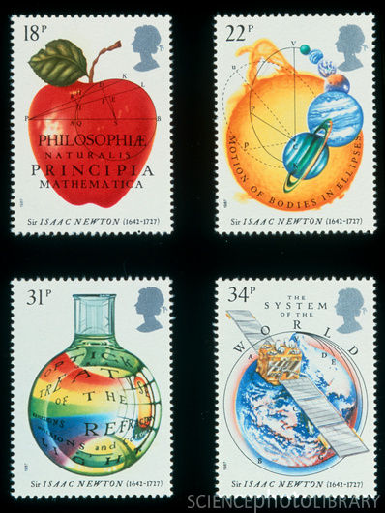
- Ground Rules
- Syllabus
- Piazza
- MyMathLab (Getting Started)
- Homework & Reading Assignments
- Team Homework Assignments (TW 1, TW 2, TW 3)
- Worksheets
- Essay Topics
- Groupwork
- Tutoring Services and Schedule
- Practice Quizzes (Qz 1, Qz 2, Qz 3, Qz 4, Qz 5, Qz 6, Qz 7)
- Practice Tests (Test 1, Test 2)
- Mathematica Labs (Lab 1, Lab 2, Lab 3)
- Quiz Solutions (Qz 1, Qz 2, Qz 3, Qz 4, Qz 5, Qz 6)
- Test Solutions (Test 1, Test 2)
- Useful References (Greek alphabet; Mathematica tutorials & websites; supplementary texts)
- MIT OCW for Calculus
- Calculus testbanks: University of Michigan; Washington University St. Louis; University of Washington;
- History of Calculus
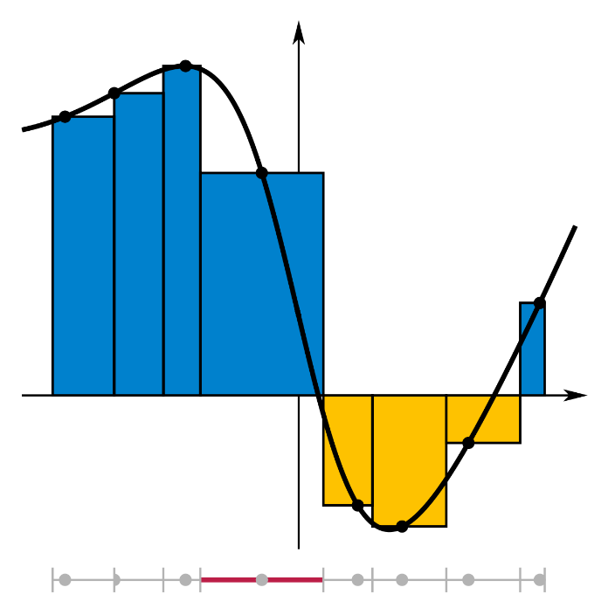

Department Home Page Loyola Home Page

