**Mathematica  Lab III**



Area and the Riemann integral

Due: 2nd December

Submit a *printed version* of your Mathematica notebook. You may work with other students and compare results, but ultimately you must submit *your own* lab results --- not a shared copy. On your front page (using Mathematica) state your name and “Mathematica Lab III” using an appropriate style, font, size and color. *Before solving each problem, state the problem. Remember to staple!*

**I** For each of the following area problems, begin by graphing the curves to see what they look like and how many points of intersection there are. Use FindRoot to find the points of intersection. The area between *f* and *g* over the interval [a, b] equals

NIntegrate[Abs[f[x]-g[x]], {x, a, b}].

1. Find the area between the curve g(x) = x4 – 15x3 + 54x2 + 26x – 257 and the x-axis.
2. Find the area between the curves y = 2 cos(9x) and y = 5x.
3. Find the area between the curves y = x + sin(2x) and y = x3.
4. Find the area between the curves y = x2cos x and y = x3 – x.

**II** (This exercise is due to G. Thomas.) [Karl Weierstrass](http://www-groups.dcs.st-and.ac.uk/~history/Mathematicians/Weierstrass.html)’ example of a continuous function that is *nowhere* differentiable is given by an infinite series



Infinite series will be explored in Math 162. However, we can learn a great deal about an infinite series by examining its first few terms. In the case of the famous Weierstrass example, let

FK(x) = 

(A) Plot *FK* for several small values of K (say, K = 1, 2, 3, 4, 5) for a suitable domain. Observe how the graph of *FK* is both “wiggly” and “bumpy.”

(B) Next, graph the *derivative of f* on another set of axes. Make a couple of observations.

*But just as much as it is easy to find the differential of a given quantity, so it is difficult to find the integral of a given differential. Moreover, sometimes we cannot say with certainty whether the integral of a given quantity can be found or not.*

- Johann Bernoulli

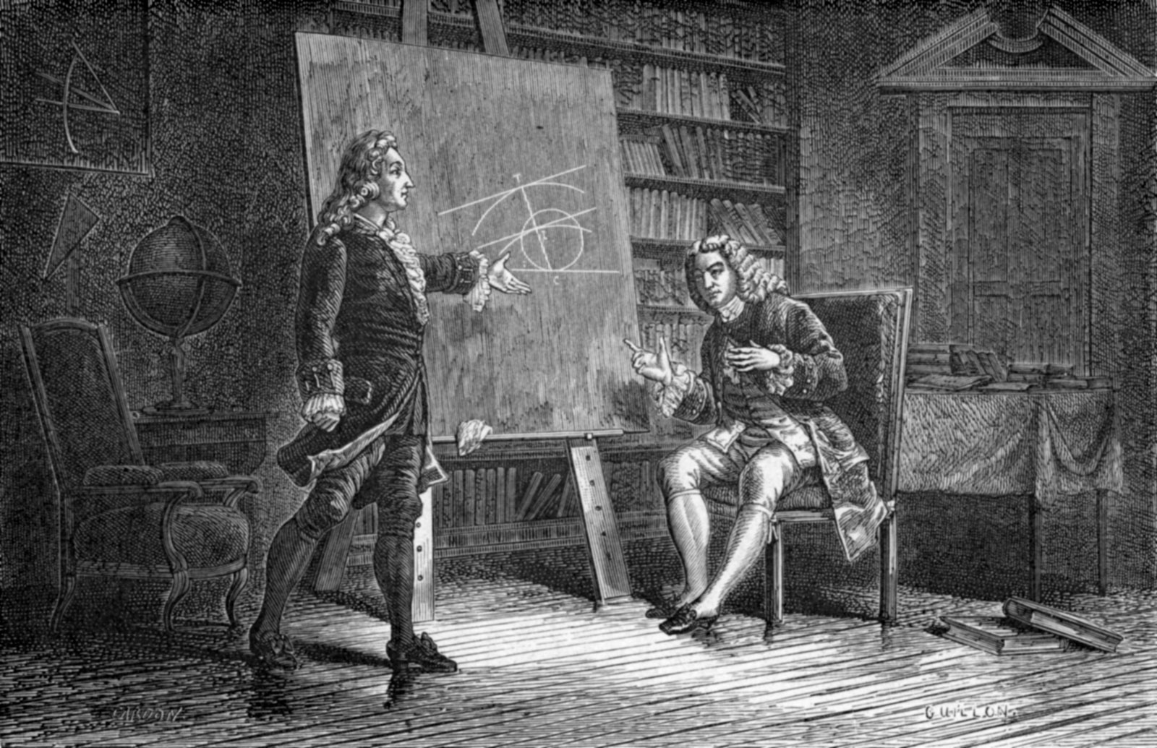

[***Johann and Jacob Bernoulli working together***](http://www.britannica.com/EBchecked/topic/62606/Johann-Bernoulli)

[Course Home Page](http://www.math.luc.edu/~ajs/courses/161fall2015/index.pdf)          [Department Home Page](http://www.math.luc.edu/)        [Loyola Home Page](http://www.luc.edu/)