# Math 161 Practice FINAL EXAM C

# 

# PART I (*6 pts each*) *Answer any 17 of the following 21 questions.* You need not justify your answer. You may answer more than 17 to obtain extra credit.

1. 

2. 

3.  where *a* and *b* are positive constants.



Compute *h*′′(e).

5. 

1. Solve the initial value problem:

 given that y = 2015 when x = 1.

7. Find an anti-derivative of 

1. Find an anti-derivative of:



9. 

10. Suppose that 



11. Find the *average value* of the function y = sec2 x over the interval [0, /4]. (Give the precise result without rounding.)

12. Find the value of *c* such that the conclusion of the Mean Value Theorem is verified for the function  on the interval [2, 5]. Express your answer to the nearest hundredth.

13. 

14. Let *a* and *b* be non-zero constants. 

Find the *slope of the tangent line* to y = f(x) at x = 0. (Your answer may include the constants *a* and *b*.)

15. Let *a* and *b* be non-zero constants. Then 

16. Suppose that  Find g(5).

 Find dy/dx when x = 1.



 (*Hint:* Convert this limit into a Riemann integral.)



21. Charlotte, the spider, lives on the x-axis. Suppose that at time t = 1 minute, she is at x = 5 cm, and that her velocity (in cm/minute) at time *t* is given by:

v(t) = 4t3 – 6t2 + 1. *Where* is Charlotte at time *t = 2 minutes*?

**PART II** *(12 pts each)*

## Answer any 11 of the following 14 problems. You may answer more than 11 for extra credit.

1. Find the equation of the tangent line to the curve defined implicitly by



at the point P = (2, 1).

2. Gilberte, who is 5 feet tall, walks away from an 18 foot lamppost. She observes that when she is 8 feet from the base of the lamppost, her shadow is increasing at a rate of 6 ft/min. Find Gilberte’s speed when she is 8 feet from the base of the lamppost.

3. Using an *appropriate tangent line approximation*, estimate the value of . Have you obtained an overestimate or an underestimate? Explain. *Sketch!*

4. Albertine wishes to approximate a root of g(x) = x4 + x – 1. Note that g(0) < 0 and g(1) > 0.

(a) How does Albertine know that there must exist a solution to g(x) = 0 in the interval (0, 1)?

(b) Let Albertine’s initial guess for the root be x1 = 0.5. Using Newton’s method, which values would she obtain for x2 and x3? (Express your answers to the nearest thousandth.)

5. Graph the function  Identify any and all local and global extrema and points of inflection.

6. Madam Verdurin is building an open planter in the shape of a rectangular box with a square base. The base is made of metal that costs $7 per square foot. The sides are made of wood that costs $3 per square foot. The planter must hold at least 8 cubic feet of dirt. Find the dimensions of the *least expensive* planter that Madame Verdurin can build.

7. The graph below shows the *RATE OF CHANGE* of the quantity of water in the Water Tower of OZ, in liters per day, during the month of April, 2015. The tower contained 12,000 liters of water on April 1. *Estimate* the quantity of water in the tower on April 30. Show your work.



8. Using the FTC, find the area bounded by the two parabolas:

*y = x2 – 5x* and *y = 20 + x – x2*. *Sketch.*

9. Use a *left-endpoint* Riemann sum with *n = 4* rectangles to approximate the area under the curve  between x = 0 and x = 2. Draw a picture to illustrate what you are computing. Is this an *underestimate* or an *overestimate* of the area? Explain!

11. Graph the cubic polynomial g(x) = x3 + x2 – 8x + 5. Identify any and all local and global extrema and points of inflection.

12. The function y = F(x) is defined below:



For which value(s) (if any) of *k* is the function *everywhere continuous*? Explain!

13. Albertine launches a model rocket from the ground at time t = 0. The rocket starts by traveling straight up in the air. The graph below illustrates the upward velocity of the rocket as a function of time.

(a) Sketch a graph of the *acceleration* of the rocket as a function of time.

1. Sketch a graph of the *height* of the rocket as a function of time.
2. Give an estimate of the *maximum height* the rocket achieved.

*14. (University of Michigan)*

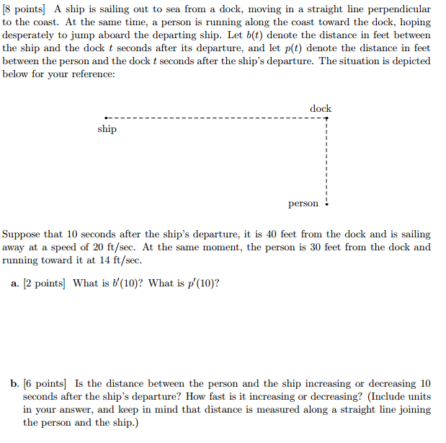

*But in the new approach, as you know, the important thing is to understand what you're doing, rather than to get the right answer.*

- [Tom Lehrer](http://en.wikipedia.org/wiki/Tom_Lehrer) (American singer-songwriter, satirist, pianist, and mathematician.)