Practice problems for QUIZ I (revised)

1. Label each of the following functions as “odd”, “even” or “neither odd nor even.” (You need not justify your answers.)

1. y = ln(1 + x4) + 1/(1 + x2)
2. y = x3 + sin(x5) + x cos x
3. y = 1 + x2 + x3
4. y = x5cosh x
5. y = (x + sinh x)2
6. For which non-zero value of *k* will the following quadratic equation have *only one* real root?

7x2 + kx + 3k = 0

1. Consider the following rational functions. For each function, determine the limiting behavior as x → ∞. Briefly explain how you arrived at your answers.
2. 

Answer: As x → ∞, y → __________

1. 

Answer: As x → ∞, y → __________

(c) 

4. Find an *equation* of a rational function whose graph is given below:

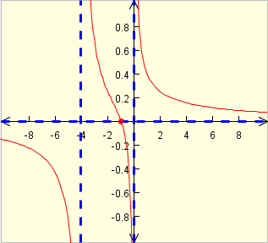

1. Sketch the graph of the following function (that includes all the significant properties):



1. Using an appropriate table (for example, letting x = 0.1, 0.01, 0.001, etc.) determine (to the nearest tenth) the behavior of the function  as x approaches 0 from the right. (*Show your work!*)

|  |  |
| --- | --- |
| ***x*** | ***f(x)*** |
| 1 |  |
| 0.1 |  |
| 0.01 |  |
| 0.001 |  |
| 0.0001 |  |
| 0.00001 |  |
| 0.000005 |  |

7. Compute each of the following limits. (Explain your reasoning. You may use estimation techniques, tables, graphing calculators, etc.)

(a) 

(b) 

(c) 

(d) 

(e) 

(f) 

1. 

8. *Estimate* the following limit by substituting appropriate values of *x*. (Show your results in tabular form. Give your answer to two decimal places.)



9. Use the graph below to find approximate values for each of the following limits (if they exist).













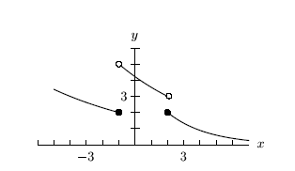

10. Calculate each of the following limits or explain why the limit does not exist. Justify each answer. If you use the *Squeeze Theorem*, be precise.

(a) 

(b) 

(c) 

(d) 

11. Compute each of the following limits or explain why the limit fails to exist. Justify your reasoning. (A calculator solution earns only partial credit.)

(a) 

(b) 

(c) 

(d) 

(e) 

12. Consider the rational function F defined by 

(a) Where is *F* *undefined*? (*Hint:* Your answer should consist of two *x* values.)

(b) Let *p* denote the smaller of the two numbers found in part (a). Is it possible to *extend* *F* to a function that is continuous at x = p? Explain.

(c) Let *q* denote the larger of the two numbers found in part (a). Is it possible to extend *F* to a function that is continuous at x = q? Explain.

13. Compute (showing your work):



14. Does the following limit exist? Explain why or why not.



15. Calculate each of the following limits. Briefly justify each answer.







16. Compute each of the following one-sided limits or explain why the limit doesn’t exist.





18. Let y = g(x) be defined as follows



1. Sketch the curve.
2. Compute each of the following or explain why the limit fails to exist.









19. Which, if any, of the following functions possess a limit as x→0? Briefly explain.

(a) y = 1/x

(b) y = sin (1/x)

(c) y = ln x

(d) y = exp(1/x)





20. Does there exist a *continuous extension* to the curve



at x = 1? If so, find it; if not explain!

21. Classify the *type of discontinuity* for each of the following:











22. Using an appropriate table, determine the behavior of the function f(x) = xln x as x approaches 0 from the right.

[*To be pleased with one's limits is a wretched state.*](http://www.quotationspage.com/quote/26267.html)

**-** [**Johann Wolfgang von Goethe**](http://www.quotationspage.com/quotes/Johann_Wolfgang_von_Goethe/)(1749 - 1832)