# MATH 161 Practice **QUIZ II**

1. Carefully state the *Squeeze Theorem*. Using the Squeeze Theorem compute each of the following limits:









2. (a) State carefully the *Intermediate Value Theorem*.

1. Using the Intermediate Value Theorem, explain why the polynomial function

g(x) = x5 – 4x3 + 3x – 1 has at least one real positive root *x*.

3. Compute . Show your work.

4. Compute  Show your work.

5. Carefully state the *Intermediate Value Theorem*. Let f(x) = 7 + 2x – x3 be defined on the interval [1, 3].

(a) Explain why *f* must assume the value 0 somewhere on this interval.

1. Must *f* assume the value -13 on the interval [1, 3]? Does the Theorem imply that *f* must assume the value 9.3 on the interval [1, 3]?

6. Compute  Show your work.

7. Compute  Have you made any assumptions about the constants *a* and *b*?

8. Charlotte the spider lives on the x-axis. Assume that Charlotte was born at time *t = 0* days and dies at time *t = 13* days. Her position at time *t* (days) is given by  feet.

1. Find Charlotte’s *position* at time t = 4 days.
2. When does Charlotte find herself to the *left of the origin*?
3. Find Charlotte’s *average velocity* during her lifetime.
4. Find Charlotte’s *average velocity* during the time interval 4 ≤ t ≤ 4 + h. *Simplify* your answer.

9. (University of Michigan problem)

.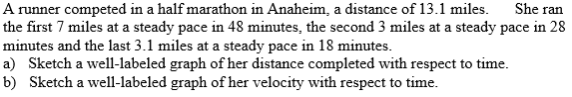

10. (University of Michigan problem)

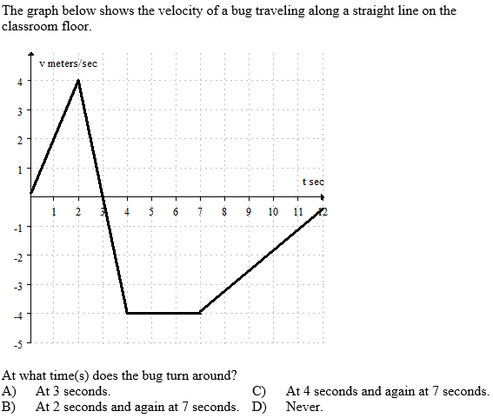

"Alice laughed: "There's no use trying," she said; "one can't believe impossible things."

"I daresay you haven't had much practice," said the Queen.

"When I was younger, I always did it forhalf an hour a day.

Why, sometimes I've believed as many as six impossible things before breakfast."

- Lewis Carroll, **Alice in Wonderland.**