# MATH 161 Practice **QUIZ III**

1. Using only the *definition* of derivative, find the derivative of the function

f(x) = ax2 + bx + c.

1. Using only the *definition* of derivative, find the derivative of the function

f(x) = x4 + 1789. (Here you may wish to use Pascal’s triangle to shorten your algebraic work.)

1. The parabola *y = x2 + x + c* is tangent to the line *y = 3x*.  Find *c*.  (Include a picture in your explanation.)

4. Find a parabola, y = ax2 + bx + c, that passes through the point (1, 4) and whose tangent lines at x = -1 and x = 5 have slopes 6 and -2 respectively.

5. Find equations of any (and all) tangent lines to the parabola y = x2 + 1 that have *x-intercept* of -4/3. Sketch.

6. Archy lives on the x-axis. His position at time *t* (hours) is

*s(t) = 4t3 – 15t2 + 12t + 1* (cm).

Assume that he was born at time t = 0.

1. What is Archy’s *position* at time t = 1?
2. What is Archy’s instantaneous *velocity* at time t = 1?
3. When is Archy moving *toward the left*? (Give one or more time intervals.)

7. The quantity, *Q* mg, of nicotine in the body *t* minutes after a cigarette is smoked is given by *Q = g(t).*

(a) Using a complete sentence, interpret the statement g(20) = 0.36.

(b) Using a complete sentence, interpret the statement g′(20) = -0.002.

(c) Using the information that you obtained above, estimate g(23).

8. Consider the function 

Find any and all points (only their x-coordinates) at which the tangent line to y = f (x) is horizontal. (You may assume that df/dt = 6x2 – 6x – 12)

9. The cost of extracting *T* tons of ore from a copper mine is *C = F(T)* dollars.

(a) Using a complete sentence that avoids mathematical terminology, explain the meaning of F(2000) = 300,000. (Include appropriate units.)

(b) Using a complete sentence that avoids mathematical terminology, explain the meaning of F′(2000) = 131. (Include appropriate units.

(c) Using the information above, estimate the cost of extracting 2,125 tons of ore from the mine.

10. Albertine travels from Chartres to Mt. Saint Michelle at an average speed of 50 km/hr. She returns to Chartres at an average speed of 60 km/hr. What is Albertine’s *average speed* during the roundtrip?

11. Given the following graph of y = f(x), use “geometric differentiation” to sketch the graph of dy/dx.

(If you wish to know, the equation of this curve is y = x5 + sin (21x) – 4x3 )



12. Given f(x) = x3 – 6x2 + 9x – 5.

(a) Find the slope of the tangent line to the curve at x = -2. (You may assume that df/dx = 3x2 – 12x + 9.)

(b) What is the equation of this tangent line?

(c) What is the equation of the normal line at x = -2.

(d) Find all points where the curve has a horizontal tangent.

13. Using only the definition of derivative, find the derivative of the function $g\left(x\right)=\frac{1}{\sqrt{x+1}}$ at x = 3. Next, find the equation of the tangent line to this g(x) at x = 3.

14. Show why (d/dx) sin x = cos x.

15. Does the curve y = x3 + x + 1 ever have a horizontal tangent line? If so, where?

16.

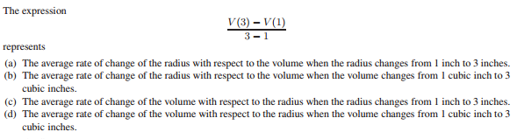

17.

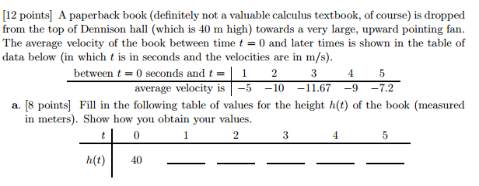

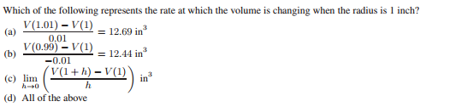

18.

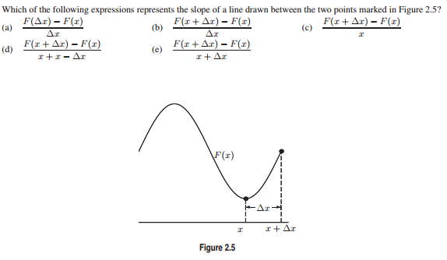

19.



20.

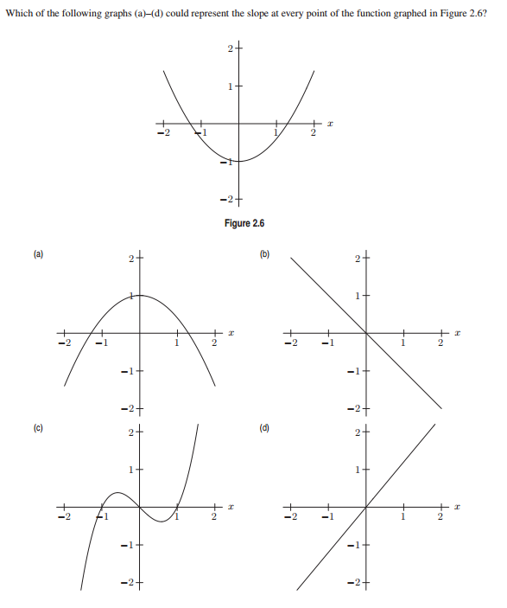

21.

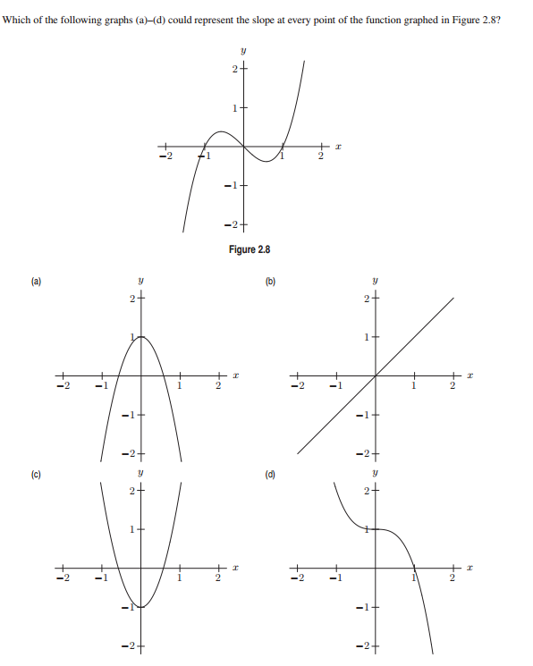

22.

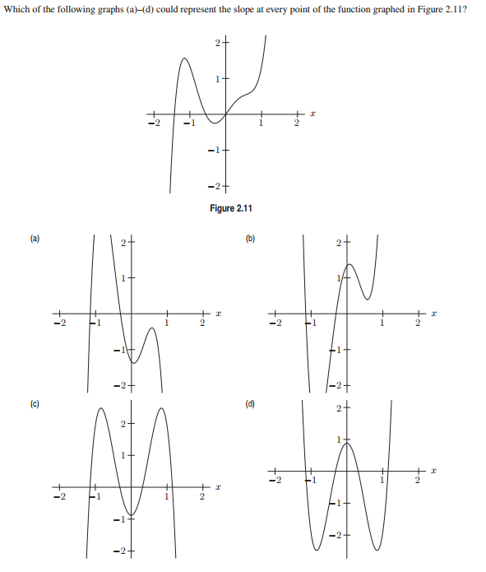

23.

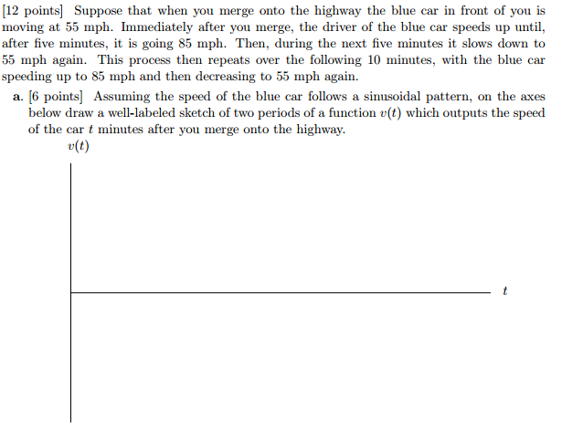

*What we call the beginning is often the end*

*And to make an end is to make a beginning.*

*The end is where we start from.*

- T. S. Eliot*, Little Gidding*