**Practice Quiz VII**

1. Solve each of the following initial value problems:







1. Solve the initial value problem:

 given that y = 2015 when x = 1.

3. Solve the differential equation:



4. (a) State **Rolle’s Theorem**.

1. Using Rolle’s Theorem, prove that the function

g(x) = (x – 2) ln (x + 1) + x sin(4x)

has *at least one* critical point between x = 0 and x = 2? Explain!

5. (a) State the **Mean Value Theorem**.

(b) Show how the Mean Value Theorem applies to the function

*f(x) = 4 + ln x* on the interval [1, e3]. Sketch! Find explicitly the *c* value.

6. Explain why any two anti-derivatives of a function F(x) must differ by a constant.

7. List three important consequences of the MVT

8. Define the function G on the interval [-1, 2] as follows:



(a) Explain why *G* satisfies the hypotheses of the Mean Value Theorem on the interval [-1, 2]. Sketch!

(b) Determine the value of *c* for the function *G* on the interval [-1, 2] that is guaranteed by the Mean Value Theorem.

9. Given the graph of y = F′(x) below, sketch the graphs of y = F′′(x) and y = F(x).

*y = F′(x)*



14. Compute each of the following sums. Simplify your answers as much as possible.

(a) 

(b) 

(c) 

15. Verify the following indefinite integral formula (by differentiating):



16. Verify the following indefinite integral formula (by differentiating):



17. Let f(x) = 1 + x2. Estimate the area beneath the graph of *f* above the interval

[2, 4] using four rectangles of equal base length using (a) left-end points, (b) right-end points, and (c) midpoints.

18. Using five rectangles, estimate the area under the curve y = ln x, 1 ≤ x ≤ 3. First find an underestimate and then an overestimate of the area. Sketch.

19. Using rectangles, estimate the *average value* of each of the following functions above the given interval:

(a) f(x) = sin x, [0, ]

(b) g(x) = x3, [0, 2]

(c) h(x) = ln x, [1, 5]

20. Below is the graph of the derivative, F′(x), of a function F(x).

1. Sketch the graph of F′′[x].
2. Sketch the graph of F[x]. Indicate local max/min, regions of increase/decrease, regions where *F* is concave up/down, and all inflection points.



21. Suppose that Charlotte, living on the x-axis, finds herself at the origin at time t = 0. In addition, assume that that her velocity (in ft/min) at time *t*, 0 ≤ t ≤ 10, is given by:



Where is Charlotte at time t = 3 minutes? t = 6 minutes? t = 10 minutes?

22. Newton’s method problems

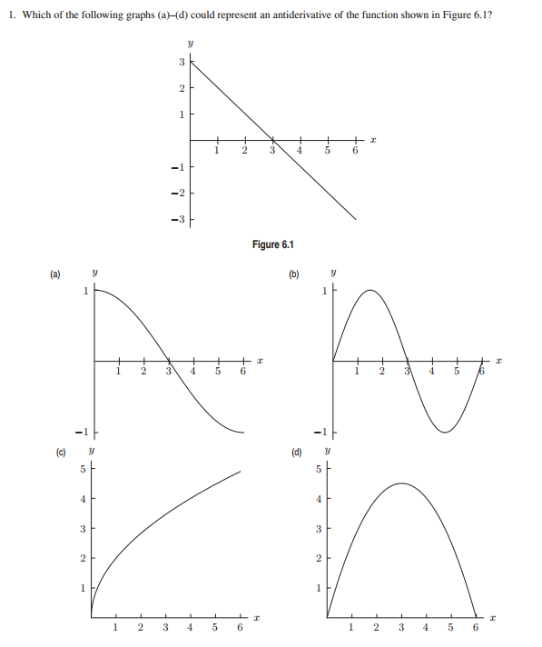

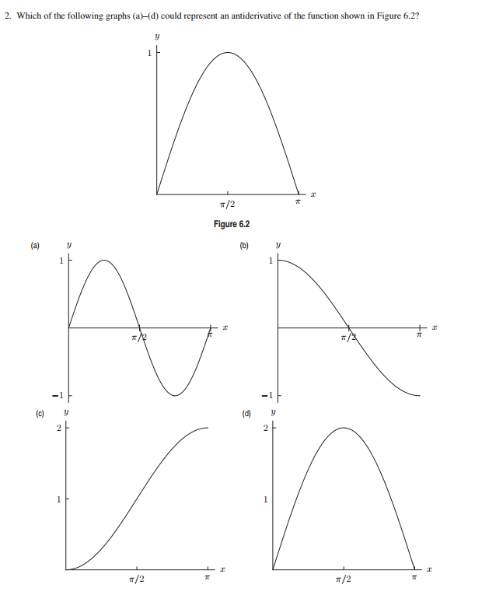

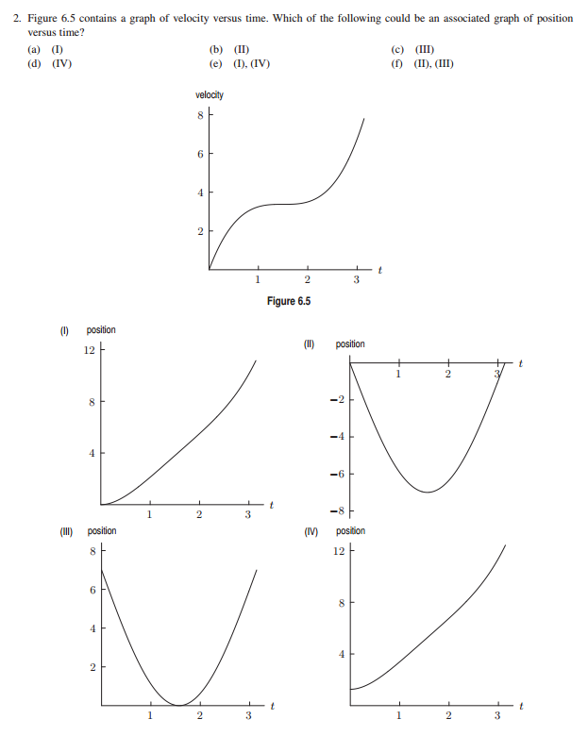



[*What we call education and culture is for the most part nothing but the substitution of reading for experience, of literature for life, of the obsolete fictitious for the contemporary real.*](http://www.quotationspage.com/quote/8289.html)

**- George Bernard Shaw**