# Practice problems for TEST I

# revised



Using *only the definition of derivative*, compute dy/dx.

2. Consider the graph of the function  given below:

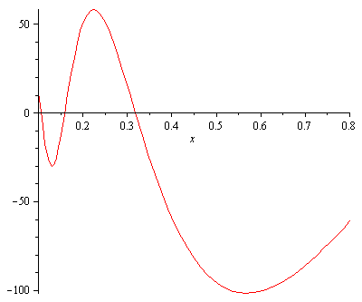

Using the method of “geometric differentiation,” sketch the graph of the function

y = g′(x).

3. Using *only the definition* of the derivative, find the equation of the tangent line to the curve  at x = 2.

4. Estimate the derivative of the following function at x = 3 by constructing an appropriate table. (Give your answer correct to two significant digits.)



5. Using the process of “geometric differentiation,” sketch the graph of the derivative of the function y = G(x) whose graph is given below:



6. Using *only the definition of the derivative*, find the *slope of the tangent line* to the curve



at x = 1. Show your work!

7. For which value(s), if any, of the constant *b* will the line y = 8x – 5 be tangent to the parabola y = x2 + 2x + b ? Sketch. Show your work.

8. Compute each of the following limits or explain why the limit fails to exist. Justify your reasoning. (A calculator solution earns only partial credit.)

(a) 

(b) 

(c) 

(d) 

9. Compute (showing your work):



10. Consider a sphere of volume *V* cm3. Express the surface area of the sphere as a function of its volume. Recall that the volume of a sphere of radius *R* is given by (4/3 )R3 and the surface area of a sphere of radius *R* is given by 4R2.

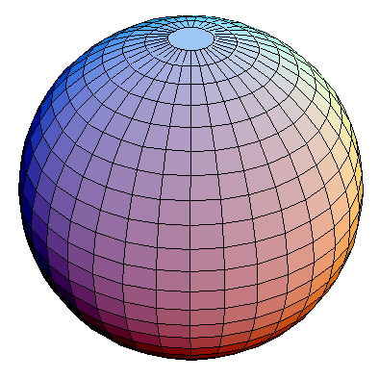

11. Consider the rational function *F* defined by 

Find the domain of *F*.

12. Charlotte the spider lives on the x-axis. Assume that Charlotte was born at time t = 0 minutes and dies at time t = 500 minutes. Her position at time *t* (days) is given by  inches.

(a) Find Charlotte’s *average velocity* during her lifetime.

(b) Find her *instantaneous velocity* at time t = 5  days.

(c) Find her *acceleration* at time t = 5  days.

(d) During which portion(s) of her lifetime is Charlotte traveling toward the right?

13. Let G(x) = x sin x. Using an appropriate table, *estimate* the slope of the tangent line to y = G(x) at x = 3. (*Hint:* Begin by writing down the definition of G′(3). Be certain to set your calculator to radian mode.)

14. Sketch the graph of the rational function . Be certain to display any and all vertical and horizontal asymptotes.

15. Without using a calculator, compute



16. Find dy/dx for each of the following functions. You may use shortcuts! (You need not simplify your answers.)

1. 
2. 
3. 
4. 
5. 
6. y = 13 ex + xe
7. y = 3 sec x + 4 tan x
8. y = sinh x
9. y = cosh x
10. y = tanh x
11. y = e + 99
12. y = tan x sec x

17. Consider the function 

Find all points (only their x-values) at which the tangent line to y = f (x) is horizontal. (You may use the rules of differentiation.)

18. Find the equation of the *normal line* to the following curve at x = 0.



19. Let F(x) = x3(x – 1) (x – 2).

(a) Using precalculus techniques, sketch the curve y = F(x).

(b) Using calculus, determine regions of increase, regions of decrease, local/global max/min.

(c) Explain the geometric significance of each of the three *critical points.*

20. Let g(x) = x4 ex.

(a) Using precalculus techniques, sketch the curve y = g(x).

(b) Using calculus, determine regions of increase, regions of decrease, local and global max/min.

21. The cost of extracting *T* tons of ore from a copper mine is *C = F(T)* dollars.

(a) Using a complete sentence that avoids mathematical terminology, explain the meaning of F(2000) = 300,000. (Include appropriate units.)

(b) Using a complete sentence that avoids mathematical terminology, explain the meaning of F′(2000) = 131. (Include appropriate units.)

(c) Using the information above, estimate the cost of extracting 2,125 tons of ore from the mine.

22. Using the *rules of differentiation* compute the derivative of each of the following functions. (You need not simplify your answers.)

(a) 

(b) y = 3 sin x + 4 cos x + e5

(c) 

(d) y = x3 tan x + ex sec x

23. *(Thomas)* A 45-caliber bullet shot straight up from the surface of the moon would reach a height of s = 832 t – 2.6 t2 ft after *t* seconds. On Earth, in the absence of air, its height would be s = 832t – 16t2 after *t* sec. How long will the bullet be aloft in each case? How high will the bullet go?

24. Calculate each of the following limits or explain why the limit fails to exist.















*(Hint: In (d) and (e), relate the limit to the definition of a particular derivative.)*

25. (a) State carefully the *Intermediate Value Theorem*.

1. Using the Intermediate Value Theorem, prove that the polynomial function g(x) = x4 – 7x2 + x + 5 has *at least one real negative* root x.

26. Assume that Charlotte, who chooses to live on the y-axis, is located at *y(t) = 3 cos t + 4 sin t* cm at time *t* (measured in minutes).

(a) Find her position at times t = 0, t = /2, and t = 

(b) Find her velocity when t = 0, t = /2, and t = 

(c) Find her acceleration when t = 0, t = /2, and t = 

27. Consider the function defined by:



Is there a value of *c* for which this function is continuous at x = 0? Explain.

28. Consider the function defined by:



1. Is there a value of *b* for which this function is continuous at x = 0? Explain.
2. Is there a value of *b* for which this function is differentiable at x = 0? Explain.

29. Let f and g be differentiable functions satisfying:

f(1) = 3, g(1) = 4, f ′(1) = 2, g′(1) = 5

Calculate the derivative at x = 1 for each of the following functions:

1. 3f – 5g + 9
2. f g
3. f/g

30. Show that differentiability of a function y = g(x) at x = p implies continuity of g at x = p.

31. Does there exist a *continuous extension* to the curve



at x = 1? If so, find it; if not explain!



32. Archy lives on the x-axis. Graphs of his *position*, *velocity* and *acceleration* during the time interval -0.7 < t < 4.3 appear below. Which is which? Explain.



33. Let *m* be a positive integer and *f* be a differentiable function.

(a) Using the product rule (only), discover a formula for the derivative of the function g(x) = (f(x))m.

(b) Using the formula that you obtained in (a), differentiate each of the following functions. [Do not use the Chain Rule, which we have not yet studied!]

(i) y = cos3 x

(ii) y = 5(sinh x)9

(iii) y = tan2015 x

(iv) y = e13x

(v) 

34. Find an equation of the *normal line* to the following curve at x = 0.



35. Classify the *type of discontinuity* for each of the following:













36. Let 

1. Sketch the curve y = g(x) using precalculus techniques.
2. Compute dy/dx. Use this information to determine the local maxima and minima of this function as well as regions of increase and decrease.
3. Sketch the curve and identify all local extrema.

37. Let 

1. Find dy/dx.
2. Find d2y/dx2.
3. Find d3y/dx3.

38. Let f(x) = sin(13x). Suppose that Albertine can prove that

d/dx (sin 13x) = 13 cos 13x and that d/dx cos 13x = -13 sin 3x.

Compute f (1789)(x).

39. Using the basic product rule, discover a formula for the derivative of the product of three functions: f(x)g(x)h(x).

40. What (if anything) can you say about the derivative of an even function? an odd function? Explain.

41. (a)   Define  cosh x.

(b)    Prove the identity:      2 (cosh x)2 = cosh (2x) + 1

42. At t = 0, Albertine’s plane takes off from Bordeaux headed toward Nice.  The flight normally takes 1 hour and 15 minutes.  However, due to poor weather conditions in Nice, the plane is forced to circle the Nice airport an additional 30 minutes before finally landing.  Sketch a graph that represents Albertine’s distance to Bordeaux ( in km) as a function of time t (hours).  (Assume that the distance between Bordeaux and Nice is roughly 780 km.)

43. Sketch the graph of the rational function . Be certain to display any and all vertical and horizontal asymptotes.

Determine each of the following:

* *Zeroes:*
* *Singularities:*
* *Sign Analysis:*
* *Limiting behavior:*

44. Mehitabel, the cat, lives on the x-axis. Her position (in centimeters) at time *t* (minutes) is given by the function x(t) = t2 + t.



(a) Find the *average velocity* of Mehitabel over the interval 1 < t < 2.

(b) Find the *average velocity* of Mehitabel over the interval 0.9 < t < 1.

(c) Calculate, using the definition of derivative, the *instantaneous velocity* of Mehitabel at time t = 1 minute.

45. For each of the following questions show your work!

(a) Solve the equation  Hint: This is a quadratic in disguise.

(b) For which value of *k* will the following quadratic equation have *only one* real root?

4x2 + (10+2k)x + 5k = 0

46. Compute each of the following limits. Show your work.

(a) 

(b) 

(c) 

(d) 



47. The graph of a function y = g(x) is given below.

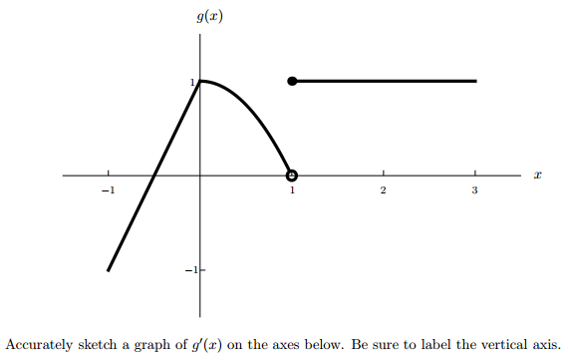

48. Let P(d) be a function expressing the total electricity that a solar array has generated,

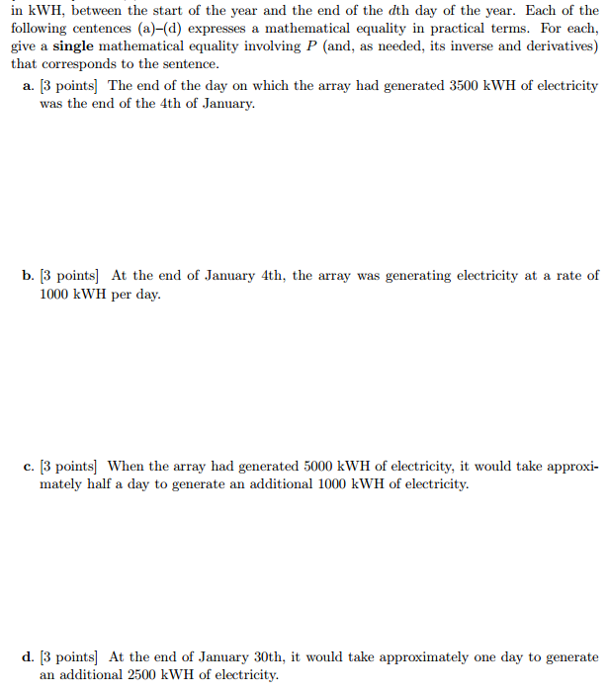

# *The quarrel [between Newton and Leibniz] is simply the expression of evil weaknesses and fostered by vile people. Just what would Newton have lost if he had acknowledged Leibniz's originality? Absolutely nothing! He would have gained a lot. And yet how hard it is to acknowledge something of this sort: someone who tries it feels as though he were confessing his own incapacity. ... It's a question of envy of course. And anyone who experiences it ought to keep on telling himself: "It's a mistake! It's a mistake! -- "*

# - Ludwig Wittgenstein (1947)