# MATH 161 Solutions: QUIZ I

1. [10 pts] The graph of a rational function is shown below.

Assume that

Zeros: x = 0, x = 3

Singularities: x = -2, x = -4

Limiting behavior: y → 3 as |x| → ∞

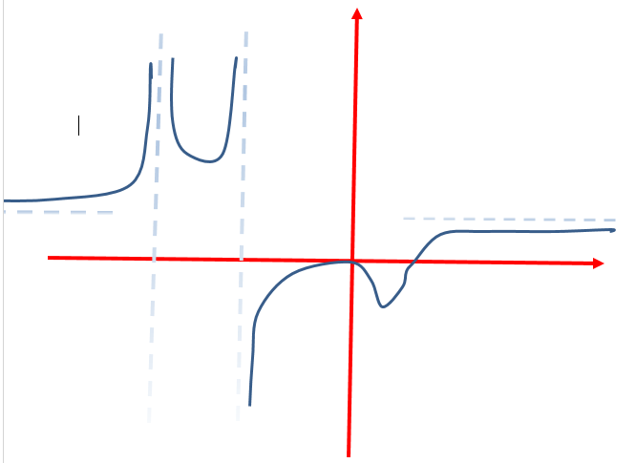

Find an equation of a rational function that incorporates all of this information. (Note that this problem may have more than one correct answer.)

*Solution:*

*Given the information about the zeros, we find that x and x + 3 must be factors of the numerator. Given the information about the singularities, x + 2 and x + 4 must be factors of the denominator.*

*Since the zero at x = 0 does not create a sign change, we find that x2 or any even power of x, must a factor of the numerator. Since the singularity at x = -4 also results in no sign change, we find that (x + 4)2 or any even power of x + 4, must be a factor of the denominator.*

*So our first guess is:*



*Noting that the value of y as x → ∞ is 1, we have only to make one change:*



2. [5 pts each] Compute each of the following limits. (*Explain your reasoning*. You may use estimation techniques, tables, graphing calculators, etc.)



*Solution: Observe that:*





*Solution:*





*Solution:*

*Observe that, as long as x ≠ 5:*





*Solution: We begin by rationalizing the numerator of the algebraic expression,*



3. [10 pts] Does there exist a *continuous extension* to the curve



at x = 1? If so, find it; if not explain! (Hint: Factor first.)

*Solution: Let’s begin by factoring, noting that the denominator is a difference of two squares.*



*Now, as x →1, we can cancel the x – 1 factor occurring both in the numerator and the denominator. So, for x ≠ 1*

**

*Now, as x →1, g(x) → 2/4 = ½ .*

*Thus x = 1 is a removable discontinuity, and we should assign the value of ½ to g(1).*

*4. [3 pts each] Identify the type of discontinuity that each of the following functions has at x = 0. (Choose from: removable, infinite, jump, or essential discontinuity.) You need not justify your answers.*

(a) 

*Solution: Since the limit of y as x→0 from the right is ¼, but the limit of y as x→0 from the left is -¼, the discontinuity at x = 0 is a jump discontinuity.*



(b) 

*Solution: Since the numerator tends toward 5 and the denominator tends toward 0, the limit does not exist. This is an infinite discontinuity*



(c) 

*Solution: Since  it follows that y → 0 as x → 0. Hence the discontinuity is removable.*



(d) 

*Since  the discontinuity is infinite.*



***Extra Credit:***

(*University of Michigan* Calculus problem (first exam, 7 Oct 2014)

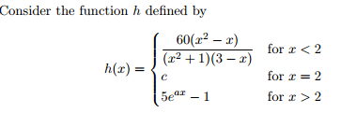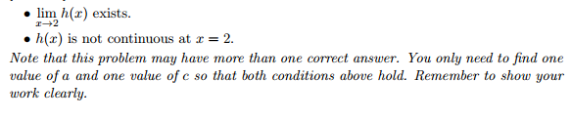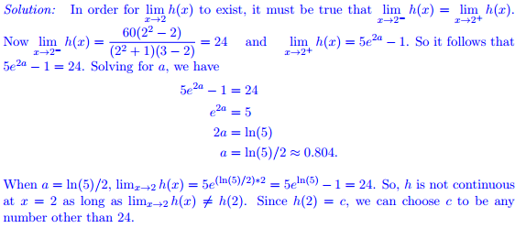

*O dear Ophelia!*

*I am ill at these numbers:*

*I have not art to reckon my groans*.

- HAMLET (Act II, Sc. 2)