# **MATH 161 Solutions: QUIZ II**

# 

1. [8 pts] *[University of Michigan]* Albertine has found a job as captain of a ship. She is making a round trip voyage between two ports. The ship sets sail from Port Jackson at noon, arrives at Port Kembla some time later, waits there for a while, and then returns to Port Jackson. Let s(t) be the ship’s distance, in kilometers, from its starting point of Port Jackson, *t* hours after noon. A graph of d = s(t) is shown below.

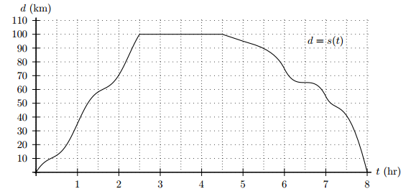

1. How far is Port Kembla from Port Jackson?

100 km

1. How long does the ship wait in Port Kembla?

2 hours

1. What is the ship’s average speed from Port Jackson to Port Kembla?



Since this number is positive, it also represents the average speed.

1. What is the ship’s average speed during the return trip from Port Kembla to Port Jackson?



Since speed is the magnitude of velocity, the average velocity is 22.73 km/hr.

**2.** [4 pts each] Evaluate each of the following limits. *Justify your answers.*



*Solution: Here we need the Squeeze Theorem.*

**

*Thus:*

**

*Since 1/x →0 and -1/x →0, the Squeeze Theorem asserts that, as x→∞,*

*(sin 9x)/x →0*



*Solution:*





*Solution:*





*Solution: Here we need the Squeeze Theorem once again.*

**

*Thus:*

**

*Since 1/x4 →0 and -1/x4 →0, the Squeeze Theorem asserts that, as x→∞,*

*((sin3x)/x)4 →0*

*Next note that*



Finally, using the law of limit of sums, we obtain

**



3. (a) [4 pts ] *Carefully* state the *Intermediate Value Theorem*.

Theorem: Let y = f(x) be a continuous function on an interval [a, b]. Let z be any number between f(a) and f(b). Then there exists a number c in the interval [a, b] for which f(c) = z.

(b) [5 pts] Using the IVT explain why the function f(x) = x5 – 2x2 + x + 3 must have at least one root.

*Solution: First remember that every polynomial is continuous on the real line, Note that f(0) > 0 and that f(-3) < 0. Now view f as a continuous function on [-3, 0]. The IVT asserts that there exists a number c between a and b for which f(c) = 0.*

**4**. [4 pts] Using the *Squeeze Theorem*, show that the function



has a limit as x → 0 and find the value of this limit. (You need not state the general theorem; only show how it can be applied here.)

*Solution: Here we need the Squeeze Theorem once again.*

**

*Thus:*

**

*Since 1/x3 →0 and -1/x3 →0, the Squeeze Theorem asserts that, as x→∞,*

*(sin3 2014x)/x →0*

5. [4 pts] Swann is making hot chocolate one morning in his unheated cottage while visiting Paradise, Michigan, in the winter. He heats it for ten minutes, during which time its temperature increases at a constant rate from 2 C to 80 C. Let H(t) be the temperature in C, of the chocolate, t minutes after Swann begins heating it.

Find a formula for H(t) which is valid for 0 < t < 10.

*Solution: Since we are told that the temperature increases at a constant rate, H(t) must be a linear function. Its slope is*



Since the y-intercept of H = H(t) is 2, the equation for H is

H(t) = 7.8 t + 2, for 0 < t < 10.

*"It's very good jam," said the Queen.*

*"Well, I don't want any today, at any rate."*

*"You couldn't have it if you did want it," the Queen said. "The rule is jam tomorrow and jam yesterday but never jam today."*

*"It must come sometimes to ‘jam to-day,’” Alice objected.*

*"No it can't," said the Queen. "It's jam every other day; today isn't any other day, you know."*

*"I don't understand you," said Alice. "It's dreadfully confusing."*

- Lewis Carroll, **Through the Looking Glass**