# **MATH 161 SOluti0ns: QUIZ III**

**1.** *[12 pts; University of Michigan]*  For the graph of y = f(x) in the figure below, arrange the following numbers from smallest to largest:

**A** The slope of the curve at A.

**B**  The slope of the curve at B.

**C** The slope of the curve at C.

**AB** The slope of the line *AB*.

1. The number 0.
2. The number 1.

Explain the positions of the number 0 and the number 1 in your ordering. Any unclear answers will not receive credit.

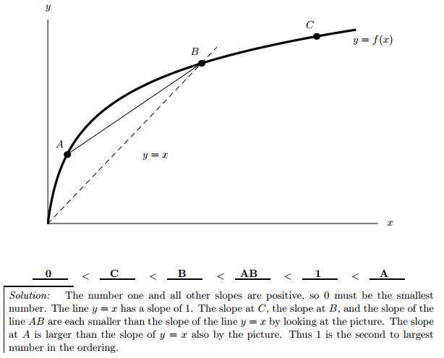

**2.** (a) [10 pts] Using *only the definition of the derivative*, find the slope of the tangent line to the curve  *at x = 1*. Show your work!

*Solution:*



1. [3 pts] Using the result obtained in part (a), write an equation of the normal line to the curve y = G(x) at x = 1.

*Solution: Since the point of tangency is (1, 3) and the slope of the tangent line is 1/6, the slope of the normal (perpendicular) line is -6. An equation of the normal line is y – 3 = -6(x – 1)*

**3.** [8 pts] Below is the graph of G(x) = x + x1.3 cos(2x) sin x defined on the interval [1.57, 7]. On the axes beneath the graph of *G*, sketch the graph of the derivative function, y = G′(x).



**4.** *[University of Michigan problem]* The Twitter Celebrity Index (TCI) measures the celebrity of Twitter users; the function T(x) takes the number of followers (in millions) of a given user and returns a TCI value from 0 to 10. Below is a graph of this function.

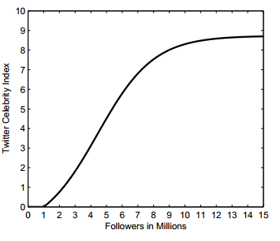

Use the graph above to help you answer the following questions. *Use complete sentences!*

1. (3 pts) Explain in practical terms what T(13.72) = 8.67 means.

*When a Twitter user has 13.72 million followers, s/he has a Twitter Celebrity Index of 8.67.*

1. (3 pts) Explain in practical terms what T-1(4.25) = 4.88 means.

*When a Twitter user has Twitter Celebrity index of 4.25, s/he has 4.88 million followers.*

1. (3 pts) Explain in practical terms what T ' (10) = 0.2278 means.

*When a Twitter user has 10 million followers, adding 100,000 followers will increase her TCI by roughly 0.02278.*

**Extra Credit**

The curves y = x2 + ax + b and y = cx – x2 have a common tangent line at the point P = (1, 0). Find *a*, *b* and *c*.

*Hint:* Recall the following result: (d/dx) ( x2 +  x + ) = 2  x + 

*Solution:*

*Since each parabola passes through (1, 0), we must have:*

*0 = 1 + a + b and 0 = c – 1*

*Thus a + b = -1 and* ***c = 1****.*

*Now the slope of the first parabola at x = 1 is dy/dx = 2x + a (at x = 1) = 2 + a*

*And the slope of the second parabola at x = 1 is dy/dx = c – 2x (at x = 1) = c – 2.*

*Since the two parabolas share a common tangent at (1, 0), we must have:*

*2 + a = c – 2.*

*Hence a = c – 4 = 1 – 4 = -3.*

*Finally, b = -1 – a = -1 – (-3) = 2.*

*Summarizing:* ***a = -3, b = 2, c = 1***

*Below is a sketch of the two parabolas and their common tangent*

*line at (1, 0).*



*It's very good jam," said the Queen.*

*"Well, I don't want any today, at any rate."*

*"You couldn't have it if you did want it," the Queen said. "The rule is jam tomorrow and jam yesterday but never jam today."*

*"It must come sometimes to ‘jam to-day,’” Alice objected.*

*"No it can't," said the Queen. "It's jam every other day; today isn't any other day, you know."*

*"I don't understand you," said Alice. "It's dreadfully confusing."*

- Lewis Carroll, **Through the Looking Glass**