MATH 100 TEST I 25 September 2015

Name: __________________________

Part I
Instructions: [6 pts each] Answer any 11 of the following 13 questions. (You may answer more than 11 to earn extra credit.) For each problem be certain to show your work! You may use your calculator, but you still must show your reasoning!

1. Compute the value of (b + 99a + 2015)⁰ + (a + 2b)² – (b – 2a)⁹⁹ when b = 2 and a = 1. Simplify your answer fully.

2. Compute the value of 7(1 + x²)³ when x = -3.

3. If p snow plows clear q streets in d days, how many days does it take for one snow plow to clear one street?
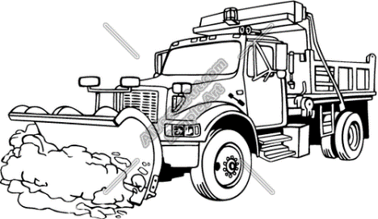

4. Multiply (a + b + c) by (a – b – c) and simplify if possible

5. Solve for x: (3x + 1)(2x + 1) = (x +3 )(6x + 3) – 14

6. Convert the following quotient to scientific notation:
169,000,000 / 0.00000013

7. If pumpkins sell at 5 for $16 dollars and Halloween candy sells at 17 bags for $10, how much will it cost to buy x pumpkins and y bags of candy?
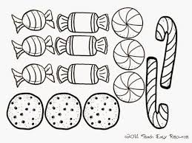

8. Subtract x⁴ – 8x³ + 2x² – 3x + 1 from x⁴ + 11x³ – x² + 4x – 4 and simplify your result.

9. Simplify fully: (a⁴b⁶c)³ (a²b³c⁵)²(abc)

10. Find the Greatest Common Divisor of the expression
99a⁵b⁶c⁷ – 88a⁴b⁷c⁶ + 110a⁸b⁵c⁶
(You need not factor the original expression.)

11. Multiply x + 2 by x² – 2x + 4. Simplify your answer.

12. Albertine purchases a bicycle from the great REI sale for $199. The bike’s price had been reduced by 17 %. What was the list price of the bike? (Disregard tax.)

13. Solve for t: 2{3 + 4(5 – 6t)} = -170

Part II
Instructions: [10 pts each] Choose any three of the following five problems. You may answer more than three to earn extra credit. Show your work!

- Solve for x: 3(5 – 6x) – 5[x – 5{1 – 3(x – 5)}] = 23

2. The sum of four consecutive odd integers is 8072. Find the smallest number.

- Ebenezer spent $112.80 in buying geese and ducks. If each goose cost 14 dimes and each duck 6 dimes, and if the total number of birds bought was 108, how many of each did he buy? (Guessing will receive very little credit, if any.)
Hint: Let x = number of geese purchased by Ebenzer. Then express the number of ducks purchased in terms of x.

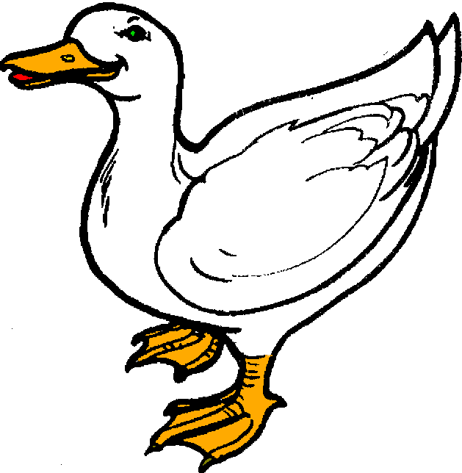

4. The sum of the ages of Archy and Mehitabel is 87 years; nine years hence Archy will be four times as old as Mehitabel. Find their present ages.

Hint: Let x = age of Archy now

5. Vladimir and Estragon are waiting for the arrival of an acquaintance. While waiting, they find employment as trash collectors on a local highway. Working alone, Vladimir can collect trash from two miles of highway in 30 hours. If Vladimir and Estragon work together, they can clean the two miles of highway in only 10 hours. How many hours would it take for Estragon, working alone, to collect trash on the two miles of highway? (You must show your work!)

There is something I don't know
that I am supposed to know.
I don't know what it is I don't know,
and yet am supposed to know,
and I feel I look stupid
if I seem both not to know it
and not know what it is I don't know.
Therefore I pretend I know it.
- R. D. Laing, Knots

