Math 161 - OLD Team Homework Assignment I
(an adaptation of a University of Michigan problem)
- Due Date: Wednesday, Oct 7th, at 5pm.
- Remember to follow the guidelines from the “Doing Team Homework.” Do not forget to submit the “reporter’s page” with the assignment
- Please show ALL work.
1. Albertine is a congenial calculus freshman attending Loyola. One afternoon, Albertine is walking back to her dorm from Metropolis Café and stoops to tie her shoe near the prairie in front of IES. She feels a light but assertive tap on the knee and hears a voice saying, “Excuse me, Albertine.” She looks up from her shoe but all she sees is a rather attentive rabbit peering at her. She looks around to see where the voice is coming from and hears it again, “Please, Albertine, we need your help.” This time, Albertine notices the voice is coming from the rabbit! Albertine sometimes gets light-headed when she drinks too much coffee so she sets about calculating how much coffee she had. Let F(t) be the total amount of coffee (in mL) that Albertine had consumed after t hours at Metropolis.
- Write a practical interpretation (using complete sentences) of the equation “F(2) = 400”.
- Describe the domain and range of F(t).
- Albertine calculates that she immediately had 200 mL of coffee when she first arrived at Metropolis and then 100 mL every hour thereafter. Write a formula for F(t).
- In her experience, Albertine has felt dizzy after drinking a liter of coffee. Calculate F⁻¹(1000) and give a practical interpretation (using complete sentences) of your solution.
2. Albertine was at Metropolis for only 2 hours, so she believes that she is probably not hallucinating and decides to hear the rabbit out. She sits down in front of the rabbit. “My name is Roger,” he begins, “and my people are in trouble.” Albertine soon learns that the population of rabbits in Roger’s land had been decreasing exponentially for the last 3 weeks. Let P(t) be the population of rabbits t days after Albertine and Roger meet. Three weeks ago, the population was 500 rabbits and it has been decreasing by 10% every week.
- Find a formula for P(t).
- Roger believes that his rabbit race will be extinct when only 1 rabbit remains. Just to be safe, he would like to save his race before the population drops below 2 rabbits. Calculate how long Albertine and Roger have to save the rabbits.
- Calculate the half-life of the rabbit population in Roger’s land.

3. Although Alberitine feels great empathy toward Roger’s plight, she still is a bit troubled by the fact that he can talk. She asks Roger if all rabbits in his land can talk. Roger tells her that a rabbit’s probability of being able to speak depends on how much attention the rabbit receives from Loyola students. He also explains that this relationshiop has been changing lately. Let f(x) be the probability that a rabbitl born prior to 3 weeks ago is able to talk if x students have paid attention to that rabbit in its lifetime. Below is a graph of the function f(x).
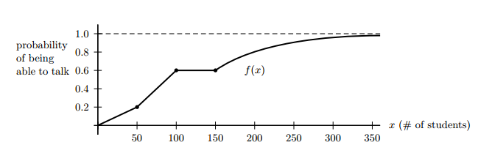

- Let g(x) be the probability that a rabbit born within the last 3 weeks is able to talk if x students pay attention to it during its lifetime. A graph of g(x) is given below.

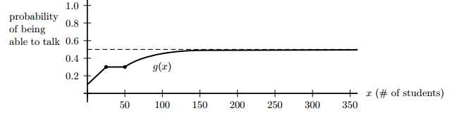
It turns out that, for x ≥ 0, g(x) can be expressed as a transformation of f(x). Find a formula for g(x) as a transformation of f(x). (For example, g(x) = 1 + 2 f(3x + 4), for x ≥ 0).
- How much attention is paid to a rabbit is proportional to the cuteness of the rabbit. (Note that we measure cuteness in terms of cuteness units.) Let h(y) be the number of students that pay attention to a rabbit over the duration of the rabbit’s life if the rabbit has y cuteness units. Give a practical interpretation (using complete sentences) of the expression g(h(8)).
- Find a formula for h(y) if a total of 100 students pay attention to a rabbit of 4 cuteness units during its life.
- Calculate f(h(6)).

4. Albertine is a very compassionate person, so she agrees to help Roger. Roger leads her to a tree near the Loyola El station where she notices a tiny doorknob on the trunk. Roger waves his tail in front of the knob and a small door appears. Another rabbit, dressed as a concierge, appears at the door. Roger tells Albertine that rabbits are exceedingly bright and only allow humans who are proficient in math to enter their secret world. So she will have to correctly answer a question before the concierge will shrink her to fit through the door. “The following scroll contains a table with the height you will be t minutes after I shrink you. Will your height be shrinking according to an exponential function of time, a linear function of time, or neither?”, asks the concierge before handing over a scroll. The data on the scroll is reproduced below. What answer should Albertine give? (Remember that you must explain your reasoning.)
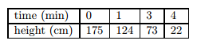
After satisfactorily answering the doorman’s question, Albertine gains access to the rabbit’s lair and begins her quest.

