Math 161 - Team Homework Assignment #5, Fall 2015
- Due Date: November 5 or 6
- Do not forget to rotate roles and include a reporter’s page each week.
- Show ALL your work.
- The city of Srebmun Foyoj sits next to a sea of lava, and the city’s citizens rely on this lava to keep them hydrated. There is an organization called Efilsi Aval whose job it is to control the amount of lava in the sea, and the lava level is a function of the annual budget of this organization. The table below shows the level ℓ(b) of the lava sea, in kilometers above a predetermined baseline level (PBL), for certain values of Aval’s annual budget b, in millions of dollars (negative values of b correspond to a budget deficit for Aval). Assume that ℓ is differentiable, that ℓ′ is continuous on the interval [−10, 10], and that both ℓ and ℓ′ are invertible.
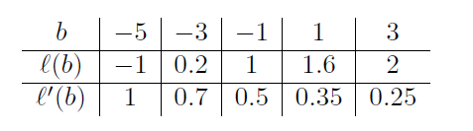
  - Compute the following quantities.

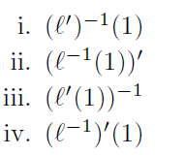
  - In the context of this problem, give a practical interpretation of the quantity you computed in part
(a)iv.
  - The lava engineer Elur Niahc does some calculations and concludes that to have enough lava to sustain the growing population, the lava level needs to be at least 2.1 kilometers above the PBL. Use a linear approximation to estimate what the budget of Aval needs to be to attain a lava level of 2.1 km above the PBL.
  - i. Is your estimate in part (c) an overestimate or an underestimate of the budget needed, or do you not have enough information to be sure? Explain. ii. What implications does this have for Aval and the citizens of Srebmun Foyoj?
- (a) Find all values of the constants c and d so that the function

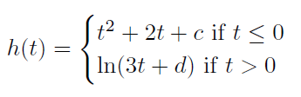
is differentiable for all values of t, or explain why no such values exist.
  - Find all values of the constant a so that the function
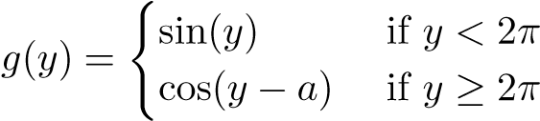.
is differentiable for all values of y, or explain why no such values exist.
  - Consider the function
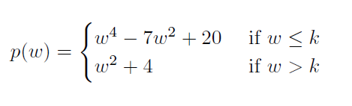
where k is a constant.
    - For which values of k is p(w) continuous for all values of w?
    - For which values of k is p(w) differentiable for all values of w?
- The graph of the implicit curve x²y² + xy = 2 is shown below.
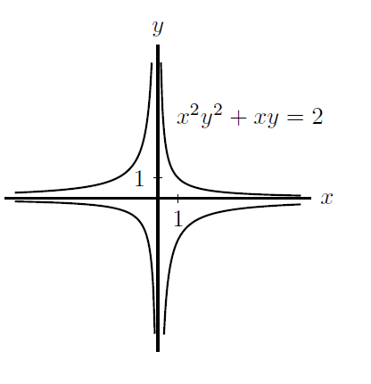

dy dx
- Find in terms of x and y.
- Consider the points 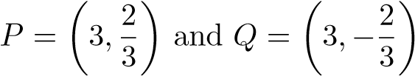. Determine which of these two points is on the curve, and find the equation of the tangent line to the curve at that point.
- Looking at the graph, it appears that this curve has no vertical tangent lines and no horizontal tangent lines. Show algebraically that this is the case.
- Find all points on the curve where the slope of the tangent line is equal to -1. (e) Find all points on the curve where the slope of the tangent line is equal to 1.
- Repeat parts (a), (c), (d), and (e) for the implicit curve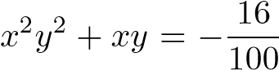, whose graph is shown below.

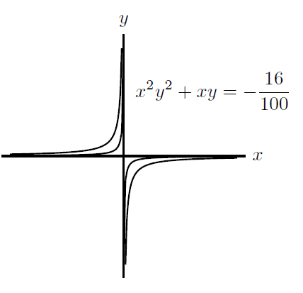x
- Consider the family of implicit curves x²y²+xy = a, where a is a constant satisfying a > −1/4. Can you find a value of a for which the curve has horizontal and/or vertical tangent lines?

