# MATH 161 Solutions: TEST I

# 

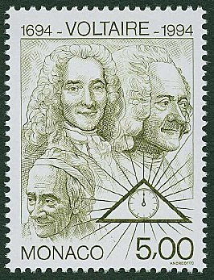

*The more you know, the less sure you are.*

**-** [Voltaire](http://plato.stanford.edu/entries/voltaire/)

1. *[University of Michigan]* For each of the following three sets of axes, exactly one of the following statements **(A)**-**(E)** is true. You may use a letter more than once. In the space provided next to each figure, enter the letter of the true statement for that figure. For each graph, note that the *x* and *y* scales are not the same.

*(A) h is the derivative of f, and f is the derivative of g.*

*(B)**g is the derivative of f, and f is the derivative of h.*

*(C)**g is the derivative of h, and h is the derivative of f.*

*(D) h is the derivative of g, and g is the derivative of f.*

*(E) none of (A) through (D) are possible*

(G1)

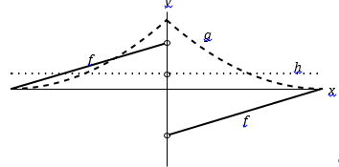ANSWER: __A_____

(G2)

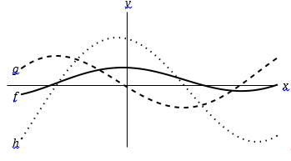 ANSWER: _E_______

(G3)

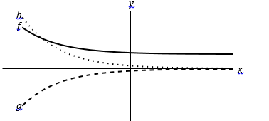ANSWER: _D_____

2. Consider the rational function 

(a) Find the *domain* of *f.*

*Solution: f(x) is defined for all real numbers except 5*

(b) Find the y–intercept of *f*.

*Solution: The y-intercept of f is f(0) = 0.*

(c) Find the zeroes of *f*.

*Solution: f(x) = 0 when x = 0, -1/3, -3/2*

(d) Find the vertical asymptote(s) of *f*.

*Solution:* A unique singularity occurs at x = 5; hence the only vertical asymptote is the line x = 5.

(e) Find the horizontal asymptote(s) of *f*.

*Solution:* For large |x|,



*Thus the only horizontal asymptote is the line: y = 144*

3. Albertine orders a large cup of coffee at Metropolis on Granville. Let F(t) be the temperature in *degrees Fahrenheit* of her coffee *t* *minutes* after the coffee is placed on her tray.

(a) Explain the meaning of the statement: F(9) = 167. (Use complete sentences. Avoid any mathematical terms!)

*Solution: Nine minutes after being served her coffee, Albertine finds that the coffee is 167 F.*

(b) Explain the meaning of the statement: F-1(99) = 17.5

*Solution: When the temperature of the coffee is 99 F, 17.5 minutes have elapsed since the coffee mug was placed on her tray.*

(c) Give the *practical* interpretation of the statement: F′(9) = – 1.10. (Use complete sentences. Do not use the words “derivative” or “rate” or any other mathematical term in your explanation.)

*Solution: Nine minutes after being served her coffee, Albertine notices that the temperature of the coffee is decreasing by about 0.11 F every tenth of a minute during the next minute or two.*

(d) What are the *units* of F′(9)?

*Solution: F/ minute (since F/ t represents change in temp/ change in time.)*

(e) Using the information given in parts (a) and (c), estimate the temperature of Albertine’s coffee seven minutes after she has been handed the coffee.

*Solution: Since after nine minutes the temperature is 167 F, we would estimate that two minutes earlier the temperature was 167 + 2(1.1) =* ***169.2 F****.*

(e) Extra Credit

Explain the meaning of the statement:

${\left(F^{-1}\right)}^{'}\left(99\right)=-1$

*Solution: When the temperature of the coffee is 99 F, the time required for the temperature of the coffee to fall to 98 F is one additional minute.*

4. The following function is *not* continuous at the points x = 5/2 and x = 4/3.



(a) *[6 pts]* Does *g* possess a *continuous extension* at x = 5/2? If so, how should g(5/2) be defined? If not, explain!

*Solution:*

*We begin by factoring:*



*If x ≠ 5/2, then cancellation yields:*



*So we see that x = 5/2 is a removable discontinuity.*

*To create a continuous extension to g at x = 5/2, we define g(5/2) as follow:*



(b) *[6 pts]* Does *g* possess a *continuous extension* at x = 4/3? If so, how should g(4/3) be defined? If not, explain!

*Solution:*

*We begin by noting that, when x ≠ 5/2,*



*Now, as x → 4/3, the numerator tends toward (4/3)3 (4/3 – 7) ≅ -13.43, but the denominator tends toward 0. Consequently, the limit of g(x) as x → 4/3 does not exist. (This is an infinite discontinuity.)*

5. *[University of Michigan]* Suppose

* 1. Using the limit definition of the derivative, write an explicit expression for $f^{'}\left(2\right).$ Your expression should not contain the letter “*f* ”. *Do not try to evaluate your expression.*

*Solution:*

* 1. Albertine discovers that the derivative of ${f\left(x\right) is f}^{'}\left(x\right)=\left(x+\frac{3}{2}\right)e^{x}$*.* Using this formula for *f* ′(*x*), write an equation for the tangent line to the graph of *f*(*x*) at *x* = 2.

*Solution: The slope is m = (2 +) e2 = e2 and the y-coordinate when x = 2 is*

*f(2) = $\left(2+\frac{1}{2}\right)e^{2}=\frac{5}{2}e^{2}$. Using the point-slope form for the tangent line, we obtain:*

* 1. *[3 points]* Write an equation for the tangent line to the graph of *f*(*x*) at *x* = *a* where *a* is an unknown constant.

*Solution: Employing virtually the same computation that we did in (b), we find:*

* 1. Extra credit Using your answer from (c), find a value of *a* so that the tangent line to the graph of *f*(*x*) at *x* = *a* passes through the origin.

*Solution: The point (0, 0) must satisfy the tangent line equation in (e). Hence*

$$0-\left(a+\frac{1}{2}\right)e^{a}=\left(a+\frac{3}{2}\right)e^{a}(0-a)$$

*Dividing each side by $e^{a}$ we obtain:*

$$-\left(a+\frac{1}{2}\right)=-a\left(a+\frac{3}{2}\right)$$

*So -2a – 1 = -2a2 – 3a*

*Simplifying: 2a2 + a – 1 = 0*

*Factoring: (2a – 1)(a + 1) = 0*

*Hence a = ½ or a = -1*

6. Compute each of the following limits. *Justify your reasoning.*



*Solution: Using the laws of limits:*





*Solution: Using the laws of limits:*





*Solution: For large values of x:*





*Solution:*



7. (a) *[6 pts]* Find an equation of the *normal line* to the curve

$y=g\left(x\right)=\frac{x^{2}-1}{x^{2}+1}$ at x = 1.

*Solution:*



Now, when x = 1, dy/dx = 

Hence the slope of the normail line is m = -1.

Also, note that g(1) = 0.

Using the point-slope form of the line: y – 0 = -1(x – 1)

or **y = 1 – x**

(b) *[6 pts]* Find an equation of the *tangent line* to the curve

y = F(x) = ex (x2 + 4x + 1) at x = 0.

*Solution:*



At x = 0, dy/dx = e0(4) + (1) e0 = 5.  
Also note that f(0) = e0 = 1.

So the equation of the tangent line at the point (0, 1) is given by:

y – 1 = 5(x – 0)

or y = 5x + 1

8. Identify the *type of discontinuity* that each of the following functions has at

x = 0. (Choose from: *removable, infinite*, *jump*, or *essential* discontinuity.) You need not justify your answers.

(a) 

***removable discontinuity*** *at x = 0*

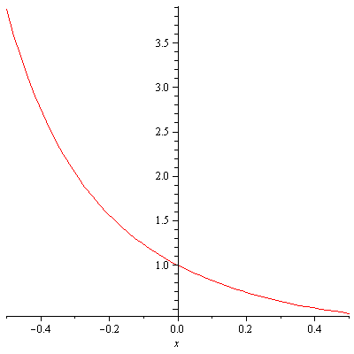

(b) 

***removable discontinuity*** *at x = 0*

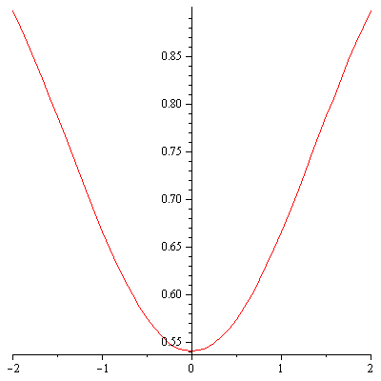

(c) 

***infinite discontinuity*** *at x = 0*

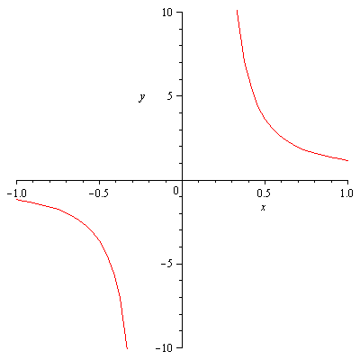

(d) 

***removable discontinuity*** *at x = 0*



9. (a) Let G(x) = a ebx, where *a* and *b* are non-zero *constants*.

Albertine, our friend, informs us that (d/dx) ebx = b ebx.

Find G (2015)(x).

*Solution:*

*G ′(x) = ab ebx*

*G ′(x) = (d/dx) G ′(x) = (d/dx) (ab ebx) = ab2 ebx*

*G′′′(x) = (d/dx) G ′(x) = (d/dx) (ab2 ebx) = ab3 ebx*

*G(4)(x) = ab4 ebx*

*G(5)(x) =a b5 ebx*

*Based upon this pattern, we infer that G (n)(x) = abn ebx*

*Thus G (2015)(2015) =* ***a b2015 e2015b***

(b) *[University of Michigan]* Your pet parakeet, Odette, is flying in a straight path that at first is toward you and then away from you for a minute. After *t* seconds, she is *f*(*t*) feet away from you, where

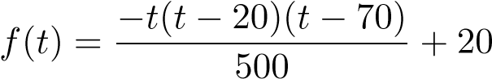*,* 0 ≤ *t* ≤ 60*.*

A graph of *y* = *f*(*t*) is shown below.

10

20

30

40

50

60

20

40

60

80

*y*

*t*

*f*

(

*t*

)

Without doing any calculations, determine which is greater: the *average velocity of Odette over the entire minute*, or her *instantaneous velocity at 30 seconds*. Explain, referring to the graph. (The absence of a clear explanation will result in no credit.)

*Solution:*

*The slope of the secant line from t = 0 to t = 60 is the average velocity over*

*the minute and the slope of the tangent line at t = 30 is the instantaneous velocity after 30 seconds. If you draw these lines on the graph, you can see that the tangent line clearly has a larger slope. Thus, Odette’s instantaneous velocity after 30 seconds is greater than her average velocity over the entire minute.*

10. (a) State carefully the *Intermediate Value Theorem* for a function y = G(x). *Provide a sketch that illustrates the statement.*

*Let y = f(x) be a continuous function on the interval [a, b]. Let u be any*

*number between f(a) and f(b). Then there exists a number c in the interval [a, b] such that f(c) = u.*

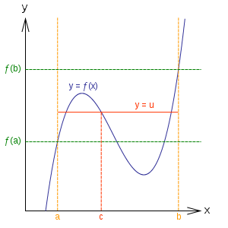

(b) Let G(x) = x5 – 5 – ln x. *Using the Intermediate Value Theorem*, carefully explain why the equation G(x) = 0 has *at least one* solution. (Your calculator is not needed here.)

*Solution:*

*Note that G(1) = 1 – 5 – ln 1 = -4 < 0 and G(e) =* e5 – 5 – ln e =

e5 – 6  *> 25 – 6 = 28 > 0.*

*Also note that G is continuous on the interval [0, ]. Since G(0) < 0 < G(e), the IVT guarantees the existence of a root of the equation G(x) = 0 in the interval*

*[0, e].*

11. Suppose that *f* and *g* are differentiable functions satisfying:

f(3) = -2, g(3) = -4, f ′(3) = 3, and g′(3) = -1.

1. Let H(x) = (f(x) + 2g(x) + 1)(f(x) – g(x) – 4). Compute H′(3)

*Solution: Using the product rule:*

*H′(x) = (f(x) + 2g(x) + 1) d/dx(f(x) – g(x) – 4) + (f(x) – g(x) – 4) d/dx(f(x) + 2g(x) + 1) = (f(x) + 2g(x) + 1) (f ′(x) – g ′(x)) + (f(x) – g(x) – 4)(f ′(x) + 2g ′(x) )*

*Thus H′(3) = (f(3) + 2g(3) + 1) (f ′(3) – g ′(3)) + (f(3) – g(3) – 4)(f ′(3) + 2g ′(3))*

*= (-2 – 8 + 1) (3 – (-1)) + (-2 – (-4) – 4)(3 + 2(-1) ) = (-9)(4) + (-2)(1) = -38*

1. Let  Compute M ′(3)

*Solution: Using the quotient rule:*



1. *[University of Michigan]* The graph of a function *h*(*x*) is given below.

−

4

−

3

−

2

−

1

1

2

3

4

2

3

4

*h*

(

*x*

)

*x*

1. *[2 point]* List all *x*-values with −4 *< x <* 4 where *h*(*x*) is not continuous. If there are none, write NONE.

*Solution: h(x) is not continuous at x = 1. Notice it is a jump discontinuity.*

1. *[2 point]* List all *x*-values with −4 *< x <* 4 where *h*(*x*) is not differentiable. If there are none, write NONE.

*Solution: h(x) is not differentiable at two points: x = 1 and x = 3.*

1. On the axes provided, carefully draw a graph of $y=h'(x)$. Be sure to label important points or features on your graph.

−

4

−

3

−

2

−

1

1

2

3

4

−

2

−

1

2

3

*x*

*h*

′

(

*x*

)

 