# MATH 161 Solutions: TEST II

*Instructions: Answer any 12 of the following 14 questions. You may answer more than 12 to earn extra credit.*



*The calculus is one of the greatest edifices constructed by mankind.*

- Cambridge Conference on School Mathematics

1. Pozzo is determined to use L’Hôpital’s rule to solve each of the following two limit problems. Show that Pozzo will succeed. (Be sure to give the value of this limit.)

1. Consider the following limit:







1. Using l’Hôpital’s rule, compute the following limit:







*2.*  Evaluate each of the following indefinite integrals (using the method of *judicious guessing*). Simplify when possible. Show your work.

(a) 

First guess: 

(b) 



(c) 

First guess: 

(d) 

First note that:





3. A parameterization of the *limaçon (represented by the graph below)* is given by

x(t) = (1 + 2 sin t) cos t, y(t) = (1 + 2 sin t) sin t.

Find the *point* P = (x, y) and the *slope* of the tangent line to the *limaçon* when t = 0.

(The word "limaçon" originates from the Latin *limax*, meaning "snail.")



4. Consider the curve y = x3e-4x. Perform all three “stages” in the curve-sketching process. On the graph, identify all local and global extrema and points of inflection. Calculate *explicitly* the x-coordinates of each such point (i.e., local extrema d inflection pts).



Solution:

dy/dx = 3x2e-4x - 4 x3e-4x = x2 (3 – 4x) e-4x



**Answers:**

zero(s): x = 0

asymptote(s): y = 0

critical point(s): x = 0, 3/4

behavior as x → ∞: y → \0

behavior as x → - ∞: y → - ∞

local max at x = 3/4

local min: none

global max at x = 3/4

global min: none

inflection point(s)



5. Consider a window the shape of which is a rectangle of height *h* surmounted by a triangle having a height *T* that is two times the width *w* of the rectangle (see the figure below which is not drawn to scale). If the total area of the window is 5 square feet, determine the dimensions of the window which minimize the perimeter.

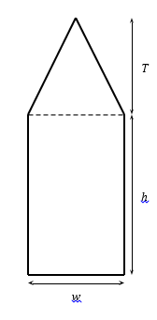

*Solution:* From the statement of the problem, we have *T* = 2*w* and adding the areas of the triangle and the rectangle, we have the total area of the window to be

*A* = *wh* + 0*.*5*Tw* = *wh* + *w*2 = 5*.*

Solving for *h*, this gives *h* = 5*/w* − *w*. To calculate the perimeter of the window, we must calculate the length, *ℓ*, of the two sides of the triangle which lie on the perimeter. By the Pythagorean theorem, we get



Now the perimeter of the window is



Setting the derivative of *P* equal to zero, we have

*.*

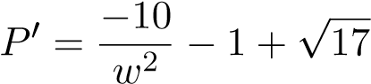

Which means



is our only critical point.

The second derivative of *P* is 20*w*−3 which is positive for all *w >* 0. This means *P* is concave up everywhere. Since we only have one critical point, it must be a global minimum. Therefore the dimensions which minimize the perimeter of the window are

,



**6.** The figure below is the graph of a differentiable function y = f(x) and the line *tangent to the graph* at the point P= (8, 2).



1. Approximate f(8.01). Is your approximation an *over* or *under*-estimate? Explain.

*Solution: The slope of the tangent line to the curve y = f(x) at P = (8, 2) is*

*(4 – 2)/(8.3 – 8) = 20/3.*

*Thus the equation of the tangent line at P is y = 2 + (20/3) (x – 8).*

*To approximate f(8.01) we compute the y-value of the tangent line at x = 8.01. This will be an* ***overestimate*** *since the tangent line lies above the graph of*

*y = f(x). Now f(8.01) ≈ 2 + (20/3) (0.01) = 31/15 ≈* ***2.0667***

1. Let h(x) = (f(x))4. Evaluate dh/dx at x = 8.

*Solution: Using the Chain Rule, dh/dx = 4(f(x))3 f ′(x).*

*At x = 8, dh/dx = 4(f(8))3 f ′(8) = 4(2)3 (20/3) = 640/3 =* ***213.3***

**7.** Harvey Swick is planning to build a rectangular garden in which to grow pumpkins. Two opposite sides of the garden will be bordered by lilacs which cost $70 per meter. The other pair of opposite sides will be bounded by a wooden fence that costs $100 per meter. The area enclosed by his garden must be 400 square meters. Harvey wishes to minimize his expenditures on shrubs and fencing. What are the dimensions of the garden that *minimizes his total cost*? (Be certain to identify your variables, draw a diagram, and use appropriate units.)

You needn’t compute the final result; just find a function of one variable which needs to be minimized.

*Solution: Let x be the length (in meters) of (one of the two) sides that is planted with lilacs, and let y be the length (in meters) of (one of the two) sides to be fenced.*

*Then the total cost is C(x, y) = 2(70x + 100y) dollars.   
The area is fixed, so we have xy = 400 square meters.*



*Our goal is to minimize C. To express C as a function of x alone, we replace y by 400/x in the equation for C to obtain:*

*C = C(x) = 2(70x + 40000/x) = 20(7x + 4000/x).*

*Clearly, 0 < x < ∞ is the domain of C.*

*Here is the completed solution:*



*To determine local/global extrema, we compute:*

*dC/dx = 20(7 – 4000/x2)*

*Factoring:*

**

*Hence C is increasing on  and decreasing on *

*Thus, applying the first derivative test, a global minimum is achieved when x =  meters. For the optimal x-value, we find that y =meters.*



***8.***  Let g(x) = x3 (x – 2)2 be defined on [-1, 2.2].

(a) Why must g possess a global max and a global min?

*Answer: Since g(x) is continuous on [-1, 2.2], a closed and bounded interval, the Extreme Value Theorem guarantees the existence of a global max and a global min on*

*[-1, 2.2].*

(b) Find all the *critical points* of *g*.

*Solution:*

*Differentiating:*

*g' (x) = x3 2(x – 2) + 3x2 (x – 2)2 = x2(x – 2) (2x + 3(x – 2) ) =*

*x2(x – 2) (5x – 6 )*

*Setting g' (x) = 0, we obtain the critical points x =* ***0, 6/5,*** *and* ***2****.*

1. *Classify* each of the *critical points* and *endpoints* as local max, local min, or neither.

*Solution: Endpoint x = -1 local and global minimum*

*x = 0 is neither*

*x = 6/5 is a local and global maximum since g(1.2) > g(2.2)*

*x = 2 is a local minimum*

*Endpoint x = 2.2 is a local maximum*

1. Find any and all *points of inflection*. Express your answers to the nearest hundredth.

*Solution:*

Applying the general product rule:

g'' (x) = 2x (x – 2)(5x – 6) + x2(5x – 6) + x2(x – 2)5 =

x { 2(x – 2)(5x – 6) + x(5x – 6) + 5x(x – 2)} =

x{10x2 – 32x + 24 + 5x2 – 6x + 5x2 – 10x} =

x(20x2 – 48x + 24) = 4x (5x2 – 12x + 6)

*Setting g'' (x) = 0 and using the quadratic formula, we find that*

*g'' (x) = 20x( x – 0.71)(x – 1.69).*

*Performing a sign analysis on g'', we find that g'' < 0 on the intervals (-1, 0) and (0.71, 1.69).*

*Hence there are three inflection points: x =* ***0,*** *x =* ***0.71*** *and x =* ***1.69***

(e) Sketch a graph of y = g(x). Label all local and global extrema. Show regions of increase and decrease. Show regions where the function is concave up and concave down.



Arrows point to global max and global min. (These are also local extrema.) The other local extrema are indicated by the symbol

**9.** Harry the potter has a *fixed* volume of clay in the form of a cylinder. As he rolls the clay, the length of the cylinder, *L*, increases, while the radius, *r*, decreases. If the length of the cylinder is increasing at a constant rate of 0.2 cm per second, find the rate at which the radius is changing when the radius is 1.5 cm and the length is 4 cm.

*Solution: We are given that dV/dt = 0 (since the potter has a fixed volume of clay) and dh/dt = 0.2.*

*We know that V =  r2 h. Since each of r and h is a function of time, we may differentiate to obtain:*

*0 = dV/dt =  r2 (dh/dt) + 2rh (dr/dt)}.*

*Thus 0 = 0.2 r2 + 2rh (dr/dt).*

*When r = 1.5 and h = 4, we find that:*

*0 = 0.2(1.5)2 + 2(1.5)(4) (dr/dt)*

*Hence dr/dt = -1.5/8 =* ***-0.0375 cm/sec***



**10.** Sketch the graph of the function  defined on the domain x > 0. Find the x-coordinates of *all local and global extrema* (if any) as well as *inflection points* (if any). On your graph label all local/global extrema and inflection points.

*Solution:*

*Stage I: Begin by noting that g is always positive (for x > 0) and thus has no zeroes. Furthermore, as x → 0+, y → ∞, and as x → ∞, y → ∞.*

*Stage II: Computing the derivative of g:*

**

*Solving for critical points, we find that x = (8/3)1/5  ≈ 1.217 is the only critical point. This is a* ***global minimum****!*

*Also there is no global maximum.*

*Stage III: Computing the second derivative of g:*

**

*Hence g is always concave up, and there are no inflection points.*



*\*

11.  The figure below is comprised of a ***rectangle* *and four* *semi-circles***. Units of length are given in meters.

|  |  |
| --- | --- |
|  | (a) Find a formula for the enclosed area, *A*, of the figure in terms of *x* and *y*.  *Solution: A = xy + (x/2)2 +  (y/2)2 =*  *xy + ( /4) (x2 + y2)*  *\* |

(b) Find a formula for the perimeter, *P*, of the figure in terms of *x* and *y*. (Note: The perimeter does *not* include the dashed lines.)

*Solution:* *P =  x +  y =  (x + y)*

*(c)*  Find the values of *x* and *y* which will *maximize* the area if the perimeter is 200 meters.

*Solution:* *Solving for y in part (b): y = P/ – x = 200/  – x*

*Substituting this expression for x in part (a):*

*A = (200/ – x) x + ( /4) x2 + ( /4) (200/ – x)2*

*= (200/ x – x2 + ( /4)x2 + ( /4) (200/ – x)2*

*= ( /2 – 1) x2 + (200/ – 100)x + 10000/*

*Note that the domain of A is given by 0 ≤ x ≤ 200/ *

*Computing dA/dx:*

*dA/dx = ( – 2) x + (200/ – 100) =*

*( – 2) x + (100/ )(2 – ) =*

*( – 2)(x – 100/)*

*The unique critical point of A is x = 100/.*

*Note that when x < 100/, dA/dx < 0 and when x > 100/, dA/dx > 0. Hence A achieves a local and global* ***minimum*** *at the critical point. Thus the maximum of A must be achieved at an end point. Because of symmetry, the value of A at each end point is the same.*

*Thus the maximum value of A is achieved when the figure reduces to a circle.*

*Here is a graph of A as a function of x.*



*\*

1. Find two *non-negative* real numbers, whose sum is 13, such that the product of one number and the square of the other number is a *maximum*.

*Solution: Let x and y be the two numbers we seek, with x 0, y 0.*

*We are given that x + y = 13.*

*We must maximize P = xy2 .*

*Replacing x by 13 – y, we obtain:*

*P(y) = (13 – y)y2*

*Now dP/dy = (13 – y) 2y + (-1)y2 = 26 – 3y2*

*Solving for critical points: 3y2 = 26 *

*Since y must be non-negative, we reject the negative root.*

*So and *

**13.** Vladimir and Estragon are 3 miles offshore in a kayak and wish to keep a rendezvous with Lucky and Pozzo at a location 7 miles down a straight shoreline from the point nearest the kayak. They can paddle at a rate of 2 mph and walk at a rate of 6 mph. *Where* should Vladimir and Estragon land their kayak to keep their rendezvous if they hope to *minimize* the time spent on their journey?

You should find a function of one-variable that needs to be minimized. You do not need to solve for the optimal solution.

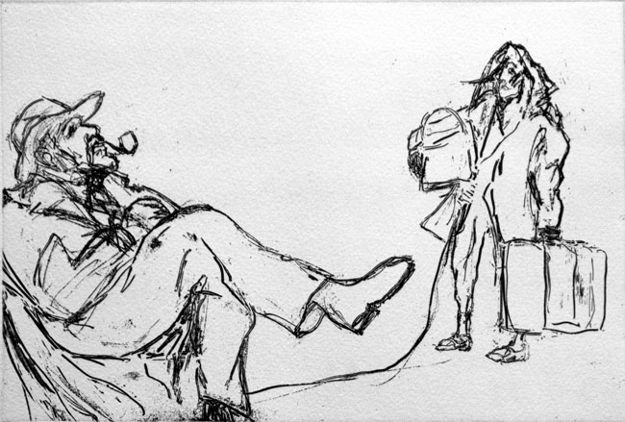

*14.* For positive *A* and *B*, the force between two atoms is a function of the distance, *r*, between them:

*r >* 0*.*

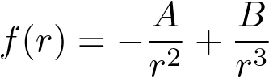

* 1. Find the zeroes of *f* (in terms of *A* and *B*).

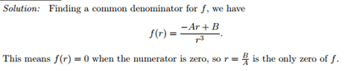

* 1. Find the coordinates of the critical points and inflection points of *f* in terms of *A* and *B*.

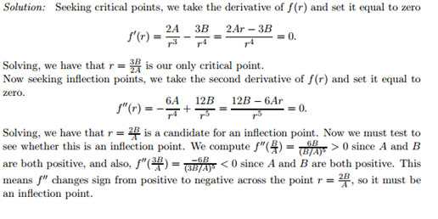

* 1. If *f* has a local minimum at (1*,*−2) find the values of *A* and *B*. Using your values for *A* and *B*, justify that (1*,*−2) is a local minimum.

