# MATH 161 Solutions: TEST III (revised)

# 

**Part I** *[5 pts each]*

1. Which of the following graphs (a)–(d) represents the area under the line shown in the figure below as a function of *x*?

*y*

1

2

3

4

5

1

*x*

(a) *y* (b) *y*

2

5

4

3

1

1

2

3

4

5

*x*

3

1

2

4

5

1

2

3

4

5

*x*

1

2

3

4

5

*x*

*y*

c

)

(

1

2

3

4

5

*x*

*y*

d

)

(

1 2 3 4 5 1 2 3 4 5

ANSWER: (a) Because the graph shown is that of a positive constant, the area will be directly proportional to the length of the interval.

1. Which of the following graphs (a)–(d) represents the area under the line shown in the figure below as a function of *x*?

*y*

1

2

3

4

5

1

2

3

4

5

*x*

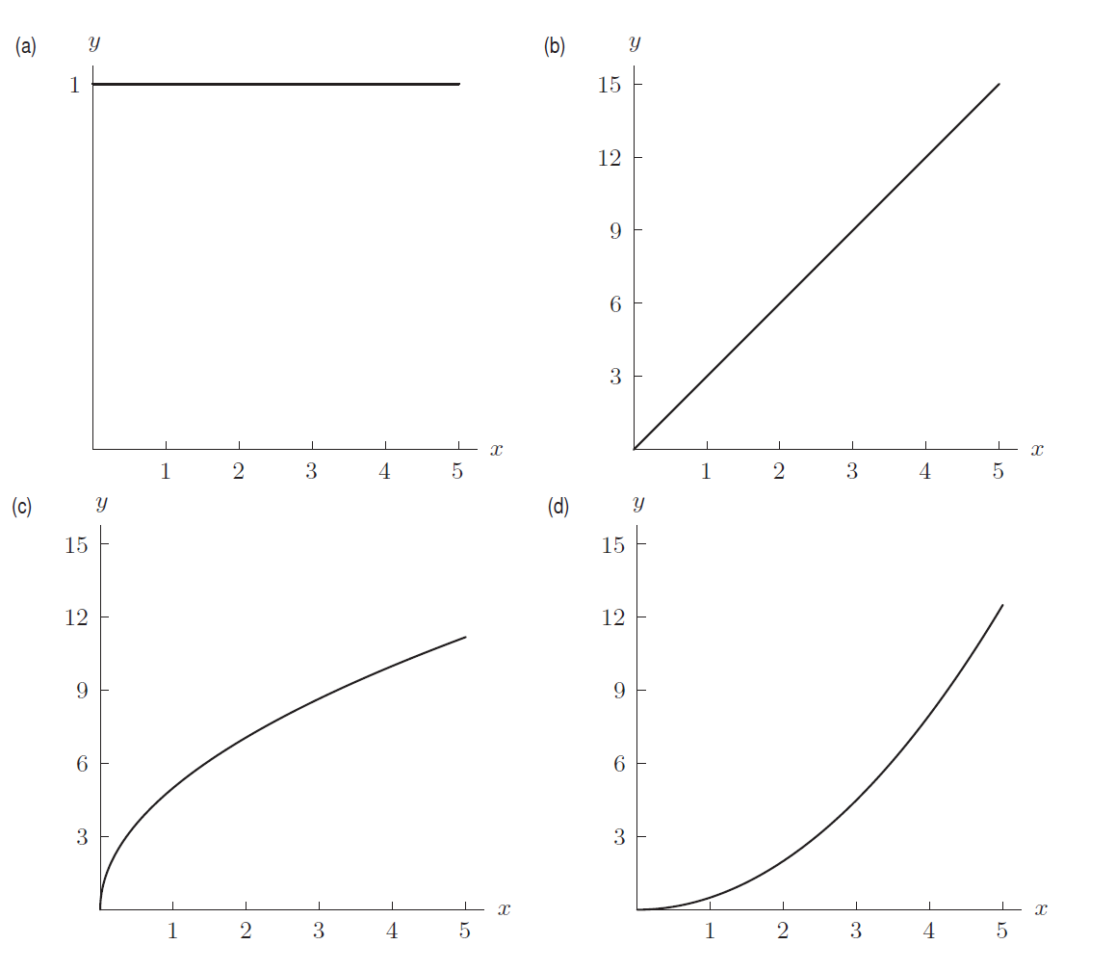

ANSWER: (d) Because the graph in the figure is positive and increasing, its antiderivative is increasing and concave up.

1. Consider the area between the two functions shown in figure below. Which of the following graphs (a)–(d) represents this area as a function of *x*?

*y*

1

2

1

2

3

4

*x*

.

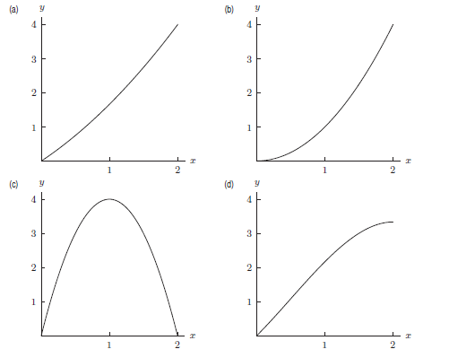

ANSWER: (d) Because the vertical distance between the two curves continually decreases, the graph of the area between these curves will be increasing and concave down.

1. Consider the area between the two functions shown in the figure below. Which of the following graphs (a)–(d) represents this area as a function of *x*?

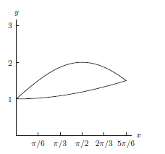

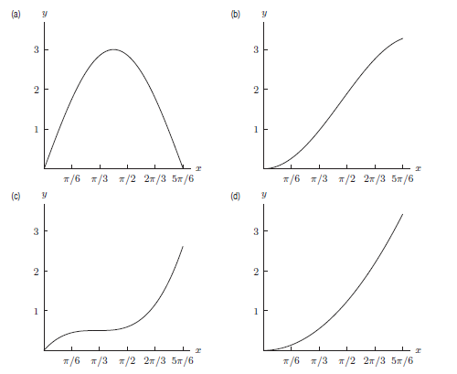

|  |
| --- |
|  |

ANSWER: (b) Because the vertical distance between the two curves increases, and then decreases, the graph of the area between them will first be concave up and then concave down.

1. Consider the area between the two functions shown in the figure below. Which of the following graphs (a)–(d) represents this area as a function of *x*?

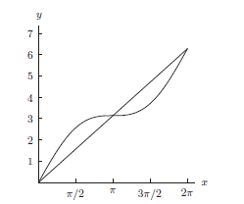

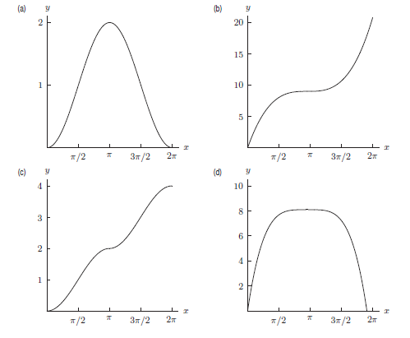

ANSWER: (c). Because the vertical distance between the two curves increases for 0 *< x < π/*2 and *π < x <* 3*π/*2, the graph of the area will be concave up in these intervals. It will be concave down in the other intervals because there the vertical distance between the given curves decreases.

**Part II** *[5 pts each]*

1. Compute the following:



*Solution:*

*Using the FTC, we obtain*



2. Compute the following:



*Solution: Using L’Hopital’s rule, since the limit is of the form ∞/∞,*



3. Evaluate and simplify fully:



*Solution: Note that, for all integers m, sin(m ) is zero. Thus*



4. Compute and simplify fully:



*Solution: This is a telescoping sum. Using associativity, the sum “collapses” to one term:*



5. Evaluate:



*Solution:*



6. Compute the following limit:



*Solution:*



7. Carefully state the *Mean Value Theorem*.

*The MVT states: Let f be continuous on [a, b] and differentiable on (a, b). Then there exists a number c in the interval (a, b) such that:*



8. Verify that the function  satisfies the hypotheses of the MVT on the interval [-1, 1]. Then find all numbers *c* that satisfy the conclusion of the MVT. *Sketch*.

*Solution: First note that arcsin x is continuous on [-1, 1] and differentiable on (-1, 1).*  We are seeking c in the interval (-1, 1) such that



So



Now it is easy to check that both values of

9. Evaluate *without the use* of the FTC the following Riemann integral.



*Solution:*





*Solution:*

* and note that f(-x)= -f(x).*

*Since f(x) is an odd function and we integrate over [-/2, /2] the resulting integral has value 0.*

**Part III**  *[10 pts each]* Answer any 8 of the following 10 questions. You may answer more than 8 to earn extra credit.

1. The *logarithmic integral*, li(x), is defined by:



1. Is li(x) increasing or decreasing for x > 2? (Hint: Use FTC)

Justify your answer.

Using the FTC, d(li x)/dx = 1/ln(x). For x > 2, ln x > 0. Thus, for x > 2, d(li x)/dx is positive, and so li(x) is increasing for x > 2.

1. Is li(x) concave up or concave down for x > 2? Justify your answer.

Now d2/dx2 (li(x)) = (d/dx) (1/ln x) = -(ln x)-2(1/x) < 0 for x > 2.

Thus, li(x) is concave down for x > 2.

2. Given that



find the value of: .

*Solution: Using the basic properties of the Riemann integral:*



3. Consider the graph of y = f(x) defined on the interval [0, 6] as represented below.





1. *What is the maximum value of G(x) on the interval [0, 6] and where is that value achieved? (Briefly explain.)*

*Solution: Using the area interpretation of the definite integral, one can see that the integral is* ***maximized when x = 4.5****. Now*

**

*Thus the* ***maximum*** *value* ***achieved*** *by G(x) on the interval [0, 6] is* ***1.25****.*

1. *What is the minimum value of G(x) on the interval [0, 6] and where is that value achieved? (Briefly explain.)*

*Solution: Using the area interpretation of the definite integral, one can see that the integral is* ***minimized when x = 1.5****. Now*

**

4. *(a)* Find the *area* of the region bounded by parabola y = 4x – x2 – 3 and the x-axis. Compute the exact answer. *Be certain to sketch the region.*

*Solution: The parabola intersects the x-axis when 0 = 4x – x2 – 3 =*

*– (x – 1)(x – 3). That is, when x = 1, x = -3. Thus the area between the parabola and the x-axis is given by:*

**



*(b)* Find the *area* of the region bounded by the parabola y = 2 – x2 and the straight line y = -x. Compute the exact answer. *Be certain to sketch the region.*

*Solution: Begin by finding the points of intersection of the curves*

*y = -x and y = 2 – x2:*

*-x = 2 – x2 x2 – x – 2 = 0 (x + 1)(x – 2) = 0 x = 2, x = -1.*

*Thus, since the parabola lies above the straight line, the area between them is:*

**



5. Albertine puts a very large marshmallow in the microwave for 40 seconds and watches as it inflates. Let m(t) be the rate of change of the volume of the marshmallow, in cm3/sec, t seconds after Albertine puts it in the microwave. The graph of y = m(t) is below.

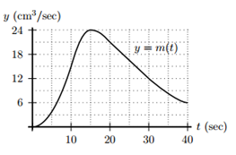

1. Write a definite integral equal to the total change in volume, in cm3, of the marshmallow while in the microwave. (Do *not* evaluate the integral.)

*Answer:*



1. Estimate your integral from part (a) using a right-hand sum with ∆t = 10. Be sure to write out all of the terms in the sum. (Use appropriate units.)

*Solution:*

*A right-hand Riemann sum from t = 0 to t = 40 with t = 10 will employ the values of m(t) at t = 10, 20, 30, and 40:*

*S = 10 m(10) + 10 m(20) + 10 m(30) + 10 m(40) = 10(15 + 21 + 12 + 6) = 540.*

*Since m(t) has units of cm3/sec and t has units of sec, the integral has units of cm3 which agrees with it being a change in volume.*

*6.* Solve the following initial value problem:



*Solution: We begin by solving the differential equation.*

*Our first guess is:*

**

*Now, since*

**

*Our second and final guess is:*

**

*To solve for t, we know that x = -1 when t = 1:*

*So -1 = (1/4) (ln 1)4 – ½ e0 + C*

*Solving for C: C = -½*

*Hence the solution to our IVP is:*

**

7. Let *a* and *b* be non-zero constants. *Verify* the following integration formula:



*Solution:*

*Computing the derivative of the right-hand side:*



8. (a) Use a *left-endpoint* Riemann sum with n = 4 rectangles to approximate the area between the curve f*(x) = ln x* and the x-axis over the interval [4, 6]. Draw a picture to illustrate what you are computing. Is this an *underestimate* or an *overestimate* of the area?

*Solution:*

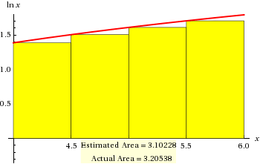

*The width of each rectangle is 0.5. Thus the left-endpoint Riemann sum is:*

*SLeft = 0.5 f(4) + 0.5 f(4.5) + 0.5 f(5) + 0.5 f(5.5) =*

*0.5(ln 4 + ln 4.5 + ln 5 + ln 5.5) 3.102*

*This is an* ***under-estimate****.*

1. Use a right-endpoint Riemann sum with n = 4 rectangles to approximate the area between the curve f*(x) = ln x* and the x-axis over the interval [4, 6]. Draw a picture to illustrate what you are computing. Is this an *underestimate* or an *overestimate* of the area?

*Solution:*

*:* 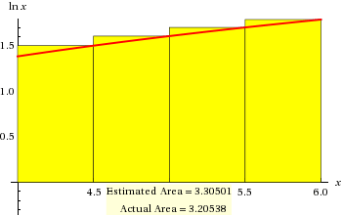

*The right-endpoint Riemann sum is:*

*SRight = 0.5 f(4.5) + 0.5 f(5) + 0.5 f(5.5) +0.5 f(6) =*

*0.5(ln 4.5 + ln 5 + ln 5.5 + ln 6) 3.305*

*This is an* ***over-estimate****.*

1. Verify that *g(x) = x ln x – x* is an anti-derivative of f(x).

*Solution: d/dx (x ln x – x) = d/dx (x ln x ) – d/dx (x) = x(1/x) + ln x – 1 = ln x*

1. Using (c) and the *Fundamental Theorem of Calculus*, find the *exact* value of the area under the curve y = ln x between x = 4 and x = 6.

*Solution: Using an anti-derivative of ln x from part (c):*



9. The graph below shows the ***velocities*** of two joggers, Albertine and Marcel, in meters per minute as they jog along the Champs-Élysées. Albertine and Marcel begin jogging from the same point at the same time.



(a) How far does Albertine jog in this 10 minute interval?

*Solution: (10 minutes) (80 m/min) = 800 min*

(b) How far does Marcel jog in this 10 minute interval?

*Solution: area beneath Marcel’s velocity curve is 840 m.*

(c) Who is jogging *faster* at time t = 6 minutes?

*Answer: Marcel*

(d) Which jogger is *ahead* (i.e. has traveled the greater distance) at time t = 6 minutes? Why?

*Solution:*

*Albertine: 6*80 = 480 m*

*Marcel: area under Marcel’s velocity curve is 360 meters*

*Hence Albertine is ahead.*

(e) If the two joggers had decided to stop at a café when they reach 400 meters, who would have arrived at the café first? Why?

*Solution: Albertine reaches 400 m in 5 minutes.*

*Marcel reaches 400 meters in about 6.33 minutes.*

*Thus Albertine would win.*

10. Consider the graph of y = f ′(x) drawn below.

(*Note: This is not the graph of f.*)



1. On which intervals, if any, is *f*  *increasing?*

*f is increasing when df/dx > 0. This occurs on the interval (3, 6).*

1. At which values of *x* does *f* have a *critical point?*

*f is as a critical point when df/dx = 0. This occurs at x = 1, x = 3, and x = 6. Note that f is not differentiable at its endpoints.*

1. On which intervals, if any, is *f* *concave up?*

*f is concave up when df/dx is increasing. This occurs on (0, 1), (2.3, 4.8), and (7.3, 8)*

1. Which values of *x*, if any, correspond to *inflection points* on the graph of *f*?

*f has a critical point when it changes concavity. Using our answer to problem (c), we find that this occurs at x = 1, x = 2.3, x = 4.8, and x = 7.3*

1. Assume that f(0) = 0. Sketch a graph of *f*. (Your graph need only have the right general shape. You do not need to put units on the vertical axis.)

*In this exercise, we are graphing an anti-derivative of f that passes through the origin.*

*“He seemed to approach the grave as a hyperbolic curve approaches a line, less directly as he got nearer, till it was doubtful if he would ever reach it at all.”*

- Thomas Hardy, ***Far from the Madding Crowd***