Recommended Supplementary Texts

- Tom Apostol, Calculus, volume 1: One-Variable Calculus with an introduction to Linear Algebra, 2nd edition, Wiley (1967)
- J. Marsden & A. Weinstein, Calculus I (Undergraduate Texts in Mathematics), Springer-Verlag (1985)
- McCallum, Hughes-Hallett, Gleason, et al, Calculus, 6th edition, Wiley (2012)
- Larson & Edwards, Calculus, 9th edition, Brooks/Cole (2009)
- G. Simmons, Calculus with Analytic Geometry, 2nd edition, McGraw-Hill Science/Engineering/Math (1996)

Lighter reading
- Adams, Hass, Thompson, How to Ace Calculus, The Streetwise Guide, Freeman (2003)
- Jason Bardi, Calculus Wars, Thunder’s Mouth Press (2006)
- Petr Beckmann, History of π, St. Martin’s Press (1971)
- David Berlinski, Tour of the Calculus, Vintage Books (1995)
- Sergiy Klymchuk, Counterexamples in Calculus, MAA (2010)
- Sergiy Klymchuk and Susan Staples, Paradoxes and Sophisms in Calculus, MAA (2013)
- Eli Maor, The Facts on File Calculus Handbook, Facts on File Science Handbooks (2003)
- Eli Maor, To Infinity and Beyond, Princeton University Press (1991)
- ed. James Newman, The World of Mathematics, 4-volumes, reprinted by Dover Publications (2003)
10. George F. Simmons, Calculus Gems, MAA (2007)
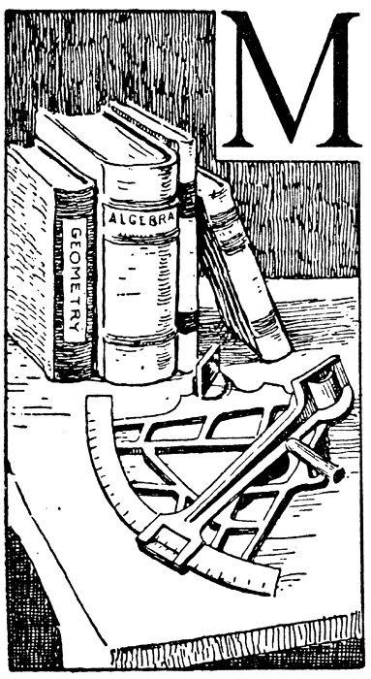

With an absurd oversimplification, the "invention" of the calculus is sometimes ascribed to two men, Newton and Leibniz. In reality, the calculus is the product of a long evolution that was neither initiated nor terminated by Newton and Leibniz, but in which both played a decisive part.
- Richard Courant and Herbert Robbins

Course Home Page Department Home Page Loyola Home Page

