Worksheets: MATH 161

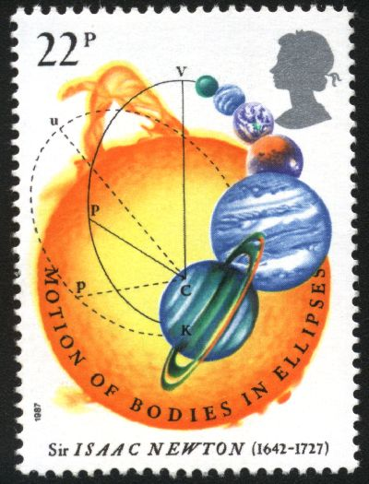

Worksheet I (algebra problems from Hall & Knight)

Worksheet II (more about functions: graphing rational functions; introducing hyperbolic functions)

Worksheet III (limits & continuity, Intermediate Value Theorem, Sandwich Theorem)

Worksheet IV (trigonometric limits; one-sided limits; (sin x)/x → 1 as x → 0)

Worksheet V (average rate of change)

Worksheet VI (interpreting the derivative)

Worksheet VII (shortcuts!)

Worksheet VIII (higher-order derivatives)

Worksheet IX (chain rule, implicit differentiation, log differentiation, inverse trig fcns)

Worksheet X (parametric equations)

Worksheet XI (related rates)

Worksheet XII (shape of curves: concavity, curve sketching, finding local/global extrema; Extreme Value Theorem)

Worksheet XIII (optimization)

Worksheet XIV (l’Hôpital’s rule)

Worksheet XV (anti-derivatives; Rolle’s Theorem; Mean Value Theorem; initial value problems; indefinite intervals)

Worksheet XVI (Newton’s method)

Worksheet XVII (Riemann sums)

Worksheet XVIII (the Riemann integral)

Worksheet XIX (Fundamental Theorem of Calculus)

Worksheet XX (Area between curves)

Worksheet XXI (substitution and the Change of Variable theorem)

Work! God wills it. That, it seems to me, is clear.
- Gustave Flaubert (letter to Louise Colet, 1845)

Course Home Page Department Home Page Loyola Home Page

