**WORKSHEET XII**

**Curve sketching**

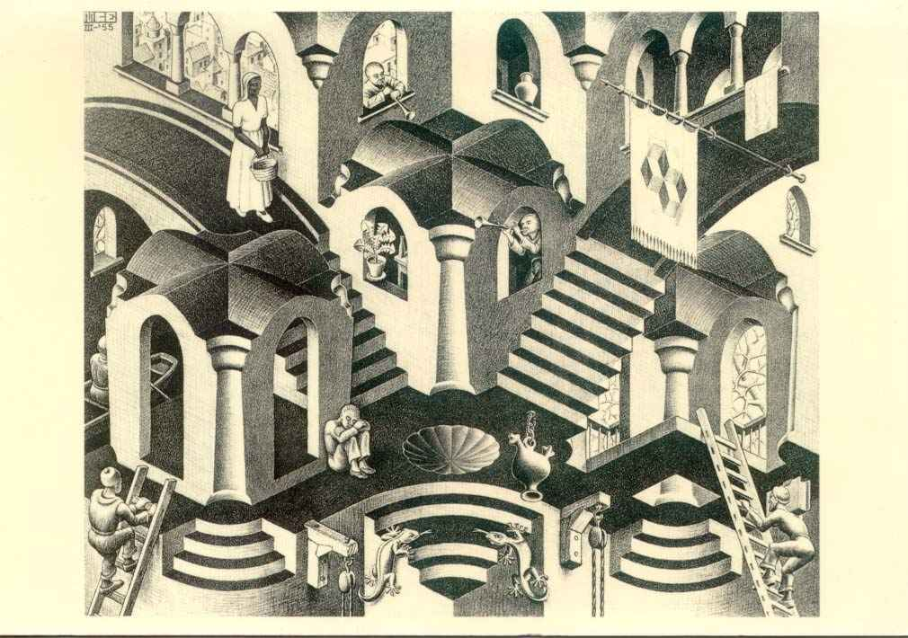

[M. C. Escher](http://www.mcescher.com/): Concave and Convex

**1.** Sketch each of the following curves, y = f(x). Follow the three-stage plan: (1) precalculus analysis, (2) first-derivative analysis (finding all critical points and identifying local & global extrema), and (3) second-derivative analysis.

(a) y = 2x3 – 14x2 + 22x – 13

(b) y = x4 – 4x3 + 10

(c) y = xex

(d) y = x4(x – 5)

(e) y = x2ln x

(f) y = x e-2x

(g) y = (x – 1)4(x – 2)9











(m) y = x + sin x

(n) y = x + 2 cos x

(0) y = e2/x

(p) y = (x2 + 4)/ (2x)

**2.** Determine all local and global extrema of the following functions, each defined on a *closed and bounded* interval.

(a) y = x + 4/x on [1, 3]















**3.** For each graph of y = g′(x) given below, draw the graphs of y = g(x) and that of y = g′′(x).

(a)



(b)



(c)



(d)



4. Given that the derivative of a smooth function y = f(x) is

y′ = (x – 1)2(x – 2)(x – 4)

Determine all points (if any) at which y has a local minimum, local maximum, or point of inflection.

5. Given that the second derivative of a smooth function

y = f(x) is

y′′ = x(x – 3)2(x – 2)3(x – 4)(x – 9)2014

find any and all points of inflection.

6. What is meant by the **First Derivative Test** for finding local extrema?

What is the **Second Derivative Test** for finding local extrema?

7. Use the *Second Derivative Test* to find local extrema of each of the following curves:

(a) y = x4 – 4x3

(b) y = x4/4 – 2x3 + 6

(c) y = 3x5 – 5x3 + 3

*Everyone knows what a curve is, until he has studied enough mathematics to become confused through the countless number of possible exceptions.*

- [Felix Klein](http://www-history.mcs.st-andrews.ac.uk/Biographies/Klein.html)

[Course Home Page](http://www.math.luc.edu/~ajs/courses/161fall2015/index.pdf)          [Department Home Page](http://www.math.luc.edu/)        [Loyola Home Page](http://www.luc.edu/)