WORKSHEET XIII
Optimization
I Albertine is planning to build a rectangular garden. Three sides of the garden will be bordered by shrubs which cost $40 per foot. The fourth side of the garden will be an iron fence that costs $70 per foot. The area enclosed by her garden must be 800 square feet. Albertine wishes to minimize her expenditures on shrubs and fencing. What are the dimensions of the garden that minimizes her cost? (Be certain to identify your variables, draw a diagram, and use appropriate units.)

II A rectangle is to be inscribed (with one side on the x-axis) under the arch of the curve y = 8 cos x from x = -π/2 to
x = π/2. Find the dimensions of such a rectangle with maximum area. (You will need to use a calculator in this problem.)

III Your company can manufacture x hundred grade A tires and y hundred grade B tires per day, where 0 < x < 4 and
Your profit on a grade A tire is twice your profit on a grade B tire. What is the most profitable number of each kind of tire to produce daily? Explain your reasoning!
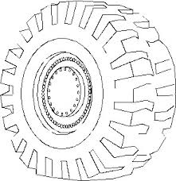
IV What are the dimensions of the lightest open-top right circular cylindrical can that will hold a volume of 1000 cm³?

V Albertine is designing a rectangular poster to contain 50 in² of printing with a 4-in. margin at the top and bottom and a 1-in. margin at each side. What overall dimensions will minimize the amount of paper used?

VI A rectangular building is to cover 20,000 square feet. Zoning regulations require 20 foot frontages at the front and the rear and 10 feet of space on either side. Find the dimensions of the smallest piece of property on which the building can be legally constructed.

VII Find two nonnegative numbers whose sum is 9 and such that the product of one number and the square of the other number is a maximum.

VIII Build a rectangular pen with three parallel partitions using 400 feet of fencing. What dimensions will maximize the total area of the pen?

IX An open rectangular box with square base is to be made from 48 ft.² of material. What dimensions will result in a box with the largest possible volume?
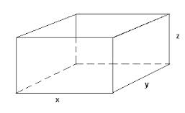
X Construct a window in the shape of a semi-circle surmounted over a rectangle. If the distance around the outside of the window is 16 feet, what dimensions will result in the rectangle having largest possible area?

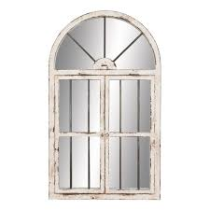
XI A movie screen on a wall is 18 feet high and 9 feet above the floor. At what distance x from the front of the room should you position yourself in order to maximize your viewing pleasure?

XII What angle α between two edges of length 3 will result in an isosceles triangle with the maximal area?

XIII A can is to have a total surface area of 20 in². Find the dimensions that will maximize the enclosed volume.

XIV An open-top cylindrical tank with a volume of ten cubic feet is to be made from a sheet of steel. Find the dimensions of the tank that will require as little material used in the tank as possible.
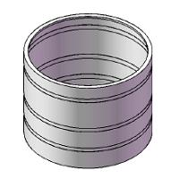
XV A child’s rectangular play yard is to be built next to a house. To make the three sides of the playpen,
21 feet of fencing are available. What should be the dimensions of the sides to maximize the area?

XVI A flexible chain of length 5 meters in cut into two pieces. One piece is used to form a circle, the other is used to form a square. Where should the cut be made in order to maximize the sum of the two areas? Minimize the sum of the two areas.
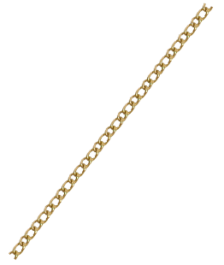

XVII Dido’s Problem

Find the figure bounded by a line which has the maximum area for a given perimeter. Assume that the seashore is one edge of the region.

The problem is based on a passage from Virgil's Aeneid:

"The Kingdom you see is Carthage, the Tyrians, the town of Agenor;
But the country around is Libya, no folk to meet in war.
Dido, who left the city of Tyre to escape her brother,
Rules here – long and labyrinthine tale of wrong
Is hers, but I will touch on its salient points in order....Dido, in great disquiet, organized her friends for escape.
They met together, all those who harshly hated the tyrant
Or keenly feared him: they seized some ships which chanced to be ready...
They came to this spot, where to-day you can behold the mighty
Battlements and the rising citadel of New Carthage,
And purchased a site, which was named 'Bull's Hide' after the bargain
By which they should get as much land as they could enclose with a bull's hide."
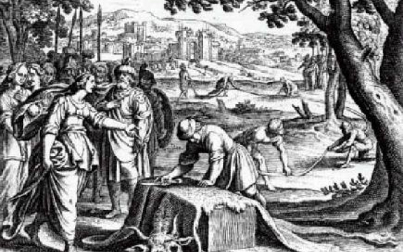

Since the fabric of the world is the most perfect and was established by the wisest Creator, nothing happens in this world in which some reason of maximum or minimum would not come to light.
- Leonhard Euler (1707 – 1783)

Course Home Page Department Home Page Loyola Home Page

