**WORKSHEET XV**

**MVT, Anti-derivatives, Indefinite integrals &**

**initial value problems**

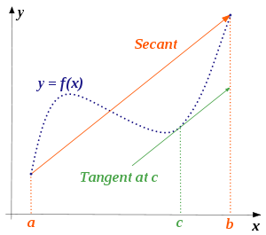



**Math Bridge in Beijing**

**I**  (a) State *Rolle’s Theorem*.

(b) State the *Mean Value Theorem*, and explain its geometric meaning.

(c) How is the MVT derived from Rolle’s Theorem?

(d) Using the Mean Value Theorem, prove that if df/dx = dg/dx on (a, b), then there exists a constant *C* for which f(x) = g(x) + C for all x∈(a,b).

(e) Let f(x) = x3 – 2x + 3 be defined on the interval [1, 3]. Apply the MVT to this function and find the corresponding value of *c*.

(f) Let g(x) = 1 + 3 sin 2x be defined on the interval [0, /12]. Apply the MVT to this function and find the corresponding value of *c*.

**II** Evaluate each of the following *indefinite integrals* (using the method of “judicious guessing”):





















**III** Solve each of the following *differential equations* (using the method of “judicious guessing”).











**IV** Solve each of the following *initial value problems* (using the method of “judicious guessing”):











**V** Charlotte the spider is traveling along the x-axis with acceleration, a(t), given by:



Assume that at time t = 0 minute her velocity, v(0), is 4/3 cm/min and her position, x(0), is – 4/15 cm. Where is Charlotte at time t = 5 minutes?

**VI** A grapefruit thrown upward has an initial velocity of 64 ft/sec from an initial height of 80 feet. (Recall that the acceleration due to gravity is -32 ft/sec2.)

1. Find the position, s(t), of the grapefruit as a function of time *t*.
2. When does the grapefruit hit the ground?

**VII** Verify the following integration formula:



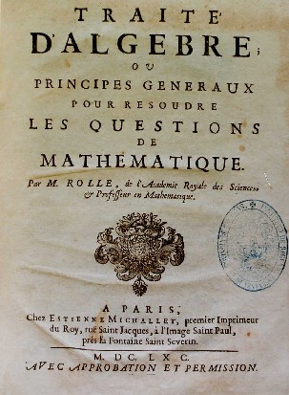

Michel Rolle (1652 –1719)

[Course Home Page](http://www.math.luc.edu/~ajs/courses/161fall2015/index.pdf)          [Department Home Page](http://www.math.luc.edu/)        [Loyola Home Page](http://www.luc.edu/)